User Manual:

Order Processing

| july-20 |

**Document Overview**

**Documentation Goals**

This documentation is intended to provide instruction for all ***Order Processing*** functions. It details the use of ***Order Entry, Releases, Bills of Lading, Credit Approval, Invoicing, Inquiries,*** and ***Reports.***

**Documentation Disclaimers**

* Teach a user how to utilize the Order Processing System.
* Provide instructions for order entry, release processing, billing, invoicing, and reporting.
* Provide detailed screenshots and field definitions for navigating the Order Processing system.

**Table of Contents**

**Overview of Advantzware Specific Keys and Icons** 7

Function Keys 7

Advanced Software Standard Function Keys 8

Program Icons 9

**Order Processing Overview** 10

**Update / Add Orders [OU]** 11

Order Entry [OU1] 11

Overview 11

Browse Order Screen 11

Add Order 17

Items Screen 23

Add Item 28

Misc. Charges Screen 33

Add Misc. Charge 36

Release 39

Add Release 42

Estimate Screen 45

Order Total 45

FG Item 46

Matrix: Browse Screen 47

Add Price Matrix 50

Ship Notes 52

Bill Notes 54

Acknowledgements [OU4] 56

Factory Ticket Print [OU5] 59

Close / Reopen Orders [OU6] 61

Browse Orders 62

Loadtag Creation [OU7] 67

FG Purchase Requirements [OU9] 70

Case Label Creation [OU)] 72

Schedule Ticket Print [OU!] 74

**Tickets for Releases [OT]** 75

Overview 75

Release Status Codes 75

Enter / Edit Releases [OT1] 76

Overview 76

Items 78

Add Items 80

Ship Notes 83

Release Edit List [OT2] 84

Print Release Tickets [OT3] 86

Create Bill of Lading [OT4] 89

**Shipping / Bill of Lading [OS]** 91

Overview 91

Enter / Edit BOL [OS1] 91

Browse BOL 91

Ship Notes 96

BOL Edit List [OS2] 97

Print Bills of Lading [OS3] 99

Master BOL Print [OS4] 102

Post BOL / Create Invoices [OS5] 103

Truckload BOL Summary [OS6] 105

Truck Plan Selection [OS7] 107

Pallet Tag for BOL [OS8] 109

BOL Packing List [OS9] 110

**Billing / Counter Sales [OB]** 113

Overview 113

Enter / Edit Invoices [OB1] 114

Browse Invoices 116

Add Invoice 119

Items 122

Add Invoice Item 123

Misc. 125

Add/Update Miscellaneous 127

FG Item 130

Estimate Screen 130

Bill Notes 130

BOL 132

OE Invoice Edit List [OB2] 133

Print OE Invoices [OB3] 135

Invoice Post / Update GL [OB4] 137

Export Electronic Invoices [OB5] 139

**Levy F.G. Returns / Credits [OL]** 140

Enter / Edit Returns [OL1] 140

Overview 140

Browse Returns 140

Add/Update Header 142

Add Items 146

Notes 147

Returns Edit List [OL2] 149

Post Returns [OL3] 150

**Credit Hold / Approve Orders [OC]** 151

Overview 151

Browse Order 152

View Order 154

Items 156

Misc. Charges 160

Release 161

Estimate 161

Order Total 162

FG Item 162

Matrix 163

Ship Notes 163

Bill Notes 165

**Web Orders Transfer / Approve [OW]** 166

Browse Order 166

Items 169

Misc. Charges 171

Release 172

Estimate 172

Order Total 173

FG Item 173

Matrix 174

Ship Notes 175

Bill Notes 176

**Query Orders [OQ]** 177

Overview 177

Order Status [OQ1] 178

Overview 178

Browse Order 180

View Order 183

Misc. Charges 185

Job Production for Order Line Item 186

Releases 187

Estimate 188

Order Total 189

FG Item 189

Invoices: Browse Invoices 189

Ship Notes 193

**Reports for Orders [OR]** 195

Overview 195

Order Backlog [OR1] 195

Scheduled Releases [OR2] 198

Job Log [OR3] 202

Sales Rep Performance [OR4] 205

Orders Booked [OR5] 207

Commissions [OR6] 211

Order Balance by PO# [OR8] 214

Scheduled Release w/ Job [OR9] 217

Orders Booked by Due Date [OR)] 219

Orders Booked by Order No. [OR!] 222

Scheduled Releases by Ship [OR@] 225

Order Backlog by Part Number [OR#] 228

On-Time Deliveries [OR$] 231

Freight Report [OR%] 234

Machine Orders by Due Date [OR&] 236

Open Order Report [OR^] 239

**Z. More Lists for Orders [OZ]** 242

Hots List [OZ1] 242

Job Tick w/ Order Printed? [OZ2] 245

Summary Invoice Cost [OZ3] 247

Actual Release [OZ4] 250

Commission by Item Cost [OZ5] 253

Hots List by Release Number [OZ6] 256

Hots List by Open Order [OZ7] 259

Hots List2 by Open Order [OZ8] 262

Order Balance by PO / Job [OZ9] 265

Sq. Ft Totals Shipped [OZ)] 268

**File Maintenance for Orders [OF]** 271

Order Entry Control [OF2] 271

Sales Price Matrix [OF3] 273

Add Price Matrix 277

Global Price Increase [OF4] 279

Copy Order [OF5] 281

Misc. Surcharges [OF6] 282

Overview 282

Add/Update Surcharge 285

Comm Cost by Item [OF7] 287

Add/Update Commission Cost 289

Import Order [OF8] 292

Date Change Reasons [OF9] 293

Add Reason 296

# **Overview of Advantzware Specific Keys and Icons**

## Function Keys

|  |  |
| --- | --- |
| BRWS | The browser, which is a list of records in this file. This is functionally equivalent to the Find option of our standard package. |
| VIEW | View record provides the ability to ADD, CHANGE, DELETE, and UPDATE an individual record. |
| SORT BY | The selections at the bottom of the browser, which will sort the list alphabetic order. |
|  |  |
| Update | Update the current record. |
| Reset | Reset the current record. |
| Add | Add a record. |
| Copy | This will copy the existing record. |
| Delete | Delete the current record displayed on the screen. |
| Cancel | Cancel the information that was entered. |
| Save | Save the record. |
|  |  |
|  | Takes the user to the first current record. |
|  | Moves backward one record. |
|  | Moves forward one record. |
|  | Takes the user to the last current record. |
|  |  |
| F1 | Miscellaneous Fields |
| F3 | Search |
| F3 | List |
| F4 | Notes |
| F6 | Browse |
| F7 | Viewer |
| F12 | Exit |

## Advanced Software Standard Function Keys

|  |  |
| --- | --- |
| Next | Shows the next sequential record. |
| Prev | Shows the previous record. |
| Add | Add a record. |
| Change | Change the current record displayed on the screen. |
| Delete | Delete the current record displayed on the screen. |
| Find | Find a record by searching by description. |
| “1”, “2” | Number 1 or 2 to go the first or second page of this record. |
| Esc | Escape from the current transaction without updating. |
| Q | Quit from the current transaction without updating. |
| F1 | Save |
| F3 | Help information is available on every data field. Simply place the cursor on a field and press F3 to display documentation regarding this particular field. |
| F3 | To insert additional data in a data field without erasing the information currently displayed. |
| F4 | Notes – General |
| F1 | Field Lookup is available on every data field which is maintained in a separate file. Place the cursor on a field and press ***“F1”*** to search for the code by description or to advance a screen of records by pressing the next key. Place the cursor next to the desired record and press enter to transfer the record to the data entry screen. See ***“Page Up”*** / ***“Page Down”*** keys below as an alternative |
| F7 | Delete |
| F8 | Notes – File Specific |
| Enter | Advances the cursor to the next field |
| Page Up | Will skim forward through each record in a data file in sequential order |
| Page Down | Will skim backward through each record in a data file in sequential order |
|  |  |

## Program Icons

|  |  |  |
| --- | --- | --- |
|  | Job Notes |  |
|  | Customer Attachments | Attach files (such as Word/Excel/Images) for this specific customer order. |
|  | Change Move/Set Column Mode |  |
|  | Print Acknowledgement |  |
|  | Export to Excel |  |
|  | Add |  |
|  | Attachments | Attachments for this Estimate. Will transfer to all future repeat orders for this estimate. |
|  | Notes |  |
|  | Spec Notes | Notes for specific finished goods items. |
|  | Utility Application |  |
|  | Help |  |
|  | UDF Viewer |  |
|  | Commissions |  |
|  | Exit |  |
|  |  |  |
|  |  |  |

# **Order Processing Overview**

The Customer Order Processing module is integrated with cost Estimating, Finished Goods, Accounts Receivable and Job Costing. Normal processing flows from order entry to release processing, Bill of Lading and invoicing. After each step an edit list may be printed prior to posting the data entered. Job specifications entered in Estimating are transferred to the order and to the Finished Goods record during order entry.

Once the order has been added, the Finished Goods quantity is allocated. Once the line item quantities are entered, the estimated (standard) costs are transferred to the job file for comparison to actual labor and material costs.

Release processing starts the delivery process by producing a Release Ticket for the warehouse clerk. The Release Ticket is marked for actual tag numbers and quantities shipped and transferred to shipping where a Bill of Lading is produced. The Bill of Lading posts the quantity shipped to the invoice file for invoicing which updates Accounts Receivable and reduces the item's quantity on hand and quantity allocated.

#### Order Status Codes

|  |  |
| --- | --- |
| A | Approved from Credit Hold |
| C | Closed Order |
| D | Deleted Order |
| H | Credit Held Order |
| I | Invoice Created from Bill of Lading (Ready to Print) |
| N | New Order |
| O | Original Invoice Created from Order (Ready to Print) |
| P | Partially Invoiced Order |
| R | Ready to Release or Ship via Bill of Lading |
| S | Ship Only Invoice |
| U | Updated Order |
| X | Invoice Printed |

# **Update / Add Orders [OU]**

## Order Entry [OU1]

### Overview

Orders for custom boxes from estimates and Stock Items from inventory are supported. Stock Item orders first require building the Finished Goods items before adding orders. Custom box orders may be added from any estimate. Orders for estimates will automatically create a Finished Goods item record and download the standard cost for the item based on estimated materials, labor and overhead costs.

The system also downloads data fields such as description, PO number, customer number, part number, estimate number, job number and order quantity from the cost Estimating and order entry files. Order Acknowledgments, Factory Tickets, Planned Releases and Order Backlog reports may be printed once orders have been entered and posted.

Please Note: For orders from two-piece box estimates, the system creates a set or parent item and two component items for the lid and bottom in the Finished Goods file. The system keeps track of total order quantities allocated for lids and bottom based on a set maintenance (bill of material) file which is automatically updated.

### Browse Order Screen

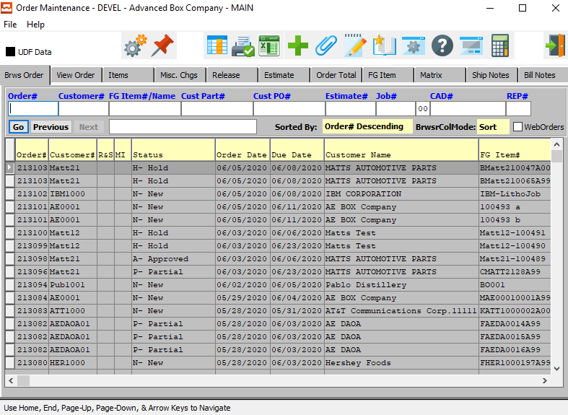

#### ADD

To add an order, simply click the ***“Green + Icon”*** button at the top of the Order Maintenance screen.

### Browse Order Field Definitions

#### Order #

Enter order number or you may use the ***“F1”*** look-up. A partial description may be typed into any field or data may be entered into multiple fields followed by pressing the ***“Go”*** button to sort the fields by the criteria that was entered. Once the data is presented on the screen, the YELLOW column heading may be clicked to sort that specific column in ascending or descending order.

The order entry browser will show only OPEN orders. The Closed Order Browser will show open or closed orders. To show only OPEN customer orders, check the box labeled Open. To show only closed orders, then check the box labeled Closed. To see both closed and open orders, click both boxes.

#### Customer #

Enter customer number or you may use the ***“F1”*** look-up. A partial description may be typed into any field or data may be entered into multiple fields followed by pressing the ***“Go”*** button to sort the fields by the criteria that was entered. Once the data is presented on the screen the YELLOW column heading may be clicked to sort that specific column in ascending or descending order.

#### FG Item #

Enter the FG item number or you may use the ***“F1”*** look-up. A partial description may be typed into any field or data may be entered into multiple fields followed by pressing the ***“Go”*** button to sort the fields by the criteria that was entered. Once the data is presented on the screen, the YELLOW column heading may be clicked to sort that specific column in ascending or descending order.

The order entry browser will show only OPEN orders. The Closed Order Browser will show open or closed orders. To show only OPEN customer orders, check the box labeled Open. To show only closed orders, then check the box labeled Closed. To see both closed and open orders, click both boxes.

#### FG Item Name

Enter the FG name that you want to search for.

#### Cust Part #

Enter the customer part number. A partial description may be typed into any field or data may be entered into multiple fields followed by pressing the ***“Go”*** button to sort the fields by the criteria that was entered. Once the data is presented on the screen, the YELLOW column heading may be clicked to sort that specific column in ascending or descending order.

The order entry browser will show only OPEN orders. The Closed Order Browser will show open or closed orders. To show only OPEN customer orders, check the box labeled Open. To show only closed orders, then check the box labeled Closed. To see both closed and open orders, click both boxes.

#### Cust PO #

Enter the customer PO number. A partial description may be typed into any field or data may be entered into multiple fields followed by pressing the ***“Go”*** button to sort the fields by the criteria that was entered. Once the data is presented on the screen, the YELLOW column heading may be clicked to sort that specific column in ascending or descending order.

The order entry browser will show only OPEN orders. The Closed Order Browser will show open or closed orders. To show only OPEN customer orders, check the box labeled Open. To show only closed orders, then check the box labeled Closed. To see both closed and open orders, click both boxes.

#### Estimate #

Enter the estimate number or you may use the ***“F1”*** look-up. A partial description may be typed into any field or data may be entered into multiple fields followed by pressing the ***“Go”*** button to sort the fields by the criteria that was entered. Once the data is presented on the screen, the YELLOW column heading may be clicked to sort that specific column in ascending or descending order.

The order entry browser will show only OPEN orders. The Closed Order Browser will show open or closed orders. To show only OPEN customer orders, check the box labeled Open. To show only closed orders, then check the box labeled Closed. To see both closed and open orders, click both boxes.

Please Note: The estimate will appear on the VIEW ORDER screen if the N-K-1 CEMENU logical is NO and the character value = CORRWARE.

#### Job #

Enter the job number or you can do a ***“F1”*** look-up from list. A partial description may be typed into any field or data may be entered into multiple fields followed by pressing the ***“Go”*** button to sort the fields by the criteria that was entered. Once the data is presented on the screen, the YELLOW column heading may be clicked to sort that specific column in ascending or descending order.

The purchase order browser will show only OPEN orders. The Closed Order Browser will show open or closed orders. To show only OPEN customer orders, check the box labeled Open. To show only closed orders, then check the box labeled Closed. To see both closed and open orders, click both boxes.

#### Job # - 00

Enter the sequential starting/finishing number for the job.

#### CAD #

Enter the cad number for your search. A partial description may be typed into any field or data may be entered into multiple fields followed by pressing the ***“Go”*** button to sort the fields by the criteria that was entered. Once the data is presented on the screen, the YELLOW column heading may be clicked to sort that specific column in ascending or descending order.

The order entry browser will show only OPEN orders. The Closed Order Browser will show open or closed orders. To show only OPEN customer orders, check the box labeled Open. To show only closed orders, then check the box labeled Closed. To see both closed and open orders, click both boxes.

#### REP #

Enter a sales rep number to search for.

### View Order Screen

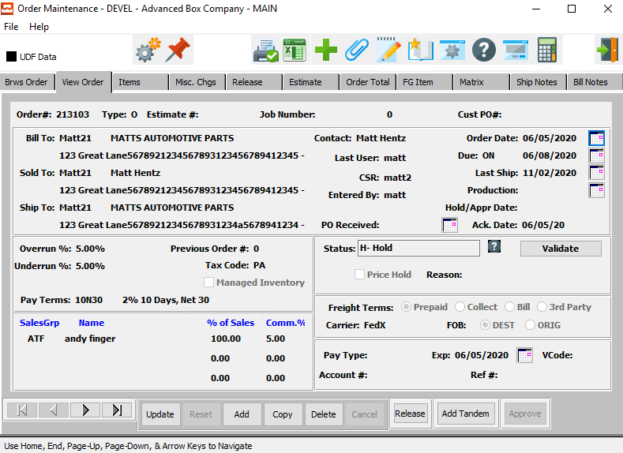

#### UPDATE

To change an order screen, simply click the ***“Update***” button at the bottom of the screen.

#### ADD

To add an order, simply click the ***“Green + Icon”*** button at the top of the Order Maintenance screen.

Alternatively, click the ***“Add”*** button at the bottom of the screen.

#### DELETE

To delete and order, simply press the ***"D"*** key. Alternatively, click the ***“Delete”*** button at the bottom of the screen.

Please Note: This option is not available once production has been posted for this order.

The delete function will reduce the quantity allocated by the quantity previously entered for this order. In addition, for custom boxes, the Finished Goods item record is also deleted. However, the item must not have any other orders or transactions posted.

#### NEXT

Press ***"N"*** (Next) to find next open order to view or modify. Alternatively, press the ***“Right Arrow”*** on the screen.

#### PREVIOUS

Press ***"P"*** (Previous) to find previous open order to view or modify. Alternatively, press the ***“Left Arrow”*** on the screen.

#### RELEASE

If the current order status is On Hold, click the ***“Release”*** button to release the current order.

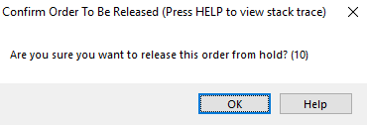

#### HOLD

If the current order status is Released, click the ***“Hold”*** button to change the order hold status on the current order.

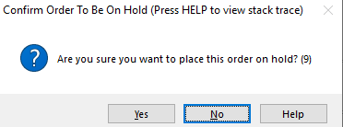

#### ADD TANDEM

Click the ***“Add Tandem”*** button to add a tandem order to the current order.

#### APPROVE

Click the ***“Approve”*** button to approve the current order.

### Update Order

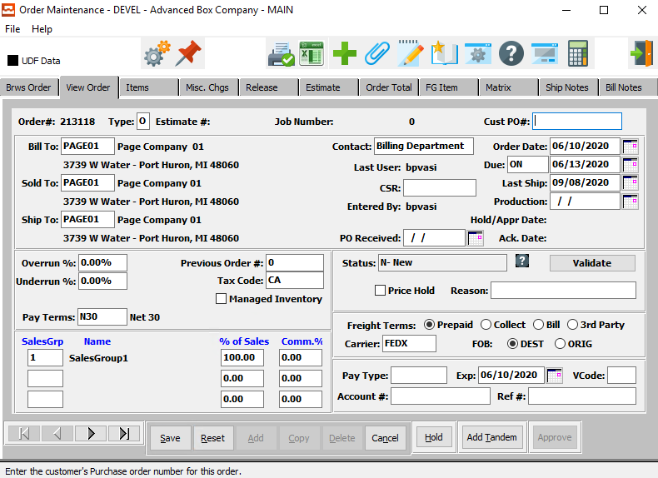

#### SAVE

Click the ***“Save”*** button to save all changes to the order.

#### RESET

Click the “***Reset”*** button to reset all fields to their original state.

#### CANCEL

Click the ***“Cancel”*** button to cancel the update without saving.

#### HOLD

If the current order status is Released, click the ***“Hold”*** button to change the order hold status on the current order.



#### ADD TANDEM

Click the ***“Add Tandem”*** button to add a tandem order to the current order.

#### NEXT

Press ***"N"*** (Next) to find next open order to view or modify. Alternatively, press the ***“Right Arrow”*** on the screen.

#### PREVIOUS

Press ***"P"*** (Previous) to find previous open order to view or modify. Alternatively, press the ***“Left Arrow”*** on the screen.

### Add Order

The system will assign the order number sequentially from the order control file. To override the order number, press the ***ALT-"O"*** keys together. This is useful when adding existing orders from another computer when first implementing Foldware order processing. The ***“F1”*** key provides searches on numerous fields during order entry add mode. For example, press ***“F1”***on the estimate field and a list of all outstanding estimates are listed. Highlight the desired estimate and press ***“Enter”*** to transfer the estimate to the order entry screen.

To override the order number, simultaneously press the ***"ALT"*** and ***"O"*** keys together.

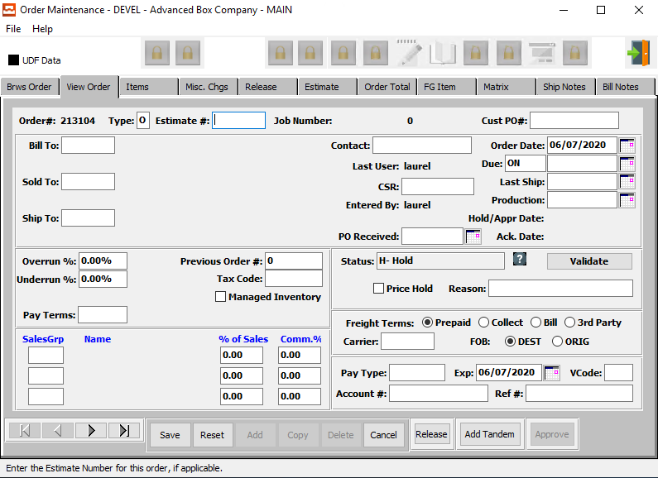

#### Custom Box Orders from Estimates

Three order types are supported, ***"O"*** (Original), ***"R"*** (Repeat) with no changes and ***"C"*** (Change for Repeat) with changes. For Repeat and Change orders, the same job number and item part numbers will be used for each repeated job. However, the last two digits or the job number will increment by 1. For Original orders, the job number will default to the estimate number entered, but may be modified. Since original orders have no existing inventory, the Finished Goods item number is created utilizing the customer part number entered in the estimate.

Please Note: The customer part number, item number and description may be modified for each item when initially adding an item. However, once entered, the item number cannot be changed without deleting the item and adding again.

Unique order processing logic has been designed for each estimate type. Simply enter the estimate number on the header screen and the estimate data will transfer to the order. Once the estimate number is entered, the customer and item information are transferred to the order, however modifications and additional information such as customers purchase order number, due date and production start may be entered.

Multiple estimates for one customer order are supported for single item estimates only, however the estimate numbers must be entered for each item on each line item screen. Orders for combination estimated for multiple customers will create a separate order for each customer. However, the same job number will be used.

#### Save

Click the ***“Save”*** button to save the order.

#### Reset

Click the ***“Reset”*** button to reset all fields.

#### Cancel

Click the ***“Cancel***” button to exit “Add Order” without saving.

#### RELEASE

If the current order status is On Hold, click the ***“Release”*** button to release the current order.



#### ADD TANDEM

Click the ***“Add Tandem”*** button to add a tandem order to the current order.

### Add/Update Order Field Definitions

#### Order #

This number automatically starts with the first number in the control file then increments by one for each order added. The order number will also become the first Job Number for this item unless the job number is changed during order entry. To override the order number, simultaneously press ***"ALT"*** and ***"O"*** together.

#### Type

Valid entrees are ***"O"*** (Original Order), ***"C"*** (Change) and ***"R"*** (Repeat Order). Original orders for custom boxes create new Finished Goods items in the Finished Goods. ***"R"*** (Repeat) orders or repeat orders with ***"C"*** (Changes) do not create new Finished Goods items. However, they do add to the inventory quantities.

#### Estimate #

For custom boxes, the estimate number must be entered. For Stock Items, the estimate number is not required. To search for an estimate number while in order entry add mode, press ***“F1”***. To search for an estimate number by another indexed field, press ***"E"*** (Estimate) from the Header Screen to access the estimating program, then press ***"F"*** (Find).

#### Job Number

The job number defaults to the estimate number, but may be modified. The Job Factory Ticket will print by job number.

Repeat jobs for an item will add a suffix to the original job number. For example, a repeat job number could be Job number 88888-01 where 88888 is the original job and the 01 is the first repeat for that item.

All costs including, standard (estimated) labor, material and overhead, work in process, actual costs and variances are maintained by job number.

#### Cust PO #

This field is not required; however, this multiple PO number may be defined for each line item or each release by accessing the Line Item and Release screens. This field is also used for alpha-numeric searches and inquiries throughout the system.

#### Bill To

Enter the customer’s bill to company name. This transfers to the order when this bill to number is entered.

#### Sold To

This defaults to the customer bill to code but may be changed. Enter a Sold To for this customer. The Sold To file provides up to 999 sold to addresses per customer. The sold to name and address may be used for selling to brokers so that the boxes appear to ship from the broker.

#### Ship To

This field is defined in the customer ship-to file which provides up to 999 Ship To addresses per customer. The Ship To defaults to ship number 1, but may be changed or new Ship-To(s) added. The Ship To address, city, state and zip code will transfer.

#### Contact

This field defaults from the customer file. However, the contact may be entered or modified.

#### Last User

The username of the last user who worked on this order.

#### Entered By

The username of the original user that added this order.

#### PO Received Date

Enter the date of the PO received from the customer. This date may vary from the Order Date and is included on the Order Booked report to allow for analysis of the time it takes a customer to create a PO to the time the order is created.

#### Order Date

The original date order was created. Defaults to date in system clock. Format is MM/DD/YY and may be modified. This date will also be written to the *Estimate* file.

#### Due Date – Code

Due date codes are used to indicate delivery time frame.

Valid codes are:

|  |  |
| --- | --- |
| BY | By a Specific Date |
| MH | Make and Hold |
| ON | On a Specific Date |
| WK | Have Ready Week Of |

#### Due – Date

Enter the date the customer wants the boxes delivered. Format is MM/DD/YY and may be modified.

#### Last Ship Date

This date is calculated by adding the total number of warehouse days in the customer file to the order date. Format is MM/DD/YY and may be modified.

#### Production Date

The starting production date may be entered. When scheduling is integrated into the order processing system, this date will be updated automatically by the system based on the due date. Format is MM/DD/YY and may be modified.

#### Hold/Appr Date

This is the date of the latest hold or approval of the order. It is not modifiable.

#### Ack. Date

This is the date of acknowledgement for the order.

#### Overrun %

Enter an allowable overrun percentage for this order. This defaults from the customer file, but may be modified. Warning messages will display when this limit is exceeded when entering Finished Goods Receipts & Releases for shipments.

#### Underrun %

Enter an allowable underrun percentage for this order. This defaults from the customer file, but may be modified. Warning messages will display when this limit is exceeded when entering Finished Goods Receipts & Releases for shipments.

#### Pay Terms

Enter a valid terms code from the terms file or press the “***F1”*** or the ***“Page Up”*** / ***“Page Down”*** keys to search for a valid code. The payment terms transfer from the order.

#### Previous Order #

The previous order number defaults from the estimate for repeat orders. Once an order is created, the new order number is written on the estimate.

#### Tax Code

Enter a valid sales tax group from the tax file. Optionally, press the ***“F1”*** key to search, or press the ***“Page Up”*** / ***“Page Down”*** keys to scroll through the Sales Tax file. Press the ***“Enter”*** key to accept the Sales Tax group displayed on the screen.

#### Managed Inventory – Toggle Box

If this is managed inventory, make sure that the Managed Inventory toggle box is checked.

#### Sales Grp

Salesman. This field defaults from the customer file once a customer number is entered. Up to three salesmen may be entered or modified. Press ***“F1”*** to search for a salesman.

#### Name

The name of the salesman. Defaults from the Sales Group salesman name. Cannot be modified.

#### % of Sales

Enter the percentage of sales which will be multiplied by the total sales value then by the commission %.

#### Comm. %

The commission percentage defined on the estimate for custom boxes or from the customer / salesman file for Stock Items will automatically transfer, but may be modified for each order. The commission can be set by customer, customer type and product category and may be calculated on the selling price or gross profit as defined in the salesman matrix file.

#### Price Hold

To place a price hold on this order, make sure that the Price Hold toggle box is checked.

#### Reason

Enter a reason for the order status, if necessary.

#### Carrier

Enter the normal common carrier for shipments to this customer. The carrier entered will automatically transfer to release screen. The system calculates the freight cost based on the total weight of the order quantity by the delivery zones and freight rates matrix defined in the common carrier file in the estimating file maintenance.

#### Status

The current status of the order. This is not modifiable here. The available status codes are as follows:

|  |  |
| --- | --- |
| A | Approved from Credit Hold |
| C | Closed Order |
| D | Deleted Order |
| H | Credit Held Order |
| I | Invoice Created from Bill of Lading (Ready to Print) |
| N | New Order |
| O | Original Invoice Created from Order (Ready to Print) |
| P | Partially Invoiced Order |
| R | Ready to Release or Ship via Bill of Lading |
| S | Ship Only Invoice |
| U | Updated Order |
| X | Invoice Printed |

#### Freight Terms

Enter the freight terms. Valid codes are ***"P"*** for prepaid, ***"B"*** for bill separately, and ***"C"*** for collect.

#### FOB

This code indicates whether the freight charges begin at your plant or at the customers location.

Valid entries are:

|  |  |
| --- | --- |
| D | Destination |
| O | Origin |

#### Pay Type

Payment Method. Enter the type of Credit Card, i.e.: Visa, MC, Discover, etc.

#### Expiration Date

Enter the expiration date shown on the Credit Card

#### VCode

Enter the verification code for this payment option.

#### Account #

Enter the credit card account number from the credit card.

#### Ref #

You can enter a Reference Number in this space, possibly the approval number from the last time the card was run.

### Items Screen

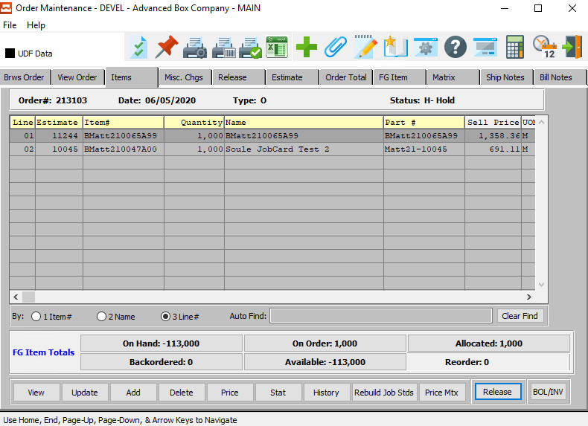

#### VIEW

Position the cursor on the line item to be modified, then press ***"V"*** (View). No changes are allowed in view mode.

#### UPDATE

To update an item, highlight the item you wish to change, and press the ***“Update***” button. Changing the quantity will cause a new calculated cost and update the quantity allocated field.

#### ADD

Please Note: If an estimate number is entered on the header, the system defaults to add mode and automatically creates the Finished Goods item number/s by using the customer part number/s defined on the estimate. Both the customer part number and item number may be changed in *Add* mode, thereafter the item number is not modifiable.

To add a new item to an order, press ***"A"*** (Add).

For Stock Items orders with multiple estimates, the ***“F1”*** key or ***“Page Up/Down”*** keys provide search capability by the customer part number, estimate number, item number and item name.

Once the selling price and quantity have been entered, the system will calculate the total sales value and standard cost. For stock items, the sell price and cost transfer from either the item file or stock matrix. For orders from estimates, the system regenerates the cost and transfers the cost to the order, item and job file. Hence profit analysis by order, Finished Goods value, and production variances from standard may be reported immediately.

#### DELETE

Position the cursor on the line item to be modified, then press ***"D"*** (Delete). Deleting the item will reduce the quantity allocated by the quantity that was ordered.

#### PRICE

Click the ***“Price”*** button to update the price of the current item.

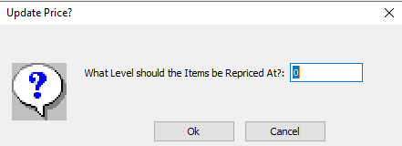

#### OKAY

Click the ***“Okay”*** button to save the updated price of the item.

#### CANCEL

Click the ***“Cancel”*** button to cancel updating the price of the item without saving.

#### STAT

Click the ***“Stat”*** button to view the Customer Credit History for the current order.

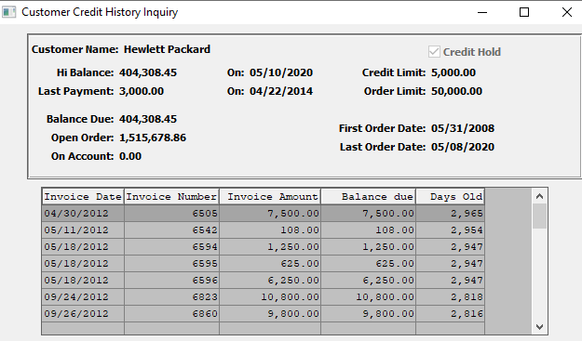

#### HISTORY

Click the ***“History”*** button to view the Sales Analysis Inquiry for the customer of the current order.

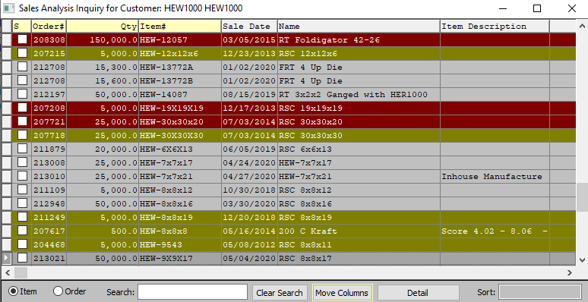

#### REBUILD JOB STANDARDS

Click the ***“Rebuild Job Standards”*** button to rebuild the standards for the current job.

#### PRICE MATRIX

Clicking the ***“Price Matrix”*** button will create or update the FG Price Matrix record from the current order line item.

#### RELEASE

Place the cursor next to the line item to modify, then press ***"R"*** to view, change, or add planned release/s for that item. Multiple Ship-To(s), Purchase Orders, and release dates may be added with different quantities per item on the order.

#### BOL / INVENTORY

Clicking the ***“BOL/INV”*** button to create a bill of lading for the current order item.

### View Item

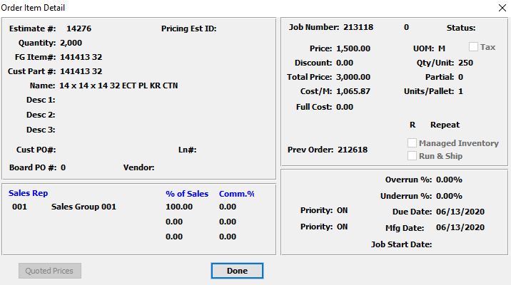

#### DONE

Click the ***“Done”*** button to close the View Item popup screen.

### Update Item

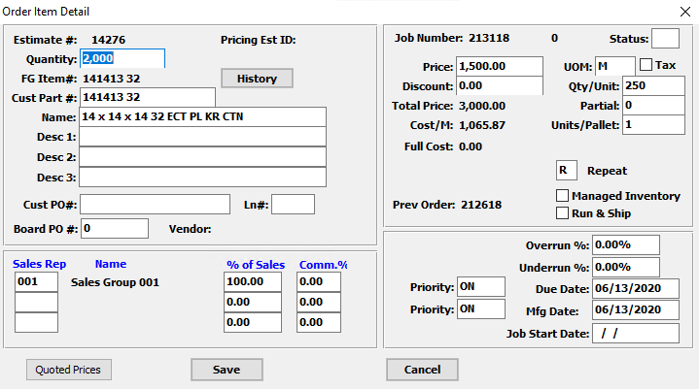

#### QUOTED PRICES

Click the ***“Quoted Prices”*** button to view the quoted prices for the current customer.

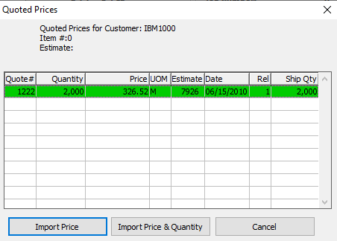

#### IMPORT PRICE

Click the ***“Import Price”*** button to import the item price from a selected Quote.

#### IMPORT PRICE & QUANTITY

Click the ***“Import Price & Quantity”*** button to import the item price and the requested quantity from a selected quote.

#### CANCEL

Click the ***“Cancel”*** button to cancel working on the Quoted Prices screen without saving changes.

#### SAVE

Click the ***“Save”*** button to save all changes to the item.

#### CANCEL

Click the ***“Cancel”*** button to cancel all changes to the item.

### Add Item

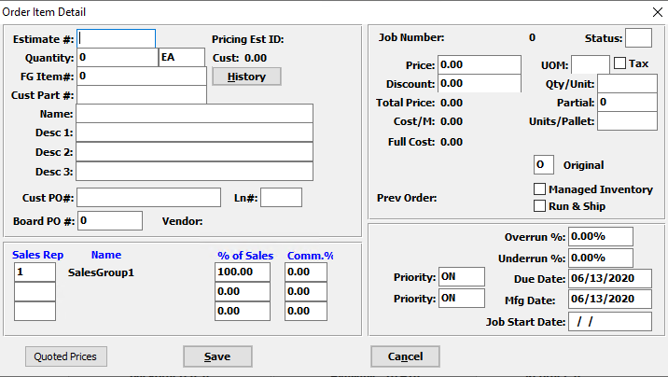

#### QUOTED PRICES

Click the ***“Quoted Prices”*** button to view the quoted prices for the current customer.



#### IMPORT PRICE

Click the ***“Import Price”*** button to import the item price from a selected Quote.

#### IMPORT PRICE & QUANTITY

Click the ***“Import Price & Quantity”*** button to import the item price and the requested quantity from a selected quote.

#### CANCEL

Click the ***“Cancel”*** button to cancel working on the Quoted Prices screen without saving changes.

#### SAVE

Click the ***“Save”*** button to save the item.

#### CANCEL

Click the ***“Cancel”*** button to cancel the new item without saving any changes.

### Add/Update Item Field Definitions

#### Estimate #

The estimate number transfers form the order file. To search for an order by estimate number while in invoice mode, press ***“F5”***. To search for an estimate number by other indexed fields criteria, press ***"E"*** (Estimate) from the Header Screen to access the estimating program, then press ***"F"*** (Find).

#### Quantity

Quantity ordered. This defaults to the quantity ordered for the item.

#### FG Item #

This field links the estimate to Finished Goods item number(s). When entering an order from an estimate that was never ordered, the customer part number defaults to the Finished Good item number, but may be modified. Once the line item screen is updated, the item/s are created in the Finished Goods file and written to the estimate. For repeat orders for that estimate, the same item number would be used rather than creating a new item.

Please Note: If entering a repeat order for the same item utilizing a different estimate, the estimate must have the same customer part number and item number, otherwise a new Finished Good item will be created. The standard cost for material, labor and overhead is recorded for each job for each item. Numerous sales, inventory and production reports by item number are available throughout the system.

#### Customer Part #

This is your customer's part number for this item. This should be entered on all estimates. However, it is mandatory for tandem runs, two-piece box estimates and combination jobs. The system looks at the customer part number in order to calculate the cost of each item based on the blank square inches as a percentage of the total square inches of all items on a form/sheet.

#### Name

The name transfers from the Finished Goods file for Stock Items, but will transfer from the estimate if no item exists. For orders from estimates, the description entered here will transfer to the Finished Good's item record. The item name provides alpha numeric search capability throughout the system.

#### Description

The description transfers from the Finished Goods file for Stock Items, but will transfer from the estimate if no item exists. For orders from estimates, the description entered here will transfer to the Finished Good's item record.

#### Customer PO #

This field is not required. However, this multiple PO number may be defined for each line item or each release by accessing the Line Item and Release screens. This field is also used for alpha-numeric searches and inquiries throughout the system.

#### Line #

This number is used to manually change the line number to match a customer PO number or for other purposes to arrange the items on the invoice in a defined order based on this line number. If left blank, lines will print in the sequence the order was entered.

#### Board PO #

Enter a Board Purchase Order number.

#### Sales Rep

This field defaults from the order, but may be modified. To search for a salesman, press ***“F1”*** to search for salesman.

#### Name (Sales Rep)

This field defaults from the sales rep records.

#### % of Sales

Enter the percentage of sales which will be multiplied by the total sales value then by the commission percentage.

#### Commission %

The commission percentage defined on the order will automatically transfer, but may be modified for each order. The commission can be set by customer, customer type and product category and may be calculated on the selling price or gross profit as defined in the salesman matrix file.

#### Status

The current release status of the job. The available release status codes are as follows:

|  |  |
| --- | --- |
| A | Actual Release |
| B | Backorder – Bill of Lading Posted |
| C | Invoice Posted |
| I | Invoice Now |
| L | Late Release. Current Date Past Due Date |
| P | Posted Release |
| S | Scheduled Release. Not Due and Not Released. |
| Z | Completed. Invoice Created but not Posted. |

#### Price

Enter the sell price per unit of measure.

#### UOM

The sell price unit of measure defaults to M for per thousand, however this may be modified. Each unit of measure will yield a different total selling price.

Valid Units of Measure are:

|  |  |
| --- | --- |
| C | Per Hundred |
| CS | Per Case |
| EA | Per Each |
| L | Per Lot |
| M | Per Thousand |

#### Tax

The tax flag defaults from the order file may be modified, however. If the item is taxable, the percentage from the tax file is used to calculate the total tax amount for each item.

#### Discount

Enter the customer’s discount percentage off of the sell price. As an alternative, a pricing matrix may be established in the price matrix file maintenance module where prices may set by customer, customer type, product category and item. Price could be based on selling price or discount off of list price in the price matrix file in the order processing file maintenance.

#### Qty / Unit

The case count transfers from the order from the Finished Goods file.

#### Partial

Enter the total number of boxes packed in a partial case. If the tag number is entered, this will default from the Finished Goods pallet load tag number.

#### Units / Pallet

Enter the number of units per pallet.

#### Job Type

Valid entrees are ***"O"*** (Original Order), ***"C"*** (Change order) and ***"R"*** (Repeat Order). Original orders for custom boxes create new Finished Goods items in the Finished Goods. ***"R"*** (Repeat) orders or repeat orders with ***"C"*** changes do not create new Finished Goods items, however they do add to the inventory quantities.

#### Managed Inventory – Toggle Box

To run the job with only managed inventory, make sure that the Managed Inventory toggle box is checked.

#### Run & Ship – Toggle Box

If this job has run and ship, make sure that the Run & Ship toggle box is checked.

#### Overrun %

Enter an allowable overrun percentage for this order. This defaults from the customer file, but may be modified. Warning messages will display when this limit is exceeded when entering Finished Goods Receipts & Releases for shipments.

#### Underrun %

Enter an allowable underrun percentage for this order. This defaults from the customer file, but may be modified. Warning messages will display when this limit is exceeded when entering Finished Goods Receipts & Releases for shipments.

#### Due Date

Enter the date the customer wants the boxes delivered. Format is mm/dd/yy and may be modified.

#### Priority (Due Date)

Due date codes are used to indicate delivery time frame.

Valid codes are:

|  |  |
| --- | --- |
| BY | By a Specific Date |
| MH | Make and Hold |
| ON | On a Specific Date |
| WK | Have Ready Week Of |

#### Manufacturing Date

The date the box plant committed to delivering the order transfers from the order.

#### Priority (Manufacturing Date)

Manufacturing date codes are used to indicate delivery time frame.

Valid codes are:

|  |  |
| --- | --- |
| BY | By a Specific Date |
| MH | Make and Hold |
| ON | On a Specific Date |
| WK | Have Ready Week Of |

#### Job Start Date

This is the date that the job production was started for this order.

### Misc. Charges Screen

All miscellaneous sub-contract costs and prep charges defined on the estimate as ***"S"*** for separate charge will automatically transfer with their associated General Ledger numbers. These charges may be included with the first shipment invoice or billed separately.

Total order value, factory cost, weight and commissions are calculated automatically. The total freight cost is automatically calculated from the common carrier file's freight rate file in the estimating module. Given the total shipping weight, the rate per hundred is found and multiplied for all line items on the estimate. The freight may be billable or non-billable for each order. The total tax, if the customer is taxable, includes all taxable line items as well as miscellaneous charges and freight. The total commissions are calculated by multiplying the total revenue for all line items by the commission percentage listed on the Order Header screen one. The total cost includes only the line items direct factory cost.

Please Note: The factory cost includes only direct materials and labor and does not include miscellaneous charges, commissions, freight or general selling and administration costs. The total order value includes all line items as well as all billable charges including tax, freight and miscellaneous charge codes. If freight or prep charges are taxable the control file must be defined to ***"Y"*** (Yes).

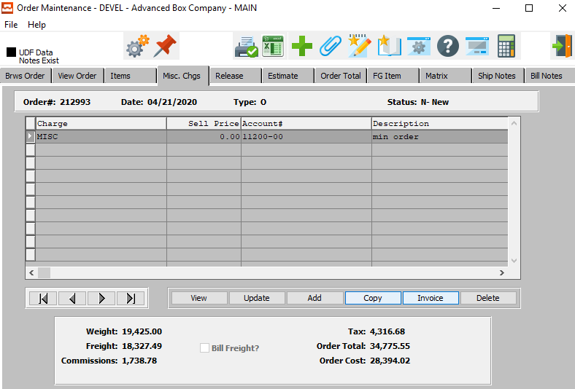

#### VIEW

Click the ***“View”*** button to view detailed information about the selected Miscellaneous Charge.

#### UPDATE

Click the ***“Update”*** button to update information about the selected Miscellaneous Charge.

#### ADD

Click the ***“Add”*** button to add a new Miscellaneous Charge top the order.

#### COPY

Click the ***“Copy”*** button to copy the currently selected miscellaneous charge.

#### INVOICE

Click the ***“Invoice”*** button to select miscellaneous items to invoice for the current order.

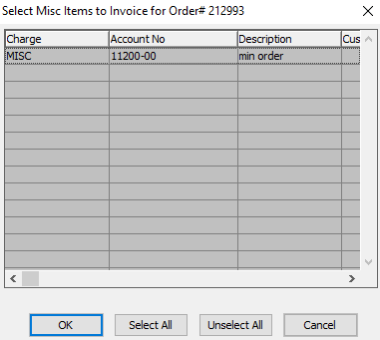

#### DELETE

Click the ***“Delete”*** button to delete the selected Miscellaneous Charge.

#### NEXT

Press ***"N"*** (Next) to find next miscellaneous charge to view or modify. Alternatively, press the ***“Right Arrow”*** on the screen.

#### PREVIOUS

Press ***"P"*** (Previous) to find previous miscellaneous charge to view or modify. Alternatively, press the ***“Left Arrow”*** on the screen.

### View Misc. Charge

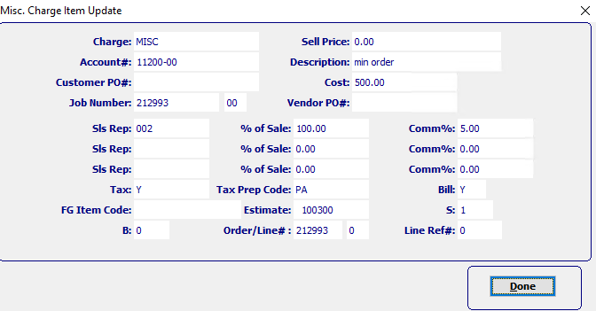

#### DONE

Click the ***“Done”*** button to exit the Misc. Item detail popup screen.

### Update Misc. Charge

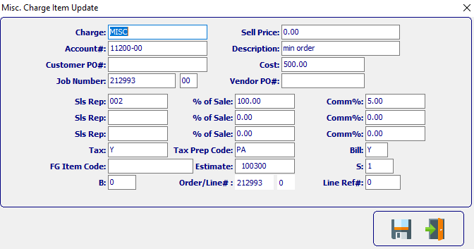

#### SAVE

Click the ***“Floppy Disc Icon”*** to save all changes to the miscellaneous charge screen.

#### EXIT

Click the ***“Exit Door Icon”*** to exit the miscellaneous charge popup screen.

### Add Misc. Charge

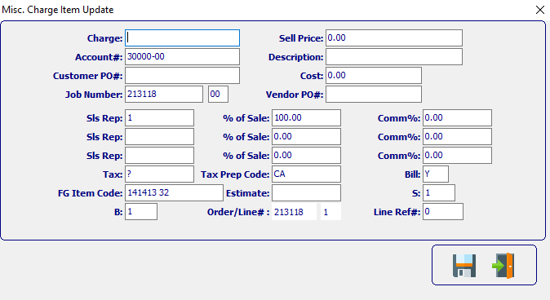

#### SAVE

Click the ***“Floppy Disc Icon”*** to save all changes to the miscellaneous charge screen.

#### EXIT

Click the ***“Exit Door Icon”*** to exit the miscellaneous charge popup screen.

### Add/Update Misc. Charges Field Definitions

#### Charge

The charge code is a combination of the estimating prep charges as well as miscellaneous sub-contract charges which were defined in the estimate as billable charges.

Please Note: The SIMON code on the estimate must be set to ***"S"*** for separate billable charge so that the charges will transfer automatically. Additional charges may be added by simply typing a new charge code and cost.

The ***“F1”*** key will also provide a pop-up window for defined prep codes for transferring to the order. The charge codes will be billed with the first invoice for this order. If commissions are to be paid on miscellaneous charges, the order processing control file must set the flag to ***"Y"*** for yes to pay commissions of prep charges.

#### Account #

The charge code General Ledger account will transfer from the estimating prep file if defined. The GL account number must be first defined in the General Ledger accounts file maintenance. To search for a valid General Ledger account number, press ***“F1”***.

#### Customer PO #

Enter the customer PO number. A partial description may be typed into any field or data may be entered into multiple fields followed by pressing the ***“Go”*** button to sort the fields by the criteria that was entered. Once the data is presented on the screen, the YELLOW column heading may be clicked to sort that specific column in ascending or descending order.

The order entry browser will show only OPEN orders. The Closed Order Browser will show open or closed orders. To show only OPEN customer orders, check the box labeled Open. To show only closed orders, then check the box labeled Closed. To see both closed and open orders, click both boxes.

#### Job Number

The job number defaults to the estimate number, but may be modified. The Job Factory Ticket will print by job number. Repeat jobs for an item will add a suffix to the original job number.

For example, a repeat job number could be Job number 88888-01 where 88888 is the original job and the 01 is the first repeat for that item.

All costs including, standard (estimated) labor, material and overhead, work in process, actual costs and variances are maintained by job number.

#### Job Number: 00

Repeat jobs for an item will add a suffix to the original job number.

#### Sell Price

The invoice amount transfers from the order automatically for all prep charges and miscellaneous charges which were defined in the estimate as billable charges. The billable amount may be changed once it has been transferred. The charge will be billed with the first invoice for this order.

#### Description

The charge code description transfers from estimating for all separately billable charges defined. The description may be modified.

#### Cost

The items cost is always per thousand. The standard factory cost for direct labor, material and overhead are automatically calculated for each order from an estimate. However, Stock Item's cost default from the Finished Goods file. For each order from an estimate, the standard cost is transferred to the item's job file for later comparison to actual costs for that job. The weighted average cost of quantities on hand is based on all jobs received for that item and is displayed in the item file as the average standard cost. The standard labor and overhead cost are calculated on either the machine standards defined on the estimate or the machine speeds defined in the machine standards file.

#### Vendor PO #

Enter a purchase order number from a vendor.

#### Sales Rep

This field defaults from the order, but may be modified. To search for a salesman, press ***“F1”*** to search for salesman.

#### % of Sale

Enter the percentage of sales which will be multiplied by the total sales value then by the commission percentage.

#### Commission %

The commission percentage defined on the order will automatically transfer, but may be modified for each order. The commission can be set by customer, customer type and product category and may be calculated on the selling price or gross profit as defined in the salesman matrix file.

#### Tax

The total tax, if the customer is taxable, includes all taxable line items as well as miscellaneous charges and freight.

#### Tax Prep Code

Enter a code for this preparation charge. Examples of preparation charges include Lock up cost per item, Step and Repeat per number up, Die Cost per Square Inch, Stamping Dies, Embossing Dies, Plates, Rerun Plate cost, Rerun Die Hours, Negatives and Sample Making.

#### Bill

The billable flag indicates whether this charge code is billable. Any prep or miscellaneous charges on the estimate defined as ***"S"*** for separate charge will default to ***"Y"*** (Yes) as a billable item. All billable items will be added to the Total Order Value field at the bottom of the screen.

#### FG Item Code

Enter ***"S"*** for Stock Box or ***"C"*** for Custom Box. When entering stock boxes an ***"S"*** must be entered. When entering a custom box during order entry, Item Code will automatically default to a ***"C"***.

#### Estimate

Automatically defaults from the estimate.

#### S

To access the FORM field, press the ***“GoTo”*** Key when modifying a Combination Run or Two-piece Box estimate. This identifies the number of forms (different sheet sizes) that are used on an estimate. This is used for two-piece boxes estimates with separate sheets for the lid and bottom, and combination runs with multiple forms. For single item and tandem runs, the form is always one.

#### B

Enter the sheet/blank number to assign to the cost of this material. Sheet fed machines end with a 0 such as 1-0 whereas blank fed machines must be 1 or greater such as 1-1 indicating form 1, blank 1.

#### Order / Line #

Enter the order number.

#### Line Reference #

Enter the line reference number.

### Release

To add planned releases for any line item, position the cursor next to the line item and press the ***"R"*** (Release) key. Multiple releases may be set for each item on the order. Each release may have a different Ship To code, Purchase Order Number, ship date and quantity.

Scheduled release reports show what is required to ship by date. Releases transfer to Bills of Lading, which in turn update invoicing automatically. Ship To instructions entered in the customer Ship To file transfer to the release screen for each Ship To entered.

The instructions may be modified if necessary, by pressing the ***"T"*** (Text) key while on the release screen. The Ship To instructions will print on the Bill of Lading. When the invoice is posted, the release quantity is updated automatically.

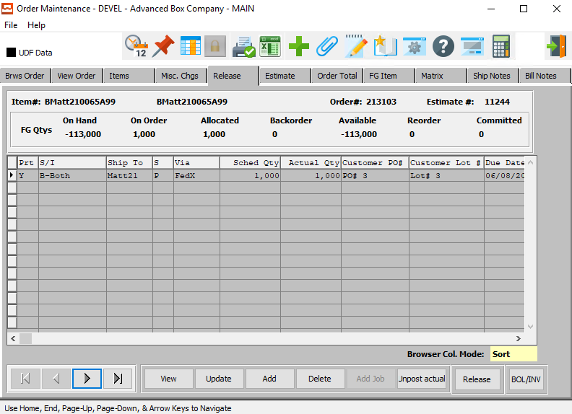

#### VIEW

Click the ***“View”*** button to view detailed information about the selected Release.

#### UPDATE

Click the ***“Update”*** button to update information about the selected Release.

#### ADD

To add releases, press ***"A"*** (Add). To search for existing Ship To locations for this customer, press the ***“F1”*** key when the cursor is on the Ship To field and select a Ship To code.

#### DELETE

Position the cursor on the line item to be deleted, then press ***"D"*** (Delete).

#### UNPOST ACTUAL

To un-post a posted release, click the ***“Unpost Actual”*** button.

Please Note: a user cannot unpost planned releases, only posted releases.

#### RELEASE

Press ***"R"*** (Release) to transfer the release immediately to the actual released orders file so that a release/packing ticket may be printed immediately.

Please note: This will create a separate release ticket for each item released. To group multiple items on one release ticket, you must manually add a release from the release processing menu, then add each item to the release.

#### BOL / INVENTORY

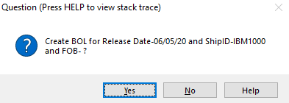

#### NEXT

Press ***"N"*** (Next) to find next open order to view or modify. Alternatively, press the ***“Right Arrow”*** on the screen.

#### PREVIOUS

Press ***"P"*** (Previous) to find previous open order to view or modify. Alternatively, press the ***“Left Arrow”*** on the screen.

### View Release

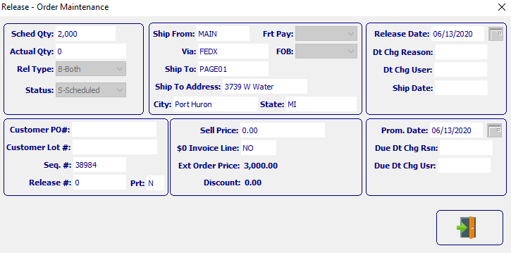

#### EXIT

Click the ***“Exit Door Icon”*** to exit the View Release popup screen.

### Update Release

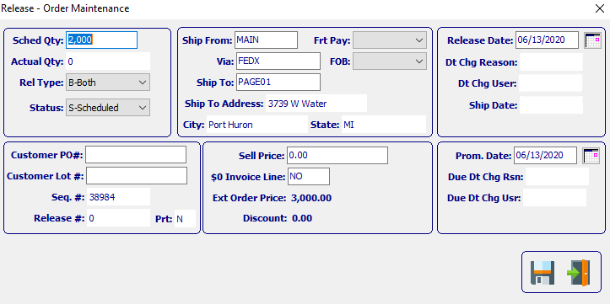

#### SAVE

Click the ***“Floppy Disc Icon”*** to save the Release information.

#### EXIT

Click the ***“Exit Door Icon”*** to exit the Update Release popup screen.

### Add Release

When the releases are posted, Ship only orders will update Bill of Lading then will update the ship quantity on the invoice when the Bill of Lading is posted. ***"I"*** (Invoice Only) releases immediately update the invoice quantity in invoicing when releases are posted. ***"B"*** (Both Ship and Invoice) type releases update Bill of Lading then update both the ship and invoice quantity on the invoice.

For each release, the total release quantity may be entered or each pallet tag number, bin location, case count and quantity of cases may be entered for each release.

To search for an item, bin or tag number, simple press the ***“Page Down”*** or ***“F1”*** keys to search for the item or tag number.

The Release Ticket /Pick/Packing ticket forms should be loaded, and an alignment test printed. The releases ticket prints the information entered on the release, hence if specific tag numbers are to be shipped, the tag numbers should be entered on the release. When ready, the tickets should be printed and posted. Release / Packing tickets may be printed by date range or order number range.

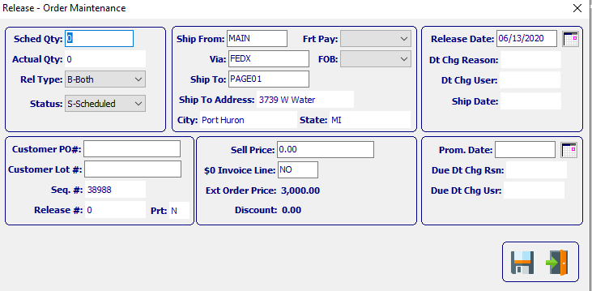

#### SAVE

Click the ***“Floppy Disc Icon”*** to save the Release information.

#### EXIT

Click the ***“Exit Door Icon”*** to exit the Add Release popup screen.

### Add/Update Release Field Definitions

#### Scheduled Qty

Enter the scheduled quantity for the release.

#### Actual Qty

Enter the actual quantity released.

#### Release Type

There are three possible release types:

|  |  |
| --- | --- |
| B | Both Ship and Invoice |
| I | Invoice Only |
| S | Ship Only |

#### Status

The release status indicates that a planned release has a print ticket outstanding.

#### Customer PO #

Enter the customer PO number. A partial description may be typed into any field or data may be entered into multiple fields followed by pressing the ***“Go”*** button to sort the fields by the criteria that was entered. Once the data is presented on the screen, the YELLOW column heading may be clicked to sort that specific column in ascending or descending order.

The order entry browser will show only OPEN orders. The Closed Order Browser will show open or closed orders. To show only OPEN customer orders, check the box labeled Open. To show only closed orders, then check the box labeled Closed. To see both closed and open orders, click both boxes.

#### Customer Lot #

Enter the customer lot number for this release.

#### Release #

Add a release number to create a case label for.

#### Part

This is your customer's part number for this item. This should be entered on all estimates. However, it is mandatory for tandem runs, two-piece box estimates and combination jobs. The system looks at the customer part number in order to calculate the cost of each item based on the blank square inches as a percentage of the total square inches of all items on a form/sheet.

#### Ship From

Valid options are: Ship from Bill of Lading and Ship from Finished Goods. Only one Ship from option is valid when using Foldware. For example, if Ship from Finished Goods is selected, your company could not process Bills of Lading.

#### Ship Via

Enter the common carrier for this release to this customer. The carrier will transfer to the Bill of Lading screen automatically. Press ***“F1”*** to search for a common carrier.

#### Ship To

Enter a ship to code or a customer code from the customer file. Do not enter a customer code unless this ship to will be invoiced. The ship-to file provides unlimited ship-to addresses per customer. During estimating or order processing, if the user enters this ship-to number, the ship to name, address, city, state, zip, common carrier and delivery zone will transfer automatically.

#### Ship To Address

The customer's Ship To address defaults for the Ship To number entered.

#### Freight Pay

Valid codes are ***"P"*** for prepaid, ***"B"*** for bill separately, and ***"C"*** for collect.

#### FOB

Valid entries are ***"O"*** for Origin or ***"D"*** for Destination. This code indicates who is paying for the freight charges.

#### Sell Price

Enter the sell price per unit of measure.

#### Release Date

The default release date is calculated by adding the number of warehousing days in the customer file to the order date. The release date may be modified so that each release may have a different release date. For customers ordering custom boxes, the warehouse days should be set to the maximum number of warehouse days so that the release date will automatically trigger shipment of inventory which has reached the latest shipment date. For Stock Item customers, the warehouse dates should be set to zero so that the release date is equal to the order entry date.

#### Date Change Reason

Enter a reason code for this date change.

Please Note: Date Change Reason Codes may be defined by the user in the ***“O” – “F” – “9”*** (*Date Change Reasons)* screen. If you do not see an applicable reason code already defined, the user may define their own.

#### Date Change User

The user who changed the date for this order.

#### Ship Date

This date is calculated by adding the total number of warehouse days in the customer file to the order date. Format is mm/dd/yy and may be modified.

#### Promised Date

The date the box plant committed to delivering the order transfers from the order.

#### Due Date Change Reason

Enter a reason code for this date change.

Please Note: Date Change Reason Codes may be defined by the user in the ***“O” – “F” – “9”*** (*Date Change Reasons)* screen. If you do not see an applicable reason code already defined, the user may define their own.

#### Due Date Change User

The user who changed the due date for this order.

### Estimate Screen

Clicking the ***Estimate*** tab will bring up a popup screen of the Estimation system.

To learn more about how the ***Estimating*** system works, please refer to the “Corrugated” or “Folding” Estimating Manuals.

### Order Total

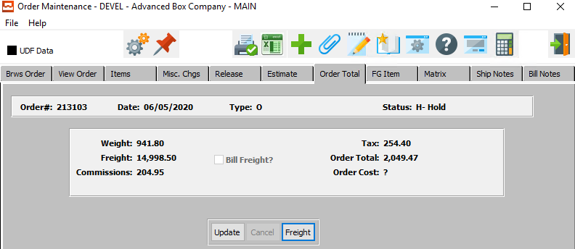

#### UPDATE

Click the ***“Update”*** button to update the Order Total information.

#### FREIGHT

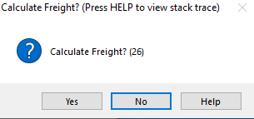

### Update Order Total

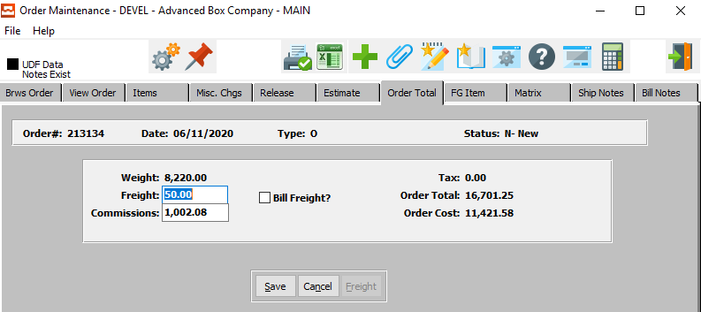

#### SAVE

Click the ***“Save”*** button to save all updated changes.

#### CANCEL

Click the ***“Cancel”*** button to cancel all updated changes without saving.

### Update Order Total Field Definitions

#### Freight

Enter the Freight cost for shipping the order.

#### Bill Freight – Toggle Box

The total freight cost may be either billable or non-billable for each order as dictated by the freight billable flag. If a user wishes to bill the customer for the freight cost, make sure that the *Bill Freight* toggle box is checked.

#### Commissions

Enter the Commissions cost for the order.

### FG Item

Clicking the ***FG Item*** tab will bring up a popup screen of the Finished Goods system.

To learn more about how the ***Finished Goods*** system works, please refer to the “Finished Goods” Manual.

### Matrix: Browse Screen

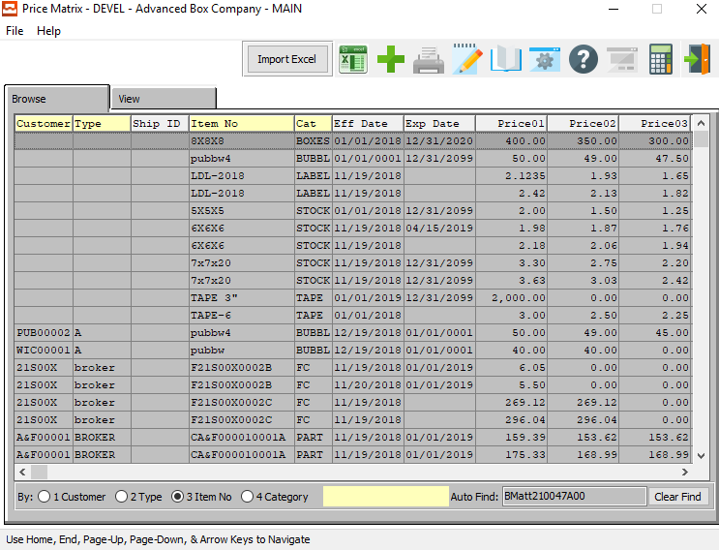

#### IMPORT EXCEL

Click on the ***“Import Excel”*** button to choose an excel file of an item to import into the system.

### Matrix: View Screen

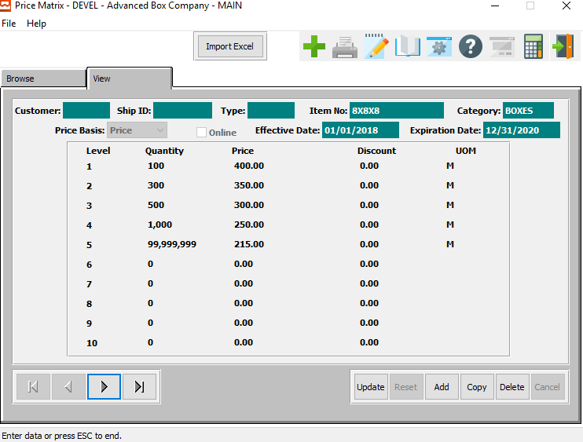

#### UPDATE

Click the ***“Update”*** button to make changes to the Price Matrix.

#### ADD

Click the ***“Add”*** button to add a new Price Matrix.

#### COPY

Click the ***“Copy”*** button to copy the current price matrix.

#### DELETE

Click the ***“Delete”*** button to delete the Price Matrix.

#### NEXT

Press ***"N"*** (Next) to find next Price Matrix to view or modify. Alternatively, press the ***“Right Arrow”*** on the screen.

#### PREVIOUS

Press ***"P"*** (Previous) to find previous Price Matrix to view or modify. Alternatively, press the ***“Left Arrow”*** on the screen.

### Update Price Matrix

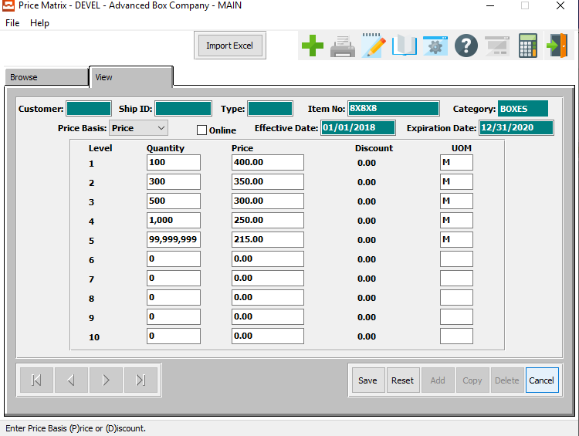

#### IMPORT EXCEL

Click on the ***“Import Excel”*** button to choose an excel file of an item to import into the system.

#### SAVE

Click the ***“Save”*** button to save all updated changes.

#### RESET

Click the ***“Reset”*** button to reset all fields to their unchanged state.

#### CANCEL

Click the “***Cancel”*** button to cancel the update without saving changes.

### Add Price Matrix

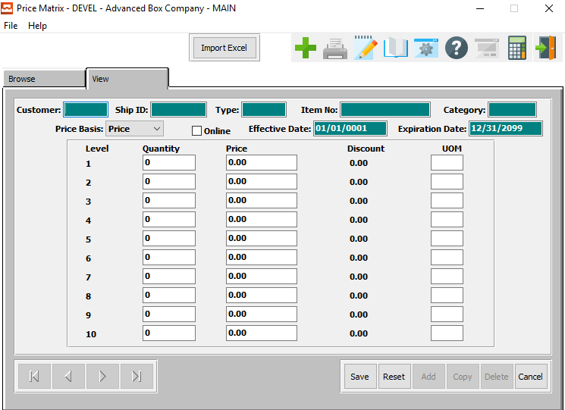

#### IMPORT EXCEL

Click on the ***“Import Excel”*** button to choose an excel file of an item to import into the system.

#### SAVE

Click the ***“Save”*** button to save all updated changes.

#### RESET

Click the ***“Reset”*** button to reset all fields to their unchanged state.

#### CANCEL

Click the “***Cancel”*** button to cancel the update without saving changes.

### Add/Update Price Matrix Field Definitions

#### Customer

Enter a unique customer number. The customer name, address, city, state, zip, salesman, common carrier and delivery zone will transfer to Estimating, Order Entry, and Accounts Receivable modules. When entering an order, for this estimate, this information would transfer to the items record so that customer, inventory reporting, and sales analysis are available.

#### Ship ID

Enter the Ship ID number for the customer.

#### Release Type

There are three possible release types:

|  |  |
| --- | --- |
| B | Both Ship and Invoice - update invoicing via Bill of Lading posting |
| I | Invoice Only - transfer directly to invoicing without passing through Bill of Lading |
| S | Ship Only - update invoicing via Bill of Lading posting |

***"S"*** (Ship Only) releases only update the ship quantity on the invoice, whereas ***"B"*** (Both Bill and Ship) type releases update both the invoice quantity and ship quantity.

#### Item Number

The item will transfer from the order file. To find an item for this order, press “***F1”*** or the ***“Page Up”*** / ***“Page Down”*** keys. Once an item is selected, a ship quantity may be added for each tag number or a total ship quantity may be entered.

#### Category

The product category description defaults from the product category file in Finished Goods file.

#### Price Basis

Enter the price basis for this matrix.

#### Online – Toggle Box

If this is an online order, make sure that the Online toggle box is checked.

#### Effective Date

Enter the first date that this price matrix will become effective.

#### Expiration Date

Enter the date that this price matrix is set to expire.

#### Quantity

The total order quantity transfers from the order.

#### Price

Enter the sell price per unit of measure.

#### UOM

The sell price unit of measure defaults to M for per thousand, however this may be modified. Each unit of measure will yield a different total selling price.

Valid Units of Measure are:

|  |  |
| --- | --- |
| C | Per Hundred |
| CS | Per Case |
| EA | Per Each |
| L | Per Lot |
| M | Per Thousand |

### Ship Notes

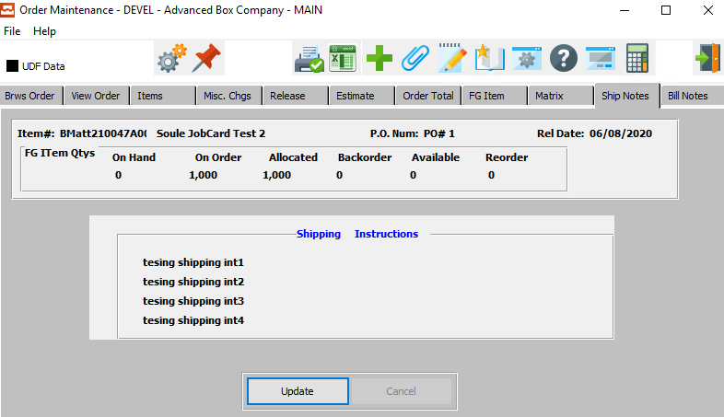

#### UPDATE

To add shipping instruction for any order, click the ***“Update”*** button. Each Ship To on the planned release screen may have unique Ship To instructions which will print on the Bill of Lading form. The Ship To instructions will transfer from the customer's Ship To file if defined.

### Update Ship Notes

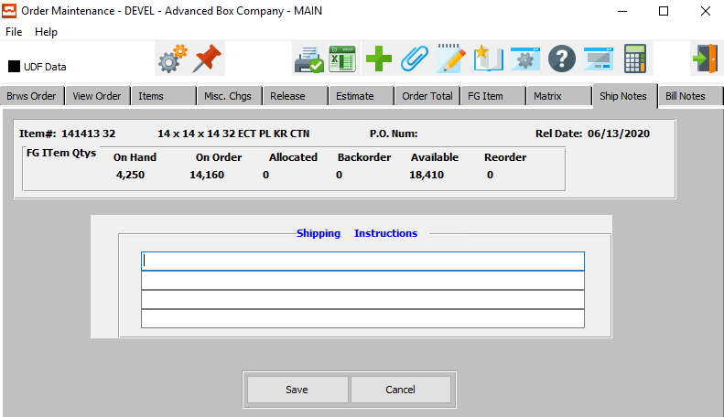

#### SAVE

Click the ***“Save”*** button to save all Shipping Instruction changes.

#### CANCEL

Click the ***“Cancel”*** button to cancel all Shipping Instruction changes without saving.

#### Shipping Instructions

Shipping instructions defined in the customers Ship To file will default for each Ship To defined on the Planned Release screen. To change simply position the cursor next to the Release Ship To location, press ***“T”*** (Text) and *Yes* to modify.

### Bill Notes

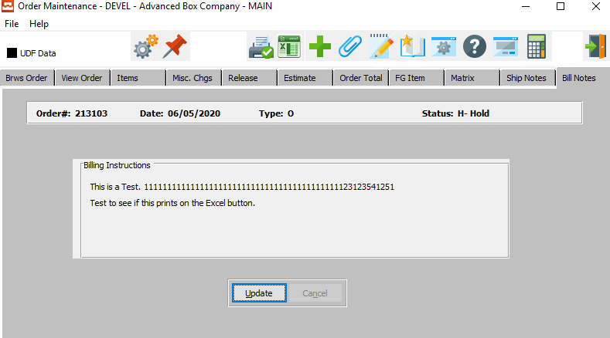

#### UPDATE

To add billing instruction for any order, click the ***“Update”*** button.

### Update Bill Notes

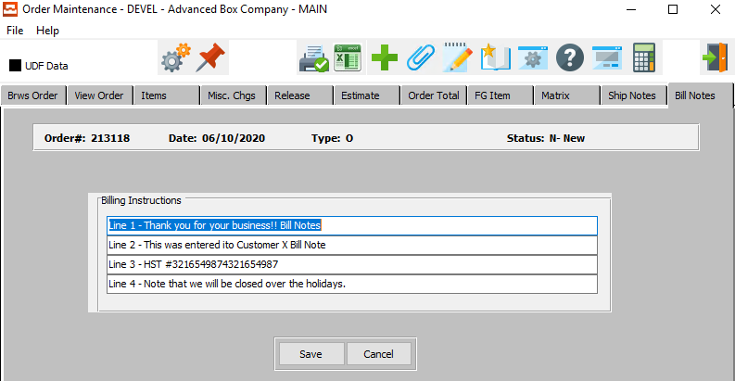

#### SAVE

Click the ***“Save”*** button to save all Billing Instruction changes.

#### CANCEL

Click the ***“Cancel”*** button to cancel all Billing Instruction changes without saving.

#### Billing Instructions

Enter special billing instructions to aid sales service for internal matters. This is not printed on any document that is sent to the customer, but provides a reference for internal personnel. For example, you may want to write a note to collect money prior to shipping within these special billing instructions.

## Acknowledgements [OU4]

Once orders have been entered, order acknowledgments may be printed. For custom developed acknowledgments, call ASI.

### Selection Parameters

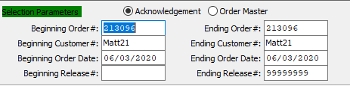

#### Beginning Order # / Ending Order #

Enter starting and ending order number.

#### Beginning Customer # / Ending Customer #

Enter starting and ending customer number.

#### Beginning Order Date / Ending Order Date

Enter starting and ending order date.

#### Beginning Release # / Ending Release #

Enter starting and ending release number.

### Report Type

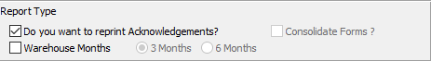

#### Do You Want to Reprint Acknowledgements? – Toggle Box

To reprint acknowledgments, make sure that the toggle box is ‘ticked’ with a checkmark.

#### Consolidate Forms? – Toggle Box

To consolidate forms, make sure that the toggle box is ‘ticked’ with a checkmark.

#### Warehouse Months – Toggle Box

To report warehouse months, make sure that the Warehouse Months toggle box is checked.

#### Warehouse Months (3/6)

If the Warehouse Months toggle box has been checked, the user can choose the preferred length of time between 3 months vs. 6 months, please make sure the desired option choice bubble is toggled.

### Print Options

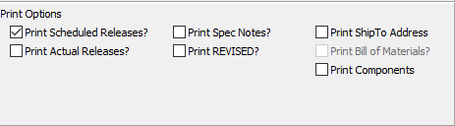

#### Print Scheduled Releases? – Toggle Box

To print scheduled releases, make sure that the toggle box is ‘ticked’ with a checkmark.

#### Print Actual Releases? – Toggle Box

To print actual releases, make sure that the toggle box is ‘ticked’ with a checkmark.

#### Print Spec Notes? – Toggle Box

To print spec notes, make sure that the toggle box is ‘ticked’ with a checkmark.

#### Print REVISED? – Toggle Box

To print revised order acknowledgements, make sure that the toggle box is ‘ticked’ with a checkmark.

#### Print Ship To Address – Toggle Box

To print the ship-to, make sure that the toggle box is ‘ticked’ with a checkmark.

#### Print Bill of Materials? – Toggle Box

To print a bill of materials, make sure that the toggle box is ‘ticked’ with a checkmark.

#### Print Components – Toggle Box

To print the order components, make sure that the toggle box is ‘ticked’ with a checkmark.

### Output Destination

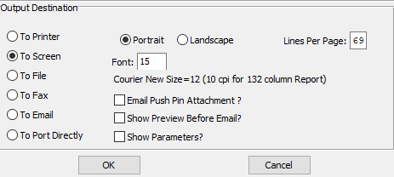

#### Destination Choice

To choose the destination where the document should be printed, please make sure that desired output destination choice bubble is toggled.

#### Layout Choice

To choose the preferred layout of Landscape vs. Portrait, please make sure the desired option choice bubble is toggled.

#### Lines Per Page

Lines per page on the report when printing.

#### Font

Enter the font number to use with this report (Font 11 is default).

#### Email Push Pin Attachment? – Toggle Box

To email push pin attachments, make sure that the toggle box is ‘ticked’ with a checkmark.

#### Show Preview Before Email? – Toggle Box

To show a preview before emailing, make sure that the toggle box is ‘ticked’ with a checkmark.

#### Show Parameters? – Toggle Box

To show parameters, make sure that the toggle box is ‘ticked’ with a checkmark.

## Factory Ticket Print [OU5]

Once orders have been posted, factory/job tickets may be printed. For a custom developed factory ticket, call ASI.

Please Note: Credit held orders will not print a factory ticket if the control flag is set to ***"N"***.

### Selection Parameters

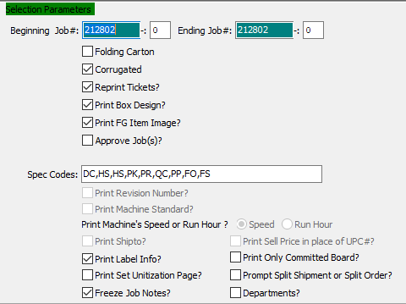

#### Beginning Job # / Ending Job #

Enter the starting and ending job number to print.

#### Beginning Job # -00 / Ending Job #: 00

Enter the sequential starting and ending number for the job to be printed.

#### Folding Carton – Toggle Box

If the user is looking for folding cartons, make sure that the toggle box is ‘ticked’ with a checkmark.

#### Corrugated – Toggle Box

If the user is looking for corrugated boxes, make sure that the toggle box is ‘ticked’ with a checkmark.

#### Reprint Tickets? – Toggle Box

To reprint tickets, make sure that the toggle box is ‘ticked’ with a checkmark.

#### Print Box Design? – Toggle Box

To print the box design, make sure that the toggle box is ‘ticked’ with a checkmark.

#### Print FG Item Image? – Toggle Box

To print a finished good item image, make sure that the toggle box is ‘ticked’ with a checkmark.

#### Approve Job(s)? – Toggle Box

To approve jobs, make sure that the toggle box is ‘ticked’ with a checkmark.

#### Print Revision Number? – Toggle Box

To print revision number, make sure that the toggle box is ‘ticked’ with a checkmark.

#### Print Machine Standard? – Toggle Box

To print machine standard, make sure that the toggle box is ‘ticked’ with a checkmark.

#### Print Machine’s Speed or Run Hour? – Toggle Box

To print the machine’s speed or run hour, make sure that this toggle box is checked.

#### (Speed/Run Hour)

If the ‘Print Machine’s Speed or Run Hour’ toggle box is checked, the user can choose the preferred method of Speed vs. Run Hour, please make sure the desired option choice bubble is toggled.

#### Print Ship To? – Toggle Box

To print ship to, make sure that the toggle box is ‘ticked’ with a checkmark.

#### Print Sell Price in Place of UPC#? – Toggle Box

To print the sell price in place of UPC#, make sure that the toggle box is ‘ticked’ with a checkmark.

#### Print Label Info? – Toggle Box

To label information, make sure that the toggle box is ‘ticked’ with a checkmark.

#### Print Only Committed Board? – Toggle Box

To only committed board, make sure that the toggle box is ‘ticked’ with a checkmark.

#### Print Set Unitization Page? – Toggle Box

To print the set unitization page, make sure that the toggle box is ‘ticked’ with a checkmark.

#### Prompt Split Shipment or Split Order? – Toggle Box

To prompt split shipment or split order, make sure that the toggle box is ‘ticked’ with a checkmark.

#### Freeze Job Notes? – Toggle Box

To freeze job notes, make sure that the toggle box is ‘ticked’ with a checkmark.

#### Departments? – Toggle Box

To print departments, make sure that the Departments toggle box is checked.

### Output Destination

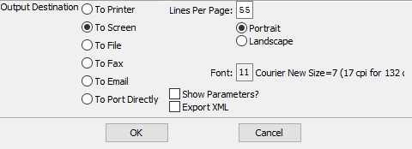

#### Destination Choice

To choose the destination where the document should be printed, please make sure that desired output destination choice bubble is toggled.

#### Layout Choice

To choose the preferred layout of Landscape vs. Portrait, please make sure the desired option choice bubble is toggled.

#### Lines Per Page

Lines per page on the report when printing.

#### Font

Enter the font number to use with this report (Font 11 is default).

#### Show Parameters? – Toggle Box

To show parameters, make sure that the toggle box is ‘ticked’ with a checkmark.

#### Export XML – Toggle Box

To export XML document, make sure that the toggle box is ‘ticked’ with a checkmark.

## Close / Reopen Orders [OU6]

To close an order, simply find the order to be closed & press ***"C"*** (Close). Answer ***"Y"*** (Yes) to close the order. Once an order has been completed or canceled, the order should be closed. Any remaining item quantity ordered by not shipped will automatically be deallocated when the order entry posting program is run.

### Browse Orders

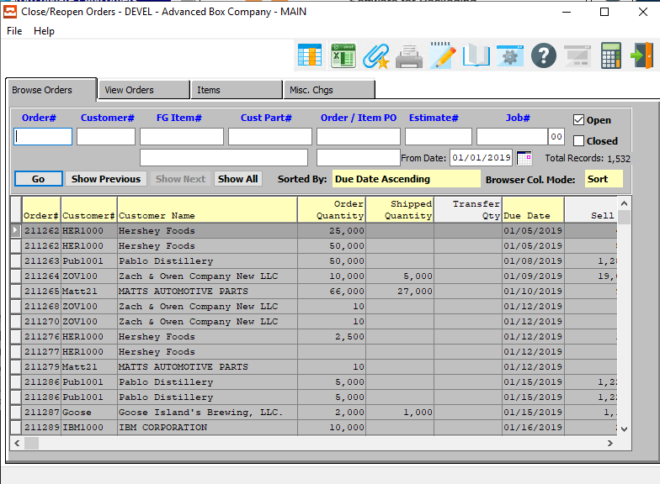

#### Order #

Enter an order number to search for.

#### Customer #

Enter a customer number to search for.

#### FG Item #

Enter an item number to search for.

#### Cust Part #

Enter a part number to search for.

#### Order/Item PO

Enter a PO number to search for.

#### Estimate #

Enter an estimate number to search for.

#### Job #

Enter a job number to search for.

#### Job # - 00

Enter a job suffix number to search for.

#### Open – Toggle Box

To search only among open orders, make sure that the Open toggle box is checked.

#### Closed – Toggle Box

To search only among closed orders, make sure that the Closed toggle box is checked.

#### From Date

Enter a date to start the search from. Only orders after this date will be displayed.

### View Orders

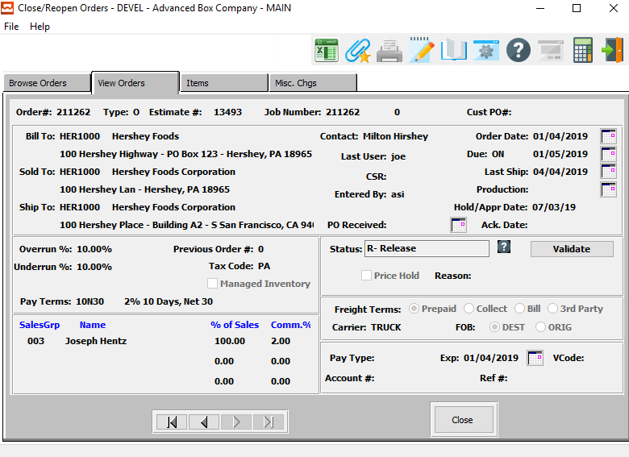

#### CLOSE

Click the ***“Close”*** button to close the View Order tab.

#### NEXT

Press ***"N"*** (Next) to find next order to view. Alternatively, press the ***“Right Arrow”*** on the screen.

#### PREVIOUS

Press ***"P"*** (Previous) to find previous order to view. Alternatively, press the ***“Left Arrow”*** on the screen.

### Items

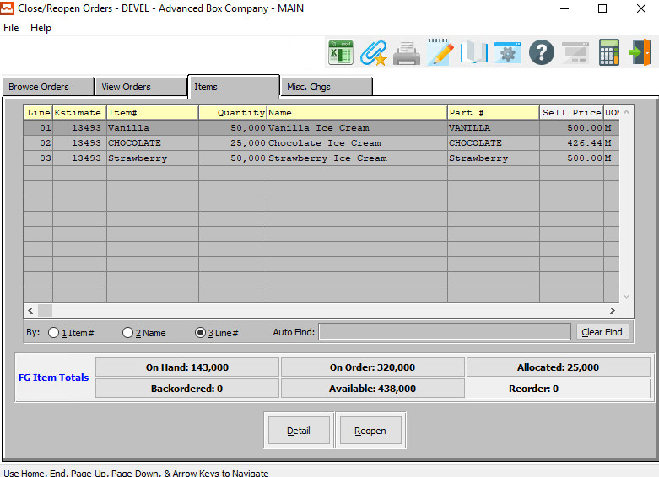

#### DETAIL

Click the ***“Detail”*** button to view detailed information about the current order line item.

#### REOPEN

Click the ***“Reopen”*** button to reopen the current order line item.

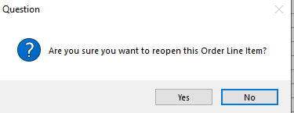

### Item Detail

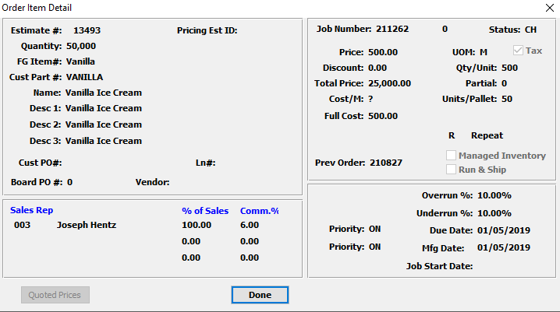

#### DONE

Click the ***“Done”*** button to exit the item detail popup screen.

### Misc. Charges

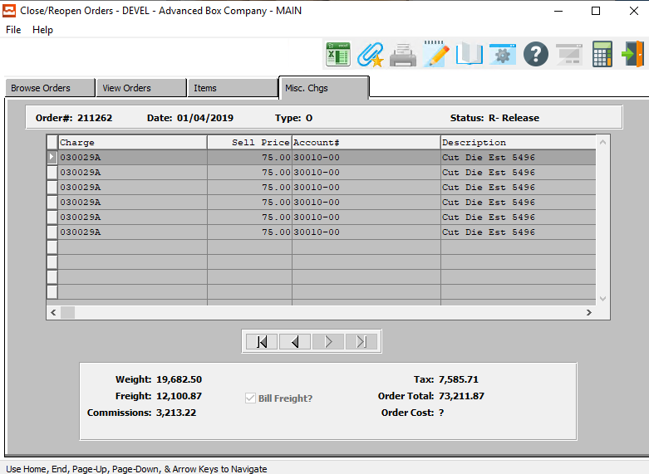

#### NEXT

Press ***"N"*** (Next) to find next miscellaneous charge to view. Alternatively, press the ***“Right Arrow”*** on the screen.

#### PREVIOUS

Press ***"P"*** (Previous) to find previous miscellaneous charge to view. Alternatively, press the ***“Left Arrow”*** on the screen.

## Loadtag Creation [OU7]

### Selection Parameters

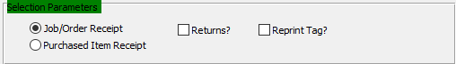

#### Receipt Choice

To choose the preferred receipt method of Job/Order vs. Purchased Item, please make sure the desired option choice bubble is toggled.

#### Returns? – Toggle Box

To create a load tag for a return, make sure that the Returns toggle box is checked.

#### Reprint Tag? – Toggle Box

If this is a reprint of an existing tag, make sure that the Reprint Tag toggle box is checked.

### Data Parameters

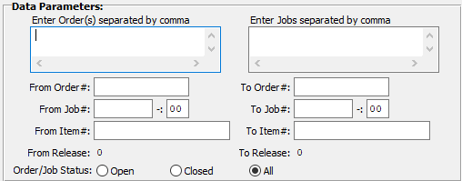

#### Enter Order(s) Separated by Comma

If the orders the user wishes to create load tags for are not sequential, the user may enter in the individual orders they wish to create load tags for. Each must be separated by a comma.

#### Enter Jobs Separated by Comma

If the jobs the user wishes to create load tags for are not sequential, the user may enter in the individual orders they wish to create load tags for. Each must be separated by a comma.

#### From Order # / To Order #

Enter the starting and ending order number create load tags for.

#### From Job # / To Job #

Enter the starting and ending job number create load tags for.

#### From Job #: 00 / To Job #: 00

Enter the sequential starting and ending number for the job to create load tags for.

#### From Item # / To Item #

Enter the starting and ending item number create load tags for.

#### From Release / To Release

Enter the starting and ending release number create load tags for.

#### Order/Job Status

The user can choose to create load tags for open orders, closed orders, or both open and closed orders. To choose the desired job status, please make sure that desired choice bubble is toggled.

### Print Options

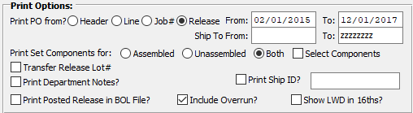

#### Print PO From? (Choice)

To choose the preferred PO layout, please make sure the desired option choice bubble is toggled.

#### From Date / To Date

Enter starting and ending date.

#### Ship To: From / Ship-To: To

Enter starting and ending Ship-To.

#### Print Set Components For (Choice)

To choose the preferred component set of Assembled vs. Unassembled (Or Both), please make sure the desired option choice bubble is toggled.

#### Select Components – Toggle Box

To print only select components, make sure that the Select Components toggle box is checked.

#### Transfer Release Lot# – Toggle Box

To transfer a release lot #, make sure that the Transfer Release Number toggle box is checked.

#### Print Department Notes? – Toggle Box

To print department notes, make sure that the Print Department Notes toggle box is checked.

#### Print Posted Release in BOL File? – Toggle Box

To print a posted release in the bill of lading file, make sure that this toggle box is checked.

#### Print Ship ID? – Toggle Box

To print a ship ID, make sure that the Print Ship ID toggle box is checked.

#### Include Overrun? – Toggle Box

To include overruns, make sure that the Include Overrun toggle box is checked.

#### Show LWD in 16ths? – Toggle Box

To show the LWD in 16ths, make sure that this toggle box is checked.

### Output Options

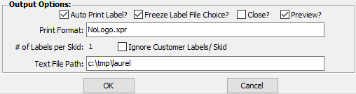

#### Auto Print Label? – Toggle Box

To automatically print the label after creation, make sure that the Auto Print Label toggle box is checked.

#### Freeze Label File Choice? – Toggle Box

To freeze the label file choice, make sure that this toggle box is checked.

#### Close? – Toggle Box

To close this job after creating the load tag, make sure that the Close toggle box is checked.

#### Preview? – Toggle Box

To preview the load tag before printing, make sure that the Preview toggle box is checked.

#### Print Format

Enter a file name and extension code for the created load tag.

#### Ignore Customer Labels/Skid – Toggle Box

To ignore the customer labels, make sure that this toggle box is checked.

#### Text File Path

Enter the file path for a text file version of the created load tags for system reference.

## FG Purchase Requirements [OU9]

The *Finished Goods Purchase Requirements* screen will print a report for the user according to the parameters they set in this function.

### Selection Parameters

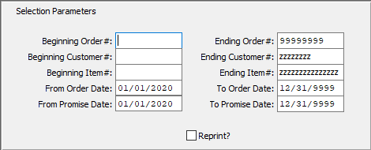

#### Beginning Order # / Ending Order #

Enter the starting and ending order number to print.

#### Beginning Customer # / Ending Customer #

Enter the starting and ending customer number to print.

#### Beginning Item # / Ending Item #

Enter the starting and ending item number to print.

#### From Order Date / To Order Date

Enter the starting and ending order date to print.

#### From Promise Date / To Promise Date

Enter the starting and ending promise date to print.

#### Reprint? – Toggle Box

If this is a reprint, make sure that the Reprint toggle box is checked.

### Output Destination

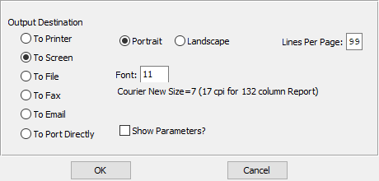

#### Destination Choice

To choose the destination where the document should be printed, please make sure that desired output destination choice bubble is toggled.

#### Layout Choice

To choose the preferred layout of Landscape vs. Portrait, please make sure the desired option choice bubble is toggled.

#### Lines Per Page

Lines per page on the report when printing.

#### Font

Enter the font number to use with this report (Font 11 is default).

#### Show Parameters? – Toggle Box

To show parameters, make sure that the toggle box is ‘ticked’ with a checkmark.

## Case Label Creation [OU)]

The *Case Label Creation* screen will create and print case labels for the user according to the parameters they set in this function.

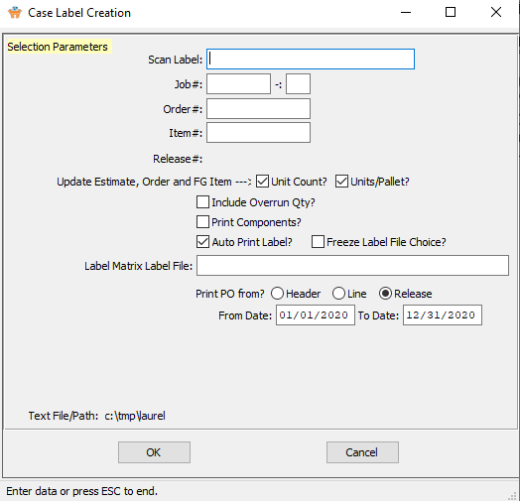

#### OKAY

Click the ***“Okay”*** button to create a new case label.

#### CANCEL

Click the ***“Cancel”*** button to cancel the creation of a new case label without saving.

### Case Label Creation Field Definitions

#### Job #

Add a job number to create a case label for.

#### Job #: 00

Add a subsequent job number to create a case label for.

#### Order #

Add an order number to create a case label for.

#### Item #

Add an item number to create a case label for.

#### Release #

Add a release number to create a case label for.

#### Update Estimate, Order, and FG Item

#### Unit Count? – Toggle Box

To update the estimate, order, and finished goods item by the unit count, make sure that the Unit Count toggle box is checked.

#### Units/Pallet? – Toggle Box

To update the estimate, order, and finished goods item by the units/pallet, make sure that the Units/Pallet toggle box is checked.

#### Include Overrun Qty? – Toggle Box

To include the overrun quantity, make sure that this toggle box is checked.

#### Print Components? – Toggle Box

To print components, make sure that the Print Components toggle box is checked.

#### Auto Print Label? – Toggle Box

To automatically print the label after creation, make sure that the Auto Print Label toggle box is checked.

#### Freeze Label File Choice? – Toggle Box

To freeze the label file choice, make sure that this toggle box is checked.

#### Label Matrix Label File

The user must enter the file path of the Label Matrix Label File they wish to use to create these case labels.

#### Print PO From? (Choice)

To choose the preferred PO printing location of Header vs. Line vs. Release, please make sure the desired option choice bubble is toggled.

#### From Date / To Date

Enter starting and ending date.

## Schedule Ticket Print [OU!]

The *Schedule Ticket Print* screen will schedule board cards for the user according to the parameters they set in this function.

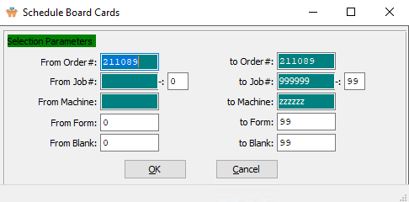

#### From Order # / To Order #

Enter the starting and ending order number to print.

#### From Job # / To Job #

Enter the starting and ending job number to print.

#### From Job #: 00 / To Job #: 00

Enter the sequential starting/finishing number for the job to be printed.

#### From Machine / To Machine

Enter the starting and ending machine to print from.

#### From Form / To Form

Enter the starting and ending form to print.

#### From Blank / To Blank

Enter the starting and ending blank to print.

# **Tickets for Releases [OT]**

## Overview

Planned releases may be defined during order entry with separate Ship-To(s), purchase order numbers, quantities and release dates. The Release Number is sequentially added by the computer for each order. The release processing function supports ship and invoice, ship only or invoice only releases. The release transaction updates the planned releases for accurately updating the item's quantities.

Once releases are entered, the Release/ Packing/Pick ticket (depending of form design) is printed. This preprinted form is updated by the warehouse clerk for actual tag numbers and cases shipped. This information transfers to the Bill of Lading for Shipping and Invoicing.

For releases defined as ***"I"*** (Invoice Only), the release posting program transfers the release quantity directly to Invoicing. Releases defined as ***"S"*** (Ship Only) or ***"B"*** (Both Ship and Invoice) require a Bill of Lading prior to invoicing.

#### Invoice Only Release

Add release with type of ***“I”*** for invoice only. Then press the “***Invoice***” button and create the invoice.

## Release Status Codes

|  |  |  |
| --- | --- | --- |
| A | Actual Release | A Scheduled release becomes an Actual release when you press “**R**” to release, say no to create a BOL (if this option is turned on) and then say yes to release the item. If the release were flagged with an **“A**”, you would locate the release in B-2-1. |
| B | Backorder Release | A release will be flagged as a “**B**” when the quantity shipped, from a prior release, is less than the released quantity. (Taking into consideration the under-run percentage) This will automatically create a backorder release that can be found in B-2-1. Note the Backorder release will not change the quantity of the original release amount. Order quantity should equal the total of all release lines, minus backorders. |
| C | Completed | A posted release becomes a “**C**” once the BOL is posted. |
| I | Invoice | A scheduled release becomes an “**I**” when today’s date is greater than the last ship date from the header page of the order. The “**I**” signifies this can be invoiced. Once the item becomes a scheduled release or a posted release the “**I**” will be changed to an “**A**” or “**P**”. |
| L | Late Release | A scheduled release will change to an “**L**” when today’s date is greater than the release date. |
| P | Posted Release | A Scheduled release becomes a posted release when you press “**R**” to release, and say yes to create a BOL (if this option is turned on) or by going to B-2-4 and posting the actual release. |
| S | Scheduled Release | When an order is first entered, the system will show a scheduled release. You can set up multiple releases and they will all show “**S**” for scheduled. |

## Enter / Edit Releases [OT1]

### Overview

Actual releases to be shipped must be released via release processing. Planned releases defined during initial order entry will print on scheduled release reports showing what is required to ship by release date, however they must be entered here to activate a shipment.

There are three possible release options:

|  |  |
| --- | --- |
| B | Both Ship and Invoice |
| I | Invoice Only |
| S | Ship Only |

When the releases are posted, ***"S"*** (Ship Only) and ***"B"*** (Both Bill and Ship) orders will update the Bill of Lading then will update the invoice when the Bill of Lading is posted. The ***"I"*** (Invoice Only) type releases immediately update the invoice quantity on the invoice, but will show zero quantity shipped.

***"S"*** (Ship Only) releases will update the ship quantity on the invoice whereas ***"B"*** (Both Bill and Ship) type releases update both the ship quantity and invoice quantity on the invoice. For each item on the release, the total release quantity may be entered, or the tag number/s and case count information may be listed. Once releases have been entered and reviewed, the release edit list should be printed, releases printed and then posted.

### Browse Release

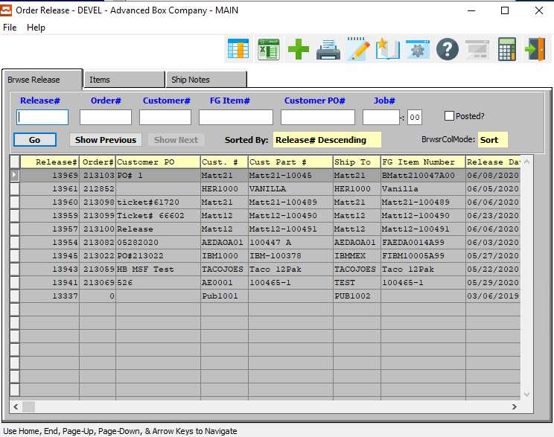

#### Release #

Enter a release number to search for.

#### Order #

Enter an order number to search for.

#### Customer #

Enter a customer number to search for.

#### FG Item #

Enter an item number to search for.

#### Customer PO #

Enter a customer PO number to search for.

#### Job #

Enter a job number to search for.

#### Job #: 00

Enter a subsequent job number to search for.

#### Posted? -Toggle Box

To search only among posted orders, make sure that the Open toggle box is checked.

### Items

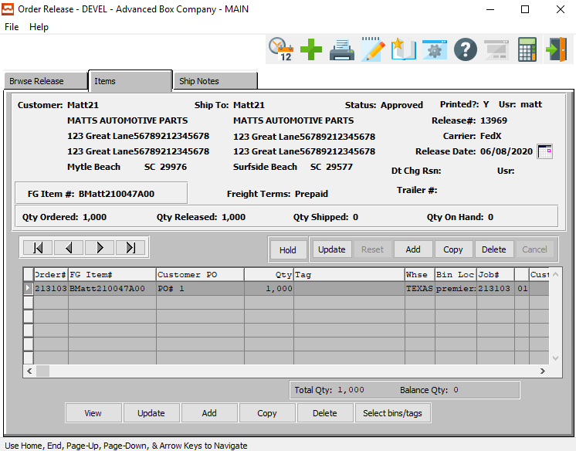

#### VIEW

Click the ***“View”*** button to view detailed information about the selected item.

#### UPDATE

Click the ***“Update”*** button to update the currently selected item.

#### ADD

Click the ***“Add”*** button to add a new item to the release.

#### COPY

Click the ***“Copy”*** button to copy information from the currently selected item.

#### DELETE

Click the ***“Delete”*** button to delete the currently selected item.

#### SELECT BINS/TAGS

Click the ***“Bins/Tags”*** button to select bins for all jobs.

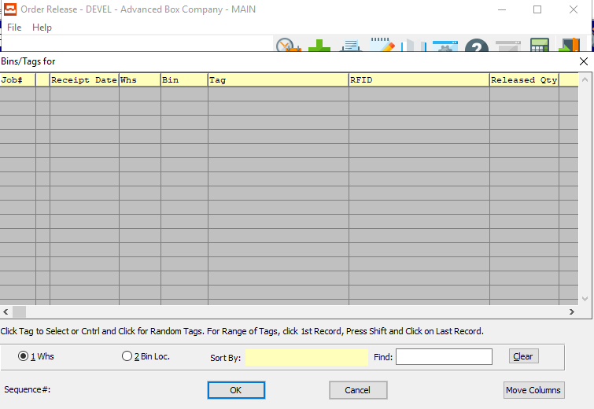

### View Items

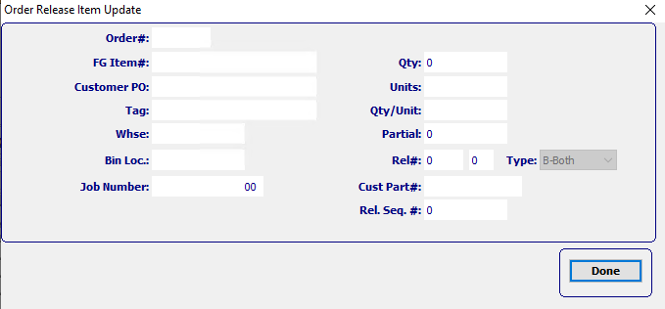

#### DONE

Click the ***“Done”*** button to exit the item detail popup screen.

### Update Items

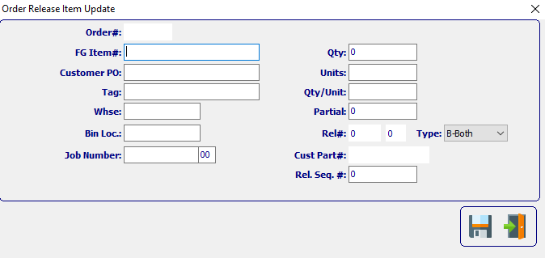

#### SAVE

Click the ***“Floppy Disc Icon”*** to save all changes to the order release item screen.

#### EXIT

Click the ***“Exit Door Icon”*** to exit the order release item popup screen.

### Add Items



#### SAVE

Click the ***“Floppy Disc Icon”*** to save all changes to the order release item screen.

#### EXIT

Click the ***“Exit Door Icon”*** to exit the add items popup screen.

### Add/Update Items Field Definitions

#### Order #

Enter an order number to add to the Bill of Lading number. Press “***F1”*** or the ***“Page Up”*** / ***“Page Down”*** keys to search for an existing order. Highlight the desired order number and press ***“Enter”*** to add the order to the Bill of Lading.

#### FG Item #

This field links this estimate to a Finished Goods item number for Stock Items or repeat items. During order entry, the Finished Good number would be used before creating a new Finished Good item. If the order is for a new item, the customer part number becomes the Finished Good's number unless it is modified. The Finished Good's item number is used for numerous sales, inventory and production reports throughout the system.

#### Customer PO #

Enter the customer PO number. A partial description may be typed into any field or data may be entered into multiple fields followed by pressing the ***“Go”*** button to sort the fields by the criteria that was entered. Once the data is presented on the screen, the YELLOW column heading may be clicked to sort that specific column in ascending or descending order.

The order entry browser will show only OPEN orders. The Closed Order Browser will show open or closed orders. To show only OPEN customer orders, check the box labeled Open. To show only closed orders, then check the box labeled Closed. To see both closed and open orders, click both boxes.

#### Tag

To list the exact tag, bin and warehouse on the Release ticket, the tag number may be entered, otherwise leave blank. Tag number is only required if the Finished Goods are received by tag number. The tag may be searched by pressing the “***F1”*** or the ***“Page Up”*** / ***“Page Down”*** keys.

#### Warehouse

To list the exact tag, bin and warehouse on the Release ticket, the warehouse location may be entered, otherwise leave blank. The location may be searched by pressing the “***F1”*** or the ***“Page Up”*** / ***“Page Down”*** keys.

#### Bin Location

To list the exact tag, bin and warehouse on the Release ticket, the bin location may be entered, otherwise leave blank. The bin location may be searched by pressing the “***F1”*** or the ***“Page Up”*** / ***“Page Down”*** keys.

#### Job Number

The job number defaults to the estimate number, but may be modified. The Job Factory Ticket will print by job number. Repeat jobs for an item will add a suffix to the original job number.

For example, a repeat job number could be Job number 88888-01 where 88888 is the original job and the 01 is the first repeat for that item.

All costs including, standard (estimated) labor, material and overhead, work in process, actual costs and variances are maintained by job number.

#### Job Number: 00

Repeat jobs for an item will add a suffix to the original job number.

#### Quantity

Enter the exact quantity per case, tag number, bin and warehouse on the Release ticket, the tag number may be entered, otherwise leave blank. The total boxes per case may be entered or the total quantity to release may be entered.

#### Partial

Enter the total number of boxes packed in a partial case. If the tag number is entered, this will default from the Finished Goods pallet load tag number.

#### Release #

Add a release number to create a case label for.

#### Release Type

There are three possible release types:

|  |  |
| --- | --- |
| B | Both Ship and Invoice - update invoicing via Bill of Lading posting |
| I | Invoice Only - transfer directly to invoicing without passing through Bill of Lading |
| S | Ship Only - update invoicing via Bill of Lading posting |

***"S"*** (Ship Only) releases only update the ship quantity on the invoice, whereas ***"B"*** (Both Bill and Ship) type releases update both the invoice quantity and ship quantity.

#### Customer Part #

This is your customer's part number for this item. This should be entered on all estimates. However, it is mandatory for tandem runs, two-piece box estimates and combination jobs. The system looks at the customer part number in order to calculate the cost of each item based on the blank square inches as a percentage of the total square inches of all items on a form/sheet.

### Ship Notes

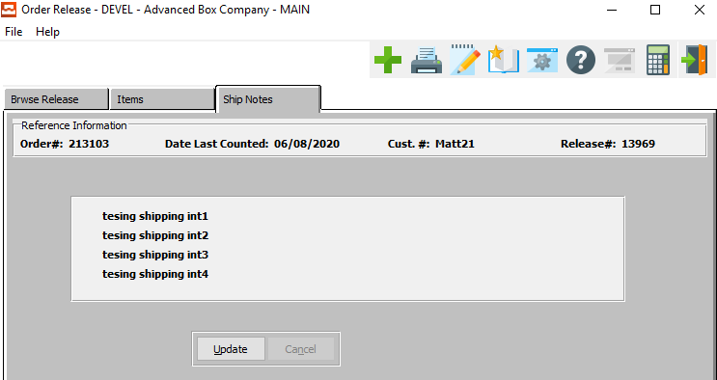

#### UPDATE

Click the ***“Update”*** button to update the shipping notes for this release.

### Update Ship Notes

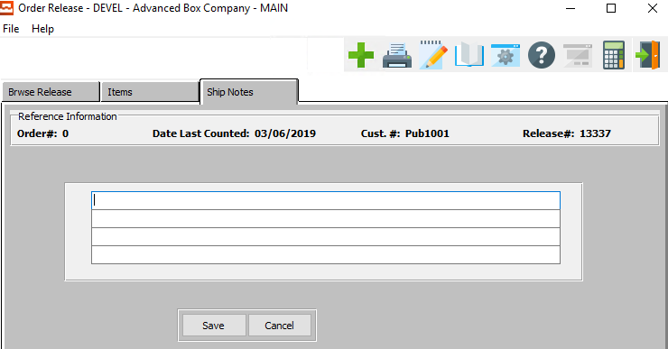

#### SAVE

Click the ***“Save”*** button to save the updated shipping notes on the release.

#### CANCEL

Click the ***“Cancel”*** button to cancel updating the shipping notes without saving.

#### Shipping Instructions

Shipping instructions defined in the customers Ship To file will default for each Ship To defined on the Planned Release screen. To change simply position the cursor next to the Release Ship To location, press ***“T”*** (Text) and *Yes* to modify.

## Release Edit List [OT2]

Once releases have been entered, an edit list may be printed to catch data entry errors. If errors are found, corrections should be made to the release before printing the release tickets. When satisfied that the data is correct, the releases should be printed.

### Selection Parameters

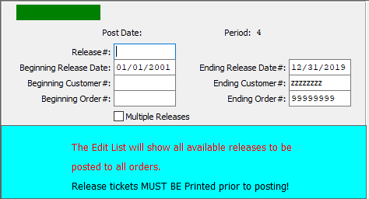

#### Release #

Enter a single release number to edit.

#### Beginning Release Date / Ending Release Date

If the user wishes to edit more than one release at a time, enter starting and ending release date.

#### Beginning Customer # / Ending Customer #

If the user wishes to edit more than one release at a time, enter starting and ending customer number.

#### Beginning Order # / Ending Order #

If the user wishes to edit more than one release at a time, enter starting and ending order number.

#### Multiple Releases – Toggle Box

If selecting multiple releases, make sure that the Multiple Releases toggle box is checked.

### Output Destination

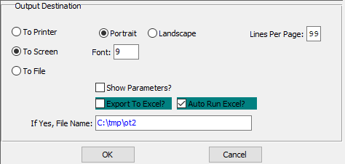

#### Destination Choice

The user must choose the destination where the document will print. “To Print” will result in the document being printed off on the system’s default printer. “To Screen” will result in the document being viewed on the user’s screen. “To File” will result in the document being saved to the user’s system in a default file.

#### Layout Choice

To choose the preferred layout of Landscape vs. Portrait, please make sure the desired option choice bubble is toggled.

#### Lines Per Page

Lines per page on the report when printing.

#### Font

Enter the font number to use with this report (Font 11 is default).

#### Show Parameters? – Toggle Box

To show parameters, make sure that the toggle box is ‘ticked’ with a checkmark.

#### Export to Excel? – Toggle Box

To export the printed file to an excel document, make sure that the Export to Excel toggle box is checked.

#### Auto Run Excel? – Toggle Box

To automatically open the new excel document, make sure that the Auto Run Excel toggle box is checked.

#### If Yes, File Name

If exporting the file to Excel, enter the desired file name.

## Print Release Tickets [OT3]

The Release/Pick/Packing ticket forms should be loaded, and an alignment test printed. Release / Packing tickets may be printed by date or order number.

Please Note: The release ticket prints whatever data is defined on the release. Either the total release quantity or all the tag number with bin location, case count and quantity of cases.

When ready, the tickets should be printed and posted. The tickets have blank areas so that the warehouse clerk and make notations for the exact tag numbers and quantities shipped so that the proper data may be entered on the Bill of Lading.

### Selection Parameters

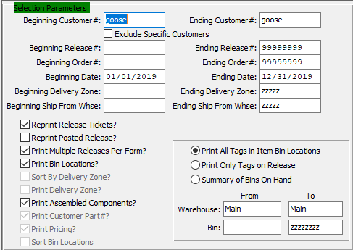

#### Beginning Customer # / Ending Customer #

Enter starting and ending customer number.

#### Exclude Specific Customers – Toggle Box

To exclude specific customers from the selection, make sure that this toggle box is checked.

#### Beginning Release # / Ending Release #

Enter the starting and ending release number.

#### Beginning Order # / Ending Order #

Enter the starting and ending order number.

#### Beginning Date / Ending Date

Enter the starting and ending date.

#### Beginning Delivery Zone / Ending Delivery Zone

Enter the starting and ending delivery zone.

#### Beginning Ship From Whse / Ending Ship From Whse

Enter the starting and ending ship from warehouse.

#### Reprint Release Tickets – Toggle Box

To reprint a release ticket, make sure that the Reprint Release Tickets toggle box is checked.

#### Reprint Posted Release? – Toggle Box

To reprint a posted release, make sure that this toggle box is checked.

#### Print Multiple Releases per Form? – Toggle Box

To print multiple releases, make sure that this toggle box is checked.

#### Print Bin Locations? – Toggle Box

To print bin locations, make sure that the Print Bin Locations toggle box is checked.

#### Sort by Delivery Zone? – Toggle Box

To sort selections by delivery zone, make sure that the Sort by Delivery Zone toggle box is checked.

#### Print Delivery Zone? – Toggle Box

To print the delivery zone, make sure that the Print Delivery Zone toggle box is checked.

#### Print Assembled Components? – Toggle Box

To print the assembled components, make sure that this toggle box is checked.

#### Print Customer Part #? – Toggle Box

To print the customer part number, make sure that this toggle box is checked.

#### Print Pricing? – Toggle Box

To print pricing, make sure that the Print Pricing toggle box is checked.

#### Sort Bin Locations – Toggle Box

To sort bin locations, make sure that the Sort Bin Locations toggle box is checked.

#### Print Options (Choice)

To choose the preferred print option, please make sure the desired option choice bubble is toggled.

#### From Warehouse / To Warehouse

Enter the starting and ending warehouse.

#### From Bin / To Bin

Enter the starting and ending bin.

### Output Destination

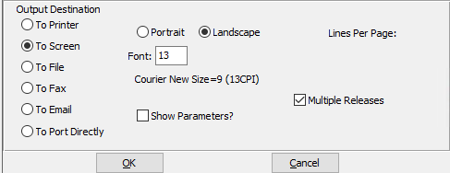

#### Destination Choice

To choose the destination where the document should be printed, please make sure that desired output destination choice bubble is toggled.

#### Layout Choice

To choose the preferred layout of Landscape vs. Portrait, please make sure the desired option choice bubble is toggled.

#### Lines Per Page

Lines per page on the report when printing.

#### Font

Enter the font number to use with this report (Font 11 is default).

#### Multiple Releases – Toggle Box

To print multiple releases, make sure that the Multiple Releases toggle box is checked.

#### Show Parameters? – Toggle Box

To show parameters, make sure that the toggle box is ‘ticked’ with a checkmark.

## Create Bill of Lading [OT4]

Finished Goods items scheduled releases may be added, changed, deleted and released for delivery via the order status inquiry which may be accessed via “***B”-“I”-“1”***. Once an order has been found via the order status inquiry, the item’s scheduled release may be changed, deleted, added or released for shipment.

Depending on the logical value flag for the (S-8) system administration control parameter field called AddRelse the system will either create an actual release ticket when the value is NO or immediately create a bill of lading when the value is YES. To create a release from the inquiry screen, simply press the Release Key then follow the normal prompts.

### Selection Parameters

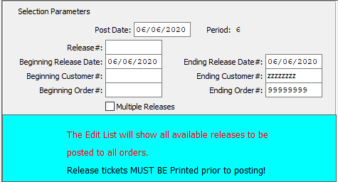

#### Post Date

The user must enter the post date of the item they wish to create a bill of lading for.

#### Release #

If creating a bill of lading for a single Release, enter the desired release number.

#### Beginning Release Date / Ending Release Date

Enter the beginning and ending release date for a run of multiple releases.

#### Beginning Customer # / Ending Customer #

Enter the beginning and ending customer number for a run of multiple customers.

#### Beginning Order # / Ending Order #

Enter the beginning and ending order number for a run of multiple orders.

#### Multiple Releases – Toggle Box

To print multiple releases, make sure that the Multiple Releases toggle box is checked.

### Output Destination

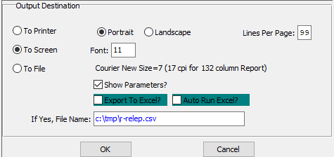

#### Destination Choice

To choose the destination where the document should be printed, please make sure that desired output destination choice bubble is toggled.

#### Layout Choice

To choose the preferred layout of Landscape vs. Portrait, please make sure the desired option choice bubble is toggled.

#### Lines Per Page

Lines per page on the report when printing.

#### Font

Enter the font number to use with this report (Font 11 is default).

#### Show Parameters? – Toggle Box

To show parameters, make sure that the toggle box is ‘ticked’ with a checkmark.

#### Export to Excel? – Toggle Box

To export the printed file to an excel document, make sure that the Export to Excel toggle box is checked.

#### Auto Run Excel? – Toggle Box

To automatically open the new excel document, make sure that the Auto Run Excel toggle box is checked.

#### If Yes, File Name

If exporting the file to Excel, enter the desired file name.

# **Shipping / Bill of Lading [OS]**

## Overview

Release / Packing tickets modified by the warehouse clerk are updated by Bill of Lading Processing for actual tag numbers and case quantities. If the quantity shipped is less than the quantity released, a backorder release is automatically created in the release file.

Once shipments are posted, the details are transferred to invoicing to update receivable and inventory.

## Enter / Edit BOL [OS1]

### Browse BOL

The browser screen shows all the BOL numbers and order numbers in the system starting with the most recent and descending to the oldest. To view the first/last, press the ***“End”*** key or ***“Home”*** key or click the icon with the circling arrows to sort ascending, then descending.

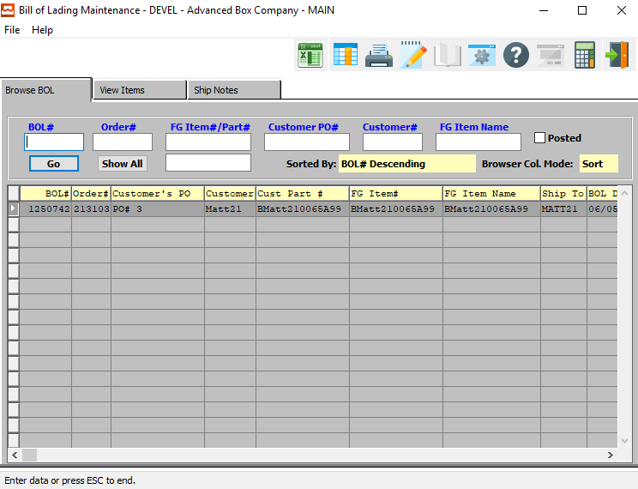

### Browse BOL File Definitions

#### BOL #

Enter a bill of lading number to search for.

#### Order #

Enter an order number to search for.

#### FG Item # / Part #

Enter an item number to search for.

#### Customer PO #

Enter a customer PO number to search for.

#### Customer #

Enter a customer number to search for.

#### FG Item Name

Enter an item name to search for.

#### Posted – Toggle Box

To search only among posted orders, make sure that the Open toggle box is checked.

### View Items

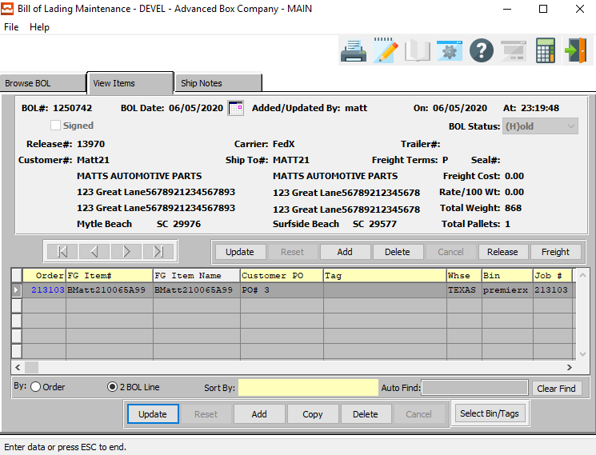

#### UPDATE

Click the ***“Update”*** button to update the currently selected BOL item.

#### ADD

Press "A" to add a Bill of Lading for one or more orders. Alternatively, click the ***“Add”*** button. The system will assign a new Bill of Lading number for each release from the order processing control file. To add multiple orders/releases on a Bill of Lading, press ***"A"*** (Add), but override the Bill of Lading number and type the same the Bill of Lading number of the order to combine shipments, then enter a new order / release number along with the tag and quantities for each item. For each item, the total quantity may be entered or each tag number with bin location, case count and quantity of cases may be listed.

To search for an item, bin or tag number, simple press “***F1”*** or the ***“Page Down”*** keys. If the tag number is entered, the case count and quantity will transfer from the Finished Goods file. If the Finished Goods receipt has not been entered or the tag number does not exist, the system will ask to create the new tag number.

#### COPY

Click the ***“Copy”*** button to copy information from the currently selected Bill of Lading item.

#### DELETE

To delete an existing release or line item, simply press the ***"D"*** key. Alternatively, click the ***“Delete”*** button. To delete a line item on a release, position the cursor on the Item to be deleted and press ***"D"***.

Please Note: This option is not available once Release tickets have been posted.

#### SELECT BIN/TAGS

Click the ***“Bins/Tags”*** button to select bins for all jobs.



### Update/Add Items Field Definitions

#### BOL #

The Bill of Lading defaults from the order processing control file. To add multiple orders to a single Bill of Lading number, type over the Bill of Lading number to add another order number. To search for a valid Bill of Lading number, press “***F1”*** or the ***“Page Up”*** / ***“Page Down”*** keys. Highlight the desired order number and press ***“Enter”*** to add a release for that order.

#### BOL Date

The date defaults to the current system date, but may be modified.

#### Added/Updated By

The username of the last user that worked on this bill of lading.

#### Added/Updated On (Date)

The date that this bill of lading was last worked on.

#### At (Time)

The exact time that this bill of lading was last changed.

#### Signed – Toggle Box

If this bill of lading has already been signed, make sure that the Signed toggle box is checked.

#### Release #

Enter the release number to add to the Bill of Lading. In change mode, the “***F1”*** or the ***“Page Up”*** / ***“Page Down”*** keys will search for an existing release number. Highlight the desired release number and press ***“Enter”*** to add the release to the Bill of Lading.

#### Customer #

This defaults from the order file. The customer name, address, city, state, zip and salesman will also transfer.

#### Customer Address

The customer's Ship To address defaults for the customer number entered.

#### Carrier

Enter the normal common carrier for this release to this customer. The carrier will transfer to the Bill of Lading screen automatically. Press ***“F1”*** to search for a common carrier.

#### Ship To #

This field is defined in the customer ship-to file which provides up to 999 Ship To addresses per customer. The Ship To defaults to ship number 1, but may be changed or new Ship To's added. The Ship To address, city, state and zip code will transfer. Press “***F1”*** or the ***“Page Up”*** / ***“Page Down”*** keys to search through the customer Ship To file.

#### Ship-To Address

The customer's Ship To address defaults for the Ship To number entered.

#### Trailer #

Enter the common carrier vehicle id or tag number.

#### Freight Terms

Enter the freight terms. Valid codes are ***"P"*** for prepaid, ***"B"*** for bill separately, and ***"C"*** for collect.

#### Freight Cost

Enter the total freight amount for the Bill of Lading. If the weight per pallet or total Bill of Lading weight is entered in addition to the freight cost per hundred weight, the total freight cost is calculated.

#### Total Weight

Enter the total weight for either the tag/pallet if the tag number is entered, otherwise enter the total Bill of Lading weight for all pallets shipped on this Bill of Lading.

#### Total Pallets

Enter the total number of the pallets.

### Ship Notes

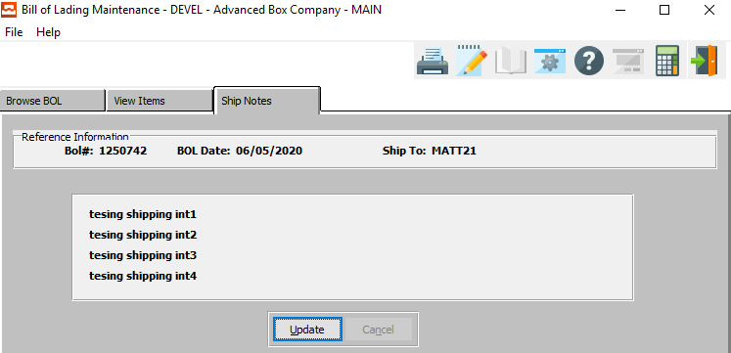

#### UPDATE

Click the ***“Update”*** button to update the bill of lading shipping notes.

### Update Ship Notes

#### SAVE

Click the ***“Save”*** button to save all shipping notes.

#### CANCEL

Click the ***“Cancel”*** button to cancel all shipping notes without saving.

#### Shipping Instructions

Shipping instructions defined in the customers Ship To file will default for each Ship To defined on the Planned Release screen. To change simply position the cursor next to the Release Ship To location, press ***“T”*** (Text) and *Yes* to modify.

## BOL Edit List [OS2]

The *Bill of Lading Edit List* will show all available Bills of Lading to be posted to all orders.

Please Note: Bills of Lading must be printed prior to posting.

### Selection Parameters

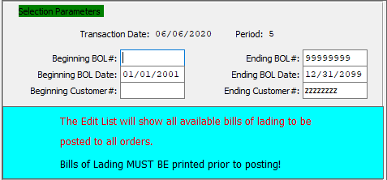

#### Beginning BOL # / Ending BOL #

Enter the beginning and ending bill of lading number.

#### Beginning BOL Date / Ending BOL Date

Enter the beginning and ending bill of lading date.

#### Beginning Customer # / Ending Customer #

Enter the beginning and ending customer number.

### Output Destination

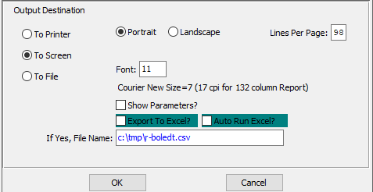

#### Destination Choice

To choose the destination where the document should be printed, please make sure that desired output destination choice bubble is toggled.

#### Layout Choice

To choose the preferred layout of Landscape vs. Portrait, please make sure the desired option choice bubble is toggled.

#### Lines Per Page

Lines per page on the report when printing.

#### Font

Enter the font number to use with this report (Font 11 is default).

#### Show Parameters? – Toggle Box

To show parameters, make sure that the toggle box is ‘ticked’ with a checkmark.

#### Export to Excel? – Toggle Box

To export the printed file to an excel document, make sure that the Export to Excel toggle box is checked.

#### Auto Run Excel? – Toggle Box

To automatically open the new excel document, make sure that the Auto Run Excel toggle box is checked.

## Print Bills of Lading [OS3]

The Bill of Lading forms should be loaded, and an alignment test printed.

Please Note: The Bill of Lading prints whatever data is defined on the Bill of Lading. Either the total quantity shipped or all the tag number with bin location, case count and quantity of cases. When ready, the tickets should be printed and posted.

### Selection Parameters

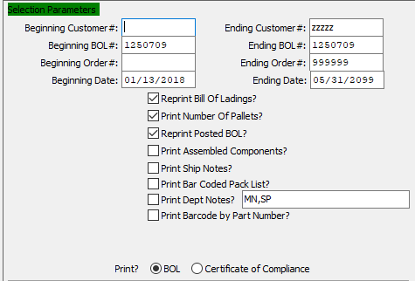

#### Beginning Customer #

Enter starting customer number.

#### Ending Customer #

Enter the ending customer number.

#### Beginning BOL #

Enter the beginning Bill of Lading Number.

#### Ending BOL #

Enter the ending Bill of Lading Number.

#### Beginning Order #

Enter the beginning order number.

#### Ending Order #

Enter the ending order number.

#### Beginning Date

Enter the beginning date.

#### Ending Date

Enter the ending date.

#### Reprint Bill of Ladings? – Toggle Box

To reprint the bill of lading, make sure that the Reprint Bill of Ladings toggle box is checked.

#### Print Number of Pallets? – Toggle Box

To print the number of pallets on the bill of lading, make sure that this toggle box is checked.

#### Reprint Posted BOL? – Toggle Box

To reprint a posted bill of lading, make sure that the Reprint Posted BOL toggle box is checked.

#### Print Assembled Components? – Toggle Box

To print assembled components on the bill of lading, make sure that this toggle box is checked.

#### Print Ship Notes? – Toggle Box

To print shipping notes on the bill of lading, make sure that the Print Ship Notes toggle box is checked.

#### Print Bar Coded Pack List? – Toggle Box

To print a bar coded pack list on the bill of lading, make sure that this toggle box is checked.

#### Print Dept Notes? – Toggle Box

To print department notes on the bill of lading, make sure that the Print Dept Notes toggle box is checked.

#### Print Barcode by Part Number? – Toggle Box

To print the barcode by part number, make sure that this toggle box is checked.

#### Print? (Choice)

To choose the preferred print options of BOL vs. Certificate of Compliance, please make sure the desired option choice bubble is toggled.

### Output Destination

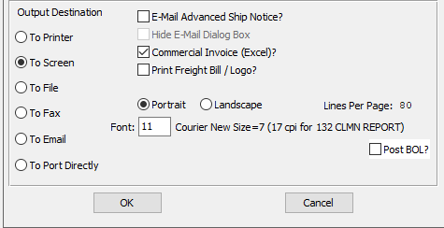

#### Destination Choice

To choose the destination where the document should be printed, please make sure that desired output destination choice bubble is toggled.

#### E-Mail Advanced Ship Notice? – Toggle Box

To email an advanced ship notice for the bill of lading, make sure that this toggle box is checked.

#### Hide E-Mail Dialog Box – Toggle Box

To hide the email dialogue box, make sure that this toggle box is checked.

#### Commercial Invoice (Excel)? – Toggle Box

To run a commercial invoice in Excel, make sure that this toggle box is checked.

#### Print Freight Bill/Logo? – Toggle Box

To print the freight bill and logo on the bill of lading, make sure that this toggle box is checked.

#### Layout Choice

To choose the preferred layout of Landscape vs. Portrait, please make sure the desired option choice bubble is toggled.

#### Lines Per Page

Lines per page on the report when printing.

#### Font

Enter the font number to use with this report (Font 11 is default).

#### Post BOL? – Toggle Box

To post the Bill of Lading after printing, make sure that the Post BOL toggle box is checked.

## Master BOL Print [OS4]

The *Master BOL Print* screen will create and print and list of multiple Bills of Lading for the user according to the parameters they set in this function.

### Selection Parameters

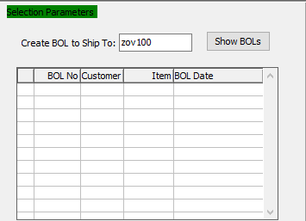

#### Customer Name

Enter a unique customer name.

#### Show BOLs

Click the ***“Show BOLs”*** button to show all current BOLs for the entered customer.

### Output Options

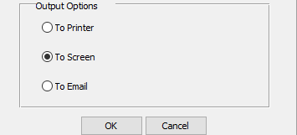

#### Destination Choice

To choose the destination where the document should be printed, please make sure that desired output destination choice bubble is toggled.

## Post BOL / Create Invoices [OS5]

#### Posting Report

Enter the transaction date to post all Bills of Lading up to that date. All Bills of Lading will be posted to the Invoice File for later Invoice Printing depending on the Order Processing Control Flag labeled "Print separate invoice per order".

The system will create one invoice per B.O.L. or multiple invoices. The Bill of Lading Posting will relieve Finished Goods quantity on hand if the Order Processing Control File update inventory when posting lag is set to B.O.L. Otherwise, Invoice Posting will update inventory on hand.

Posting Bills of Lading will also automatically create a backorder release if the quantity shipped is less than the release quantity.

#### Posting & Inventory Control

Once Bills of Lading are posted an audit trail should be printed. The posting procedure will transfer the ship quantity and invoice quantity to the invoice for ***"B"*** (Both Bill and Ship) type releases. However, for ***"S"*** (Ship Only) type releases only the ship quantity will transfer to the invoice.

The order processing control file allows Finished Goods to be relieved at either ***"B"*** (Bill of Lading Posting) or ***"I"*** (Invoice Posting), although we recommend invoice posting. If inventory is relieved during ***"I"*** (Invoice Posting), the Bill of Lading posting program will transfer the invoice quantity and the ship quantity to the invoice and the invoice posting program will reduce the items quantities on hand for each tag number shipped.

The invoice quantity or Ship To quantity may be modified however the totals must match the total quantities shipped for all pallet/tag numbers. Alternatively, if inventory is relieved at ***"B"*** (Bill of Lading) time, the Bill of Lading posting program reduces the items quantity on hand for each tag number listed on the Bill of Lading.

Please Note: The quantity invoiced and shipped cannot be changed during invoice processing under this method.

### Selection Parameters

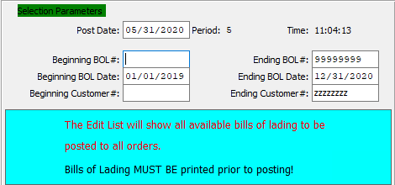

#### Post Date

Enter the post date of the selected orders.

#### Beginning BOL # / Ending BOL #

Enter the beginning and ending bill of lading number.

#### Beginning BOL Date / Ending BOL Date

Enter the beginning and ending bill of lading date.

#### Beginning Customer # / Ending Customer #

Enter starting and ending customer number.

### Output Destination

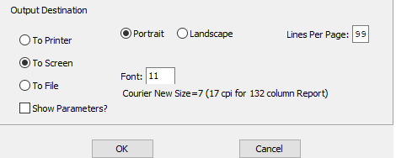

#### Destination Choice

To choose the destination where the document should be printed, please make sure that desired output destination choice bubble is toggled.

#### Layout Choice

To choose the preferred layout of Landscape vs. Portrait, please make sure the desired option choice bubble is toggled.

#### Show Parameters? – Toggle Box

To show parameters, make sure that the toggle box is ‘ticked’ with a checkmark.

## Truckload BOL Summary [OS6]

The *Truckload Bill of Lading Sumary* screen will print a report for the user according to the parameters they set in this function.

### Selection Parameters

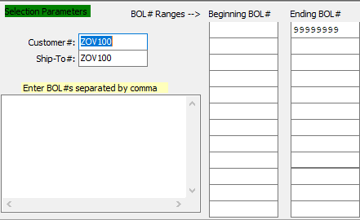

#### Customer #

Enter the customer number of the BOLs.

#### Ship-To #

Enter the Ship-To number of the BOLs.

#### Enter BOL#s Separated by Comma

If the desired BOLs are not in sequential order, enter individual bill of ladings to print truckload summary for.

#### BOL # Ranges--> Beginning BOL #

Enter the beginning bill of lading number.

#### BOL # Ranges--> Ending BOL #

Enter the ending bill of lading number.

### Output Destination

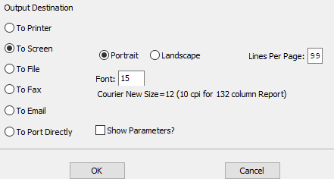

#### Destination Choice

To choose the destination where the document should be printed, please make sure that desired output destination choice bubble is toggled.

#### Layout Choice

To choose the preferred layout of Landscape vs. Portrait, please make sure the desired option choice bubble is toggled.

#### Lines Per Page

Lines per page on the report when printing.

#### Font

Enter the font number to use with this report (Font 11 is default).

#### Show Parameters? – Toggle Box

To show parameters, make sure that the toggle box is ‘ticked’ with a checkmark.

## Truck Plan Selection [OS7]

The *Truck Plan Selection* screen will print a truck plan report for the user according to the parameters they set in this function.

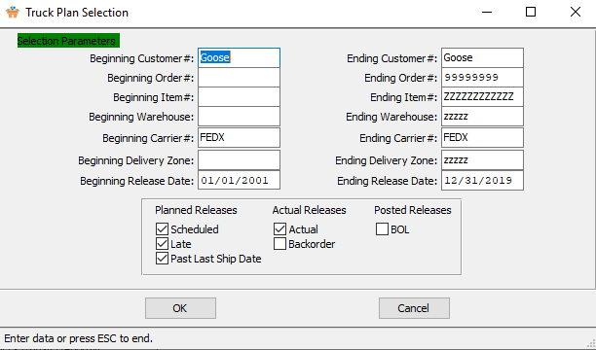

### Truck Plan Selection Field Definitions

#### Beginning Customer # / Ending Customer #

Enter starting and ending customer number.

#### Beginning Order # / Ending Order #

Enter the beginning and ending order number.

#### Beginning Item # / Ending Item #

Enter the beginning and ending item number.

#### Beginning Warehouse / Ending Warehouse

Enter the beginning and ending warehouse.

#### Beginning Carrier # / Ending Carrier #

Enter the beginning and ending carrier number.

#### Beginning Delivery Zone / Ending Delivery Zone

Enter the beginning and ending delivery zone.

#### Beginning Release Date / Ending Release Date

Enter the beginning and ending release date.

#### Planned Releases (Scheduled) – Toggle Box

To print scheduled planned releases, make sure that this toggle box is checked.

#### Planned Releases (Late) – Toggle Box

To print late planned releases, make sure that this toggle box is checked.

#### Planned Releases (Past Last Ship Date) – Toggle Box

To print planned releases that are past their last ship date, make sure that this toggle box is checked.

#### Actual Releases (Actual) – Toggle Box

To print actual releases, make sure that this toggle box is checked.

#### Actual Releases (Backorder) – Toggle Box

To print backordered releases, make sure that this toggle box is checked.

#### Posted Releases (BOL) – Toggle Box

To print posted bill of ladings, make sure that this toggle box is checked.

## Pallet Tag for BOL [OS8]

The *Pallet Tag for Bill of Lading* screen will print pallet tags for the user according to the parameters they set in this function.

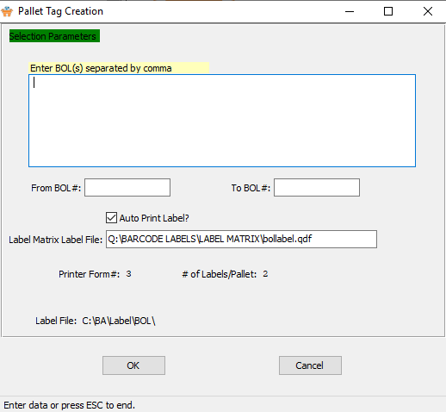

### Pallet Tag Creation File Definitions

#### Enter BOL(s) Separated by Comma

If printing pallet tags that are not in sequential order, enter each of their numbers separated by a comma.

#### From BOL # / To BOL #

Enter the beginning and ending bill of lading number.

#### Auto Print Label? – Toggle Box

To automatically print labels, make sure that the Auto Print Label toggle box is checked.

#### Label Matrix Label File

To choose a label outline from a label matrix files, enter the correct file path.

## BOL Packing List [OS9]

### Screen-Specific Icons

|  |  |  |
| --- | --- | --- |
|  | Save |  |
|  | Web Browser | Export the Machine Order parameters to a web browser doc. |
|  | Excel CSV | Export the Machine Order parameters to an Excel CSV document. |
|  | Excel XLS | Export the Machine Order parameters to an Excel XLS document. |
|  | Word DocX | Export the Machine Order parameters to a Word document. |
|  | PDF | Export the Machine Order parameters to a PDF document. |
|  | HTML | Export the Machine Order parameters to an HTML document. |
|  | Print | Print the Machine Order parameters to the default printer. |
|  | Jasper Viewer | View the Machine Order parameters in the Jasper Viewer. |
|  | Tasks | Run the machine Order jasper files. |

### Parameters

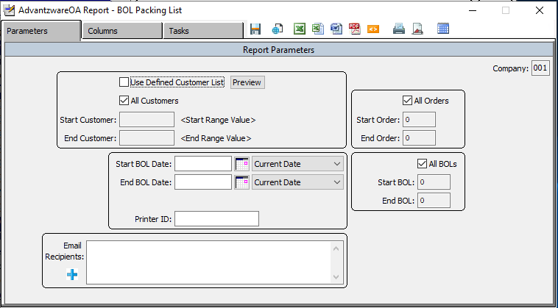

### Parameters Field Definitions

#### Use Defined Customer List – Toggle Box

To use a User Defined Customer List, make sure that this toggle box is checked.

#### All Customers – Toggle Box

If the user wishes to run the report for all customers, make sure that the All Customers toggle box is checked. If the user wishes to define their own run of customers, make sure that this toggle box remains blank/unchecked.

#### Start Customer / End Customer

Enter the beginning and ending customer.

#### Start BOL Date / End BOL Date

Enter the beginning and ending bill of lading date.

#### Date Choice (Start) / Date Choice (End)

Enter a starting and ending date.

#### Printer ID

The ID number of the selected printer to print the bill of lading packing list from.

#### Email Recipients

To add a recipient, click the ***“Blue + Icon”*** and check the toggle box next to each user they wish to email the report to.

#### All Orders – Toggle Box

If the user wishes to run the report for all orders, make sure that the All Orders toggle box is checked. If the user wishes to define their own run of orders, make sure that this toggle box remains blank/unchecked.

#### Start Order / End Order

Enter the beginning and ending order.

#### All BOLs – Toggle Box

If the user wishes to run the report for all bills of lading, make sure that the All BOLS toggle box is checked. If the user wishes to define their own run of BOL’s, make sure that this toggle box remains blank/unchecked.

#### Start BOL / End BOL

Enter the beginning and ending bill of lading.

### Columns

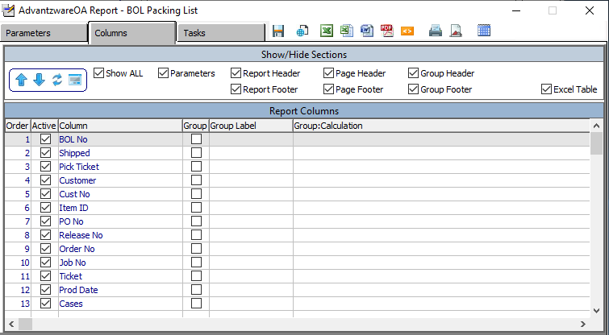

The user should choose all of their desired columns for their parameters.

### Tasks

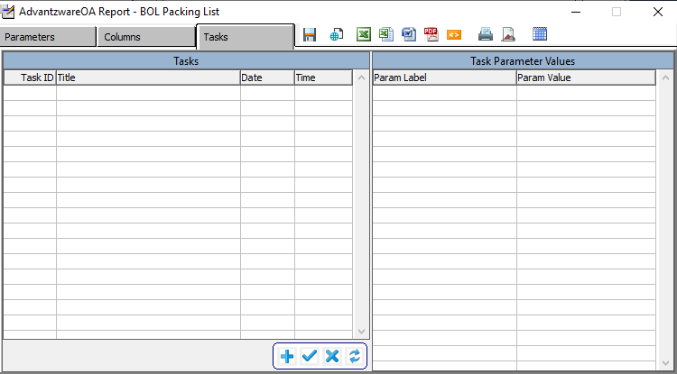

#### ADD

Click the ***“Blue + Icon”*** button at the bottom of the page to add a new task.

#### SAVE

Click the ***“Blue Check Mark Icon”*** button at the bottom of the page to save parameter values to the task ID.

#### DELETE

Click the ***“Blue X Icon”*** button at the bottom of the page to delete the selected task.

#### APPLY

Click the ***“Blue Refresh Icon”*** button at the bottom of the page to apply task values to the parameter values.

# **Billing / Counter Sales [OB]**

## Overview

Prior to Invoicing the General Ledger Accounts must first be defined in the Accounts Receivable Control file, the Finished Goods Product category File, and the Product Line File. Once defined, the debits and credits will occur automatically and are listed on the detail invoice list. Once releases and Bills of Lading shipments are posted, the details are transferred to invoicing to update receivable and inventory. Modifications to the invoice are allowed prior to printing the invoice.

To bill miscellaneous prep and freight charges the ***"M"*** (Miscellaneous) screen Bill Flag must be set to “Yes”. Invoice only invoices will transfer the quantity invoiced to a customer owned warehouse call "CUST" which is automatically created by the system. Utilizing this method provides the ability to value inventory for customer owned inventory versus inventory that has not been billed.

To show all inventory, simply print both warehouse locations when selecting reports options.

## Enter / Edit Invoices [OB1]

#### Invoicing Methods

There are three possible invoicing methods depending on the release type.

|  |  |
| --- | --- |
| B | Both Ship and Invoice |
| I | Invoice Only |
| S | Ship Only |

***"I"*** (Invoice Only) releases **will not** update Bill of Lading, however they will update the invoice quantity immediately upon posting releases.

Bill of Lading may only be created for ***"S"*** & ***"B"*** type releases. In addition, when the Bill of Lading is posted, the invoice is updated. ***"B"*** (Both Bill and Ship) type releases will update both the invoice quantity and ship quantity fields on the invoice, whereas ***"S"*** (Ship Only) type releases will only update the ship quantity field.

Allowing the update of either the invoice quantity and / or the ship quantity field during invoicing will insure proper updates to either the customer Accounts Receivable balance and / or the Finished Goods quantity on hand.

Please Note: If the ship quantity is less than the release quantity, the quantity short will automatically create a back ordered release. The back ordered release will retain the same release number, but will have a suffix -01 added to the original release number.

#### Invoicing Items

The order processing control file allows Finished Goods to be relieved at either Bill of Lading posting or invoice posting. We recommend invoice posting, however both methods are supported. If inventory is relieved during invoicing, the Bill of Lading posting program will transfer the invoice quantity and/or the ship quantity (depending on the release type) to the invoice.

Once the invoice edit register has been reviewed and changes made, the invoice posting program will reduce the items quantities on hand for each tag number shipped. The invoice quantity or Ship To quantity may be modified however the totals must match the total quantities shipped for all pallet/tag numbers. Alternatively, if inventory is relieved at Bill of Lading time, the Bill of Lading posting program reduces the items quantity on hand for each tag number listed on the Bill of Lading.

Please Note: The quantity invoiced and shipped cannot be changed during invoice processing under this method.

#### Invoicing Freight

The freight cost field may be entered or modified at invoicing time. However, the weight and freight cost will transfer from the Bill of Lading if entered.

Please Note: Only releases types ***"S"*** (Ship Only) and ***"B"*** (Both Bill and Ship) pass through Bill of Lading processing.

#### Invoicing Control

Depending on the control file flags and release type, the reduction of Finished Goods quantities is supported by either Bill of Lading, invoicing or Finished Goods shipments. We recommend relieving inventory via invoicing.

The SHIP FROM flag in the order processing control file dictates the methodology selected by your company. ***“F"*** indicates shipments through Finished Goods warehouse transactions, whereas ***"B"*** indicates shipping via Bill of Lading. If ***"B"*** for Bill of Lading is entered in the SHIP FROM field, then the UPDATE FINISHED GOODS field dictates the method of reducing inventory.

Either ***"B"*** (Bill of Lading Posting) or **"I"** (Invoice Posting) must be entered on the Update inventory field. If ***"B"*** is used, no changes to ship quantities are allowed during invoicing, therefore we do not recommend this method. If ***"I"*** is selected to relieve Finished Goods, then the Bill of Lading posting program updates the ship quantity field on the invoice.

However, the total quantity or quantity per tag/pallet number may be modified during invoicing by pressing the ***"S"*** (Shipping) key from the line item screen. If the SHIP FROM field is ***"F"*** from Finished Goods warehouse transactions is defined, then Bill of Lading are not supported. In addition, only ***"I"*** (Invoice) release types are supported if the Ship From field is ***"F"*** since the ship quantity is reduced by warehouse transactions.

### Browse Invoices

The browser screen shows all the invoices, BOL, customer numbers and customer names in the system starting with the most recent and descending to the oldest. To view the first/last, press the ***“End”*** key or ***“Home”*** key or click the icon with the circling arrows to sort ascending, then descending.

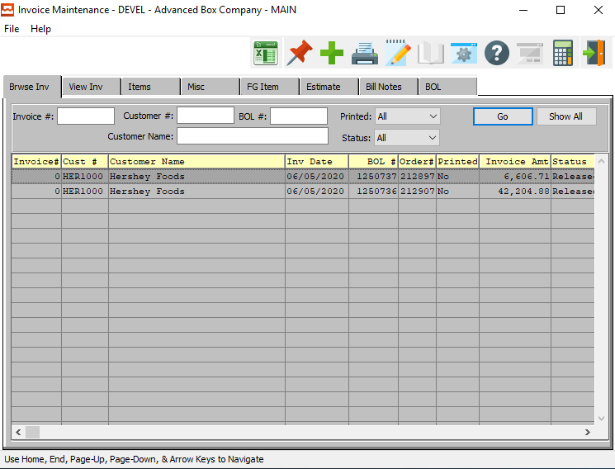

#### Invoice #

Enter a specific invoice number to search for.

#### Customer #

Enter a specific customer number to search for.

#### BOL #

Enter a specific bill of lading number to search for.

#### Printed

The user may choose if they wish to view Printed Invoices only (by choosing *‘Yes’* from the drop down menu), Unprinted Invoices only (by choosing *‘No’* from the drop down menu), or All Invoices (by choosing ‘*All*’ from the drop down menu.)

#### Status

The user may choose if they wish to view Released Invoices only (by choosing *‘Released’* from the drop down menu), Credit Held Invoices only (by choosing *‘Hold’* from the drop down menu), or Invoices with a Wait/App status (by choosing ‘*Wait/App’* from the drop down menu.)

### View Invoice

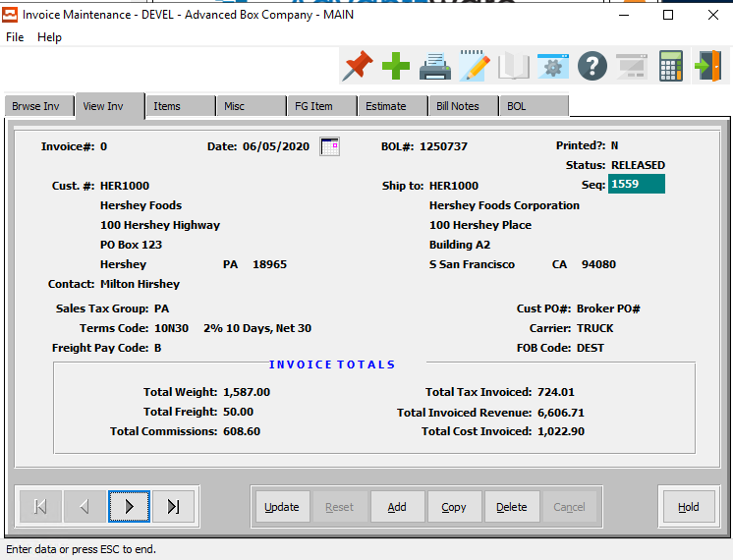

#### UPDATE

Click the ***“Update”*** button to update information about the current invoice.

#### ADD

Click the ***“Add”*** button to add a new invoice.

#### COPY

Click the ***“Copy”*** button to copy information from the current invoice.

#### DELETE

Click the ***“Delete”*** button to delete the current invoice.

#### HOLD

Click the ***“Hold”*** button to place the current invoice on hold.

Please Note: This option is only available for invoices whose current status is not ‘On-Hold’.

#### APPROVE

Click the ***“Approve”*** button to approve the current invoice.

Please Note: This option is only available for invoices whose current status is not ‘Approved’.

### Update Invoice

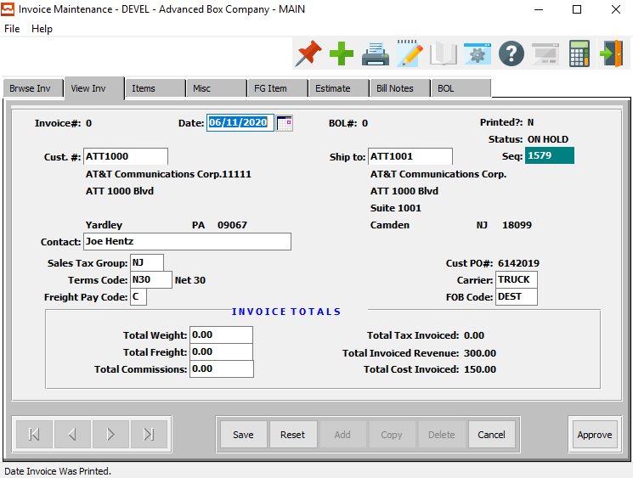

#### SAVE

Click the ***“Save”*** button to save all changes to the invoice.

#### RESET

Click the ***“Reset”*** button to reset all fields back to their original state.

#### CANCEL

Click the ***“Cancel”*** button to cancel all changes to the invoice without saving.

#### HOLD

Click the ***“Hold”*** button to place the current invoice on hold.

Please Note: This option is only available for invoices whose current status is not ‘On-Hold’.

#### APPROVE

Click the ***“Approve”*** button to approve the current invoice.

Please Note: This option is only available for invoices whose current status is not ‘Approved’.

### Add Invoice

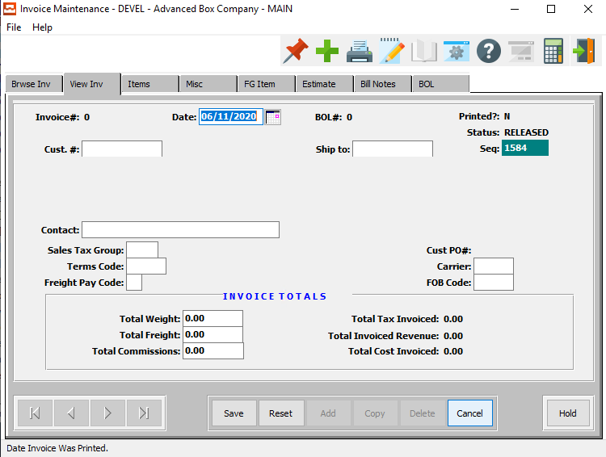

#### SAVE

Click the ***“Save”*** button to save all changes to the invoice.

#### RESET

Click the ***“Reset”*** button to reset all fields back to their original state.

#### CANCEL

Click the ***“Cancel”*** button to cancel all changes to the invoice without saving.

#### HOLD

Click the ***“Hold”*** button to place the current invoice on hold.

Please Note: This option is only available for invoices whose current status is not ‘On-Hold’.

#### APPROVE

Click the ***“Approve”*** button to approve the current invoice.

Please Note: This option is only available for invoices whose current status is not ‘Approved’.

### Add/Update Invoice Field Definitions

#### Invoice Date

The date the invoice was created which defaults to date in system clock. Format is mm/dd/yy and may be modified. For releases that are ***"I"*** (Invoice Only), this will default to the date the release was entered. For releases that are ***"S"*** (Ship Only) or ***“B"*** (Both Ship and Invoice), the invoice date will default to the date the Bill of Lading was entered. In any advent, the date may be modified, whereby the aging report will be calculated from the invoice date.

#### Customer #

Enter the customer number for this invoice.

#### Ship To/Sold To

Upon clicking on this field, the user will be prompted with the question of whether they wish continue to use the Ship To, or if they would prefer to change to Sold To.

Then, the user may enter the customer's (broker's) ship-to or sold-to company number. When entering the number, the company name transfers to the order.

#### Contact

The contact that you sent the quote to.

#### Sales Tax Group

Enter a valid sales tax group from the tax file. Optionally, press the ***“F1”*** key to search through, or the ***“Page Up” / “Page Down”*** keys to scroll through the Sales Tax file. Press the ***“Enter”*** key to accept the Sales Tax group displayed on the screen.

#### Terms Code

Enter a valid terms code from the terms file. Optionally, press the ***“F1”*** key to search through, or the ***“Page Up” / “Page Down”*** keys to scroll through the Terms file. Press the ***“Enter”*** key to accept the terms code displayed on the screen.

#### Freight Pay Code

Valid codes are as follows:

|  |  |
| --- | --- |
| B | Bill Separately |
| C | Collect |
| P | Prepaid |

#### Carrier

Enter the normal common carrier for shipments to this customer. The carrier entered will automatically transfer from the Bill of Lading.

#### FOB Code

This code indicates who is paying for the freight charges.

Valid entries are as follows:

|  |  |
| --- | --- |
| DEST | Destination |
| ORIG | Origin |

#### Total Weight

The total weight of all line items is automatically calculated from the estimate calculations. The total shipping weight is based on the style file square inch formula which is multiplied by the boards basis weight. This total carton weight adds an average weight of 2 pounds per case and 50 pounds per pallet to yield the total shipping weight.

#### Total Freight

The total freight cost may be either billable or non-billable for each order as dictated by the freight billable flag

#### Total Commissions

The commission percentage defined in the customer and/or salesman file will automatically transfer, but may be modified for a particular estimate. The commission can be set by customer, customer type and product category and may be calculated on the selling price or gross profit as defined in the salesman file.

### Items

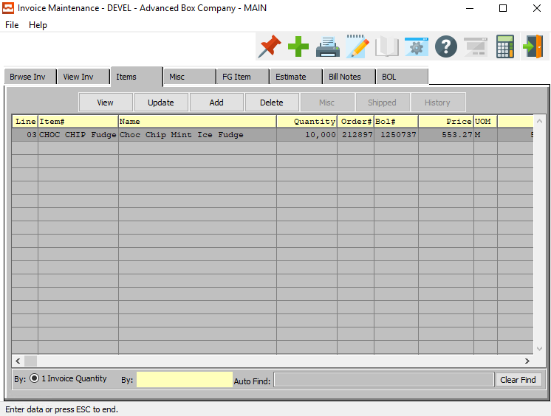

#### VIEW

Click the ***“View”*** button to view detailed information about a selected item.

#### UPDATE

Click the ***“Update”*** button to update the information of the currently selected item.

#### ADD

Click the ***“Add”*** button to add a new item to the invoice. Alternatively, click the ***“Green + Icon”***

#### DELETE

Click the ***“Delete”*** button to delete the selected item from the current invoice.

### Add Invoice Item

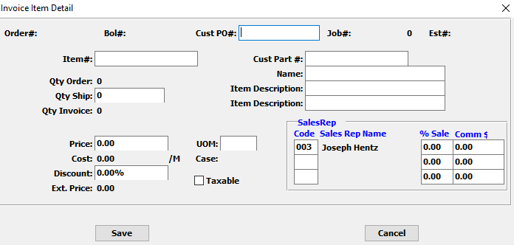

#### SAVE

Click the ***“Save”*** button to save changes to the invoice item.

#### CANCEL

Click the “***Cancel”*** button to cancel all changes to the invoice item without saving.

### Add/Update Invoice Item Field Definitions

#### Customer PO #

Enter the customer PO number for this item.

#### Item #

Enter the Finished Goods Item number in this field.

#### Customer Part #

Enter the customer part number for this item.

#### Name

Enter the item name on this line.

#### Item Description

Enter the description on these two lines.

#### Qty Ship

Enter the quantity shipped for this item.

#### Price

Enter the price for this item.

#### UOM

The sell price unit of measure defaults to M for per thousand, however this may be modified. Each unit of measure will yield a different total selling price.

Valid Units of Measure are:

|  |  |
| --- | --- |
| C | Per Hundred |
| CS | Per Case |
| EA | Per Each |
| L | Per Lot |
| M | Per Thousand |

#### Discount

Enter the discount, if any, applied to.

#### Taxable – Toggle Box

If this item is taxable, make sure that the Taxable toggle box is checked.

#### Sales Rep

Enter salesman code who entered this order you can also use the pop-up menu by selecting the ***“F3”*** key.

#### % Sale

Enter the percentage of sales which will be multiplied by the total sales value then by the commission percentage.

#### Commission $

Enter the commission price for the sales rep.

### Misc.

All miscellaneous sub-contract costs and prep charges defined on the estimate as ***"S"*** for separate charge will automatically transfer with their associated General Ledger numbers. These charges may be included with the first shipment invoice or billed separately.

Total order value, factory cost, weight and commissions are calculated automatically. The total freight cost is automatically calculated from the common carrier file's freight rate file in the estimating module. Given the total shipping weight, the rate per hundred is found and multiplied for all line items on the estimate. The freight may be billable or non-billable for each order. The total tax, if the customer is taxable, includes all taxable line items as well as miscellaneous charges and freight. The total commissions are calculated by multiplying the total revenue for all line items by the commission percentage listed on the Order Header screen one. The total cost includes only the line items direct factory cost.

Please Note: The factory cost includes only direct materials and labor and does not include miscellaneous charges, commissions, freight or general selling and administration costs. The total order value includes all line items as well as all billable charges including tax, freight and miscellaneous charge codes. If freight or prep charges are taxable the control file must be defined to ***"Y"*** (Yes).

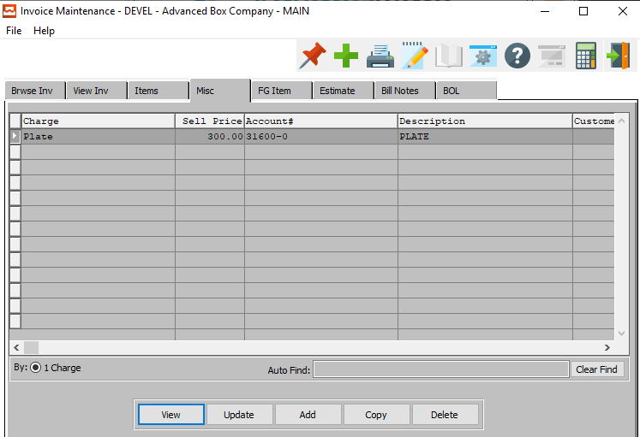

#### VIEW

Click the ***“View”*** button to view detailed information about the currently selected miscellaneous charge.

#### UPDATE

Click the ***“Update”*** button to update information about the currently selected miscellaneous charge.

#### ADD

To add miscellaneous charges, press ***"A"*** (Add). To search for existing prep charges, press the ***“F1”*** key and select a prep code. Alternatively, click the ***“Add”*** button.

#### COPY

Click the ***“Copy”*** button to copy information from the currently selected miscellaneous charge.

#### DELETE

Position the cursor on the line item to be deleted, then press ***"D"*** (Delete). Alternatively, click the ***“Delete”*** button

### View Miscellaneous

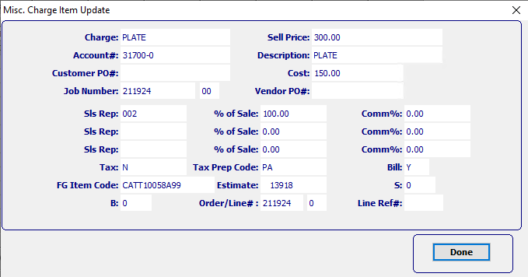

#### DONE

Click the ***“Done”*** button to exit the miscellaneous charge detail popup screen.

### Add/Update Miscellaneous

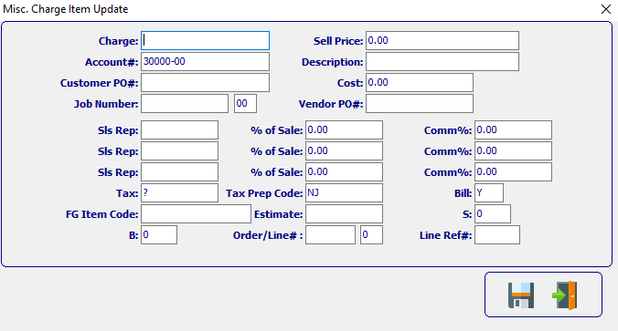

#### SAVE

Click the ***“Floppy Disc Icon”*** to save all changes to the Miscellaneous Charge Item screen.

#### EXIT

Click the ***“Exit Door Icon”*** to exit the Add/Update Miscellaneous Charge Item popup screen.

### Add/Update Miscellaneous Field Definitions

#### Charge

The charge code is a combination of the estimating prep charges as well as miscellaneous sub-contract charges which were defined in the estimate as billable charges.

Please Note: The SIMON code on the estimate must be set to ***"S"*** for separate billable charge so that the charges will transfer automatically. Additional charges may be added by simply typing a new charge code and cost.

The ***“F1”*** key will also provide a pop-up window for defined prep codes for transferring to the order. The charge codes will be billed with the first invoice for this order. If commissions are to be paid on miscellaneous charges, the order processing control file must set the flag to ***"Y"*** for yes to pay commissions of prep charges.

#### Account #

The charge code General Ledger account will transfer from the estimating prep file if defined. The GL account number must be first defined in the General Ledger accounts file maintenance. To search for a valid General Ledger account number, press ***“F1”***.

#### Customer PO #

Enter the customer PO number. A partial description may be typed into any field or data may be entered into multiple fields followed by pressing the ***“Go”*** button to sort the fields by the criteria that was entered. Once the data is presented on the screen, the YELLOW column heading may be clicked to sort that specific column in ascending or descending order.

The order entry browser will show only OPEN orders. The Closed Order Browser will show open or closed orders. To show only OPEN customer orders, check the box labeled Open. To show only closed orders, then check the box labeled Closed. To see both closed and open orders, click both boxes.

#### Job Number

The job number defaults to the estimate number, but may be modified. The Job Factory Ticket will print by job number. Repeat jobs for an item will add a suffix to the original job number.

For example, a repeat job number could be Job number 88888-01 where 88888 is the original job and the 01 is the first repeat for that item.

All costs including, standard (estimated) labor, material and overhead, work in process, actual costs and variances are maintained by job number.

#### Job Number: 00

Repeat jobs for an item will add a suffix to the original job number.

#### Sell Price

The invoice amount transfers from the order automatically for all prep charges and miscellaneous charges which were defined in the estimate as billable charges. The billable amount may be changed once it has been transferred. The charge will be billed with the first invoice for this order.

#### Description

The charge code description transfers from estimating for all separately billable charges defined. The description may be modified.

#### Cost

The items cost is always per thousand. The standard factory cost for direct labor, material and overhead are automatically calculated for each order from an estimate. However, Stock Item's cost default from the Finished Goods file. For each order from an estimate, the standard cost is transferred to the item's job file for later comparison to actual costs for that job. The weighted average cost of quantities on hand is based on all jobs received for that item and is displayed in the item file as the average standard cost. The standard labor and overhead cost are calculated on either the machine standards defined on the estimate or the machine speeds defined in the machine standards file.

#### Vendor PO #

Enter the purchase order number from a vendor.

#### Sales Rep

This field defaults from the order, but may be modified. To search for a salesman, press ***“F1”*** to search for salesman.

#### % of Sale

Enter the percentage of sales which will be multiplied by the total sales value then by the commission percentage.

#### Commission %

The commission percentage defined on the order will automatically transfer, but may be modified for each order. The commission can be set by customer, customer type and product category and may be calculated on the selling price or gross profit as defined in the salesman matrix file.

#### Tax

The total tax, if the customer is taxable, includes all taxable line items as well as miscellaneous charges and freight.

#### Tax Prep Code

Enter a code for this preparation charge. Examples of preparation charges include Lock up cost per item, Step and Repeat per number up, Die Cost per Square Inch, Stamping Dies, Embossing Dies, Plates, Rerun Plate cost, Rerun Die Hours, Negatives and Sample Making.

#### Bill

The billable flag indicates whether this charge code is billable. Any prep or miscellaneous charges on the estimate defined as ***"S"*** for separate charge will default to ***"Y"*** (Yes) as a billable item. All billable items will be added to the Total Order Value field at the bottom of the screen.

#### FG Item Code

Enter ***"S"*** for Stock Box or ***"C"*** for Custom Box. When entering stock boxes an ***"S"*** must be entered. When entering a custom box during order entry, Item Code will automatically default to a ***"C"***.

#### Estimate

Automatically defaults from the estimate.

#### S

To access the FORM field, press the ***“GoTo”*** Key when modifying a Combination Run or Two-piece Box estimate. This identifies the number of forms (different sheet sizes) that are used on an estimate. This is used for two-piece boxes estimates with separate sheets for the lid and bottom, and combination runs with multiple forms. For single item and tandem runs, the form is always one.

#### B

Enter the sheet/blank number to assign to the cost of this material. Sheet fed machines end with a 0 such as 1-0 whereas blank fed machines must be 1 or greater such as 1-1 indicating form 1, blank 1.

#### Order / Line #

Enter the order number.

#### Line Reference #

Enter the line reference number.

### FG Item

Clicking the ***FG Item*** tab will bring up a popup screen of the Finished Goods system.

To learn more about how the ***Finished Goods*** system works, please refer to the “Finished Goods” Manual.

### Estimate Screen

Clicking the ***Estimate*** tab will bring up a popup screen of the Estimation system.

To learn more about how the ***Estimating*** system works, please refer to the “Corrugated” or “Folding” Estimating Manuals.

### Bill Notes

Billing may be entered during order entry or during invoicing simply by pressing the ***"T"*** (Text) key from either the Header screen or the Line Item Screen. The notes will then print on the invoice.

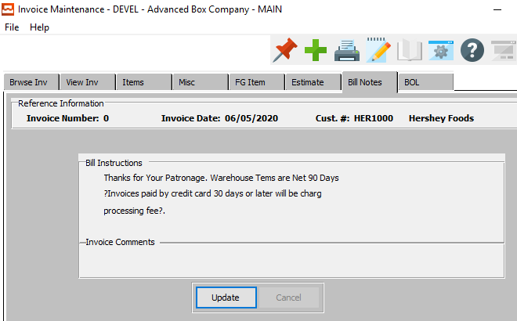

#### UPDATE

Click the ***“Update”*** button to update the billing instructions and invoice comments.

### Update Bill Notes

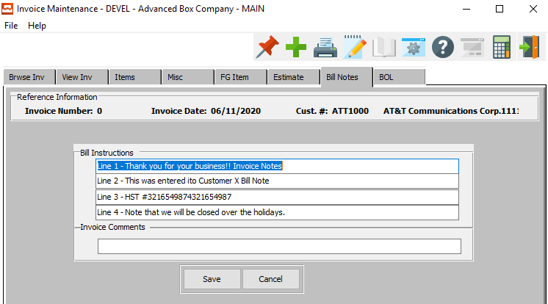

#### SAVE

Click the ***“Save”*** button to save all changes to the billing instructions and invoice comments.

#### CANCEL

Click the ***“Cancel”*** button to cancel all changes to the billing instructions and invoice comments without saving.

#### Bill Instructions

Enter special billing instructions to aid sales service for internal matters. This is not printed on any document that is sent to the customer, but provides a reference for internal personnel. For example, you may want to write a note to collect money prior to shipping within these special billing instructions.

#### Invoice Comments

Enter any comments you have about this invoice here.

### BOL

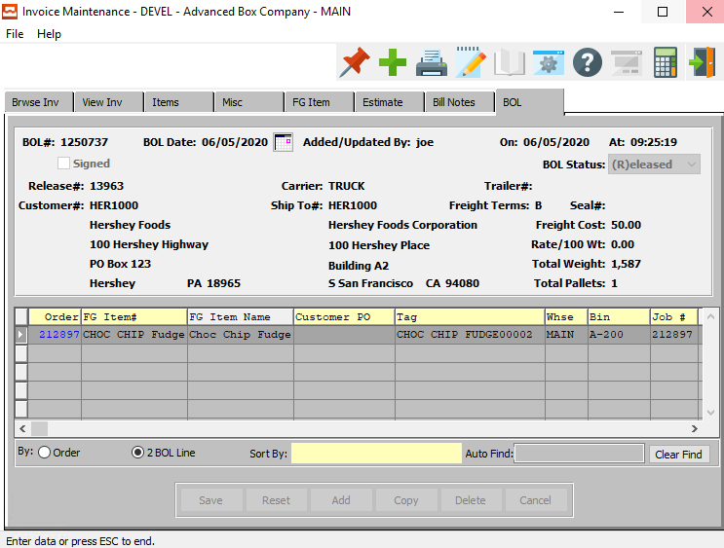

## OE Invoice Edit List [OB2]

Once order have been entered, an edit list should be printed to check for data entry errors. Once corrections have been made, the orders should be posted. Posting the orders updates the open order balances for the customers.

### Selection Parameters

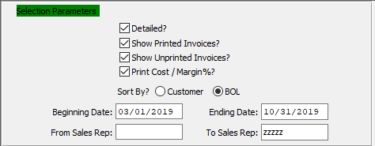

#### Detailed? – Toggle Box

To print detailed invoices, make sure that the Detailed toggle box is checked.

#### Show Printed Invoices? – Toggle Box

To show printed invoices, make sure that the Show Printed Invoices toggle box is checked.

#### Show Unprinted Invoices? – Toggle Box

To unprinted invoices, make sure that the Show Unprinted Invoices toggle box is checked.

#### Print Cost / Margin %? – Toggle Box

To print cost and margin percentages, make sure that this toggle box is checked.

#### Sort By? (Choice)

To choose the preferred sorting option of Customer vs. Bill of Lading, please make sure the desired option choice bubble is toggled.

#### Beginning Date / Ending Date

Enter the starting and ending date.

#### From Sales Rep # / To Sales Rep #

Enter the starting and ending sales rep number.

### Output Destination

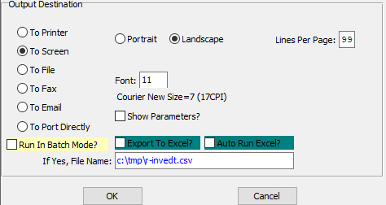

#### Destination Choice

To choose the destination where the document should be printed, please make sure that desired output destination choice bubble is toggled.

#### Layout Choice

To choose the preferred layout of Landscape vs. Portrait, please make sure the desired option choice bubble is toggled.

#### Lines Per Page

Lines per page on the report when printing.

#### Font

Enter the font number to use with this report (Font 11 is default).

#### Show Parameters? – Toggle Box

To show parameters, make sure that the toggle box is ‘ticked’ with a checkmark.

#### Run in Batch Mode? – Toggle Box

To run the printouts in batch mode, make sure that the Run in Batch Mode toggle box is checked.

#### Export to Excel? – Toggle Box

To export the printed file to an excel document, make sure that the Export to Excel toggle box is checked.

#### Auto Run Excel? – Toggle Box

To automatically open the new excel document, make sure that the Auto Run Excel toggle box is checked.

#### If Yes, File Name

If exporting the file to Excel, enter the desired file name.

## Print OE Invoices [OB3]

Once the invoice edit register has been printed and reviewed for data entry error, the invoices may be printed. Once printed, the system will post the invoices so that Accounts Receivable and inventories are adjusted.

### Selection Parameters

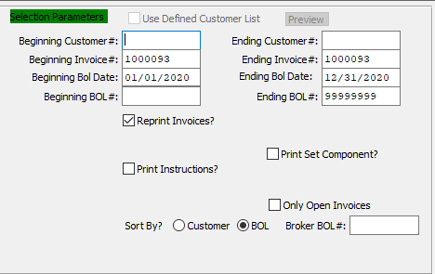

#### Use Defined Customer List – Toggle Box

To use a User Defined Customer List, make sure that this toggle box is checked.

#### Beginning Customer # / Ending Customer #

Enter starting and ending customer number.

#### Beginning Invoice # / Ending Invoice #

Enter the starting and ending invoice number.

#### Beginning BOL Date / Ending BOL Date

Enter the starting and ending bill of lading date.

#### Beginning BOL # / Ending BOL #

Enter the starting and ending bill of lading number.

#### Reprint Invoices? – Toggle Box

To reprint already printed invoices, make sure that the Reprint Invoices toggle box is checked.

#### Print Set Component – Toggle Box

To print set components, make sure that the Print Set Component toggle box is checked.

#### Print Instructions? – Toggle Box

To print any billing or shipping instructions, make sure that the Print Instructions toggle box is checked.

#### Only Open Invoices – Toggle Box

To only print open invoices, make sure that the Only Open Invoices toggle box is checked.

#### Sort By? (Choice)

To choose the preferred sorting option of Customer vs. Bill of Lading, please make sure the desired option choice bubble is toggled.

#### Broker BOL #

If the user wishes to print only one OE invoice, enter a broker’s bill of lading number.

### Output Destination

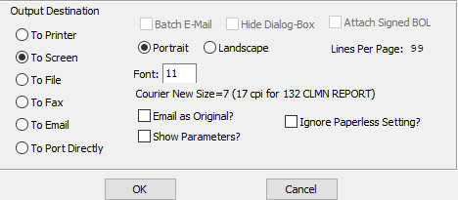

#### Destination Choice

To choose the destination where the document should be printed, please make sure that desired output destination choice bubble is toggled.

#### Layout Choice

To choose the preferred layout of Landscape vs. Portrait, please make sure the desired option choice bubble is toggled.

#### Lines Per Page

Lines per page on the report when printing.

#### Font

Enter the font number to use with this report (Font 11 is default).

#### Show Parameters? – Toggle Box

To show parameters, make sure that the toggle box is ‘ticked’ with a checkmark.

#### Email as Original? – Toggle Box

To email the invoice as the original invoice, make sure that the Email as Original toggle box is checked.

#### Ignore Paperless Setting? – Toggle Box

To ignore paperless settings from default printing options, make sure that the Ignore Paperless Settings toggle box is checked.

## Invoice Post / Update GL [OB4]

Please Note: This screen will on post invoices that have already been printed.

### Selection Parameters

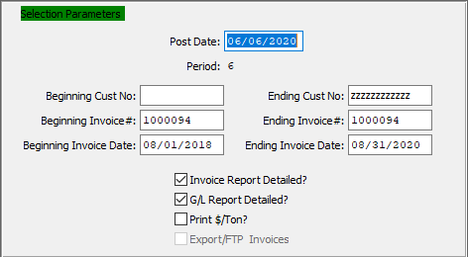

#### Beginning Customer # / Ending Customer #

Enter starting and ending customer number.

#### Beginning Invoice # / Ending Invoice #

Enter the starting and ending invoice number.

#### Beginning Invoice Date / Ending Invoice Date

Enter the starting and ending invoice date.

#### Invoice Report Detailed? – Toggle Box

To print a detailed invoice report, make sure that the Invoice Report Detailed toggle box is checked.

#### G/L Report Detailed? – Toggle Box

To print a detailed general ledger report, make sure that the G/L Report Detailed toggle box is checked.

#### Print $/Ton – Toggle Box

To print price per ton, make sure that the Print $/Ton toggle box is checked.

#### Export/FTP Invoices – Toggle Box

To print exports and FTP invoices, make sure that this toggle box is checked.

### Output Destination

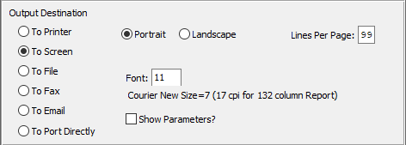

#### Destination Choice

To choose the destination where the document should be printed, please make sure that desired output destination choice bubble is toggled.

#### Layout Choice

To choose the preferred layout of Landscape vs. Portrait, please make sure the desired option choice bubble is toggled.

#### Lines Per Page

Lines per page on the report when printing.

#### Font

Enter the font number to use with this report (Font 11 is default).

#### Show Parameters? – Toggle Box

To show parameters, make sure that the toggle box is ‘ticked’ with a checkmark.

## Export Electronic Invoices [OB5]

The *Export Electronic Invoices* screen will generate and export invoices to user-selected companies.

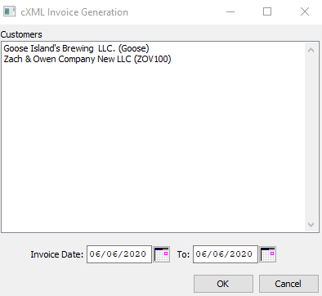

#### Customers

Click a customer to highlight them within the list. Invoices will only generate for the highlighted companies.

#### Invoice Date

Enter the starting invoice date.

#### To Invoice Date

Enter the ending invoice date.

# **Levy F.G. Returns / Credits [OL]**

## Enter / Edit Returns [OL1]

### Overview

This menu will allow you to issue Return Authorization (R/A) Numbers. You can also Enter Returns. Once the Returns are entered, you can print an edit list to check for data entry errors, etc. Once you are satisfied with the corrections, you can Post the Returns. Posting Returns add the returned items back into physical inventory at whatever Warehouse it came from. It will also credit your Accounts Receivable and debit your inventory asset account.

### Browse Returns

The browser screen shows all the RA numbers, invoices and customer numbers in the system starting with the most recent and descending to the oldest. To view the first/last, press the ***“End”*** key or ***“Home”*** key or click the icon with the circling arrows to sort ascending, then descending.

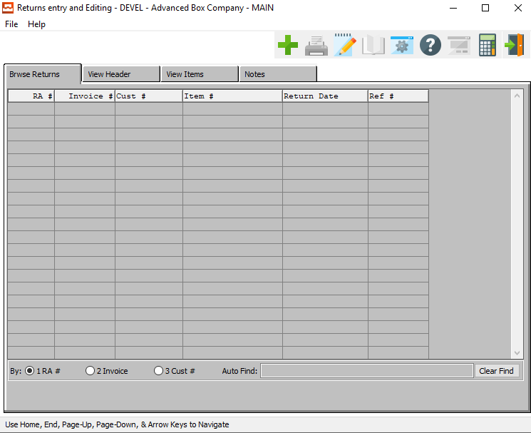

#### ADD

To add a new return, click the ***“Green + Icon”.***

### View Header

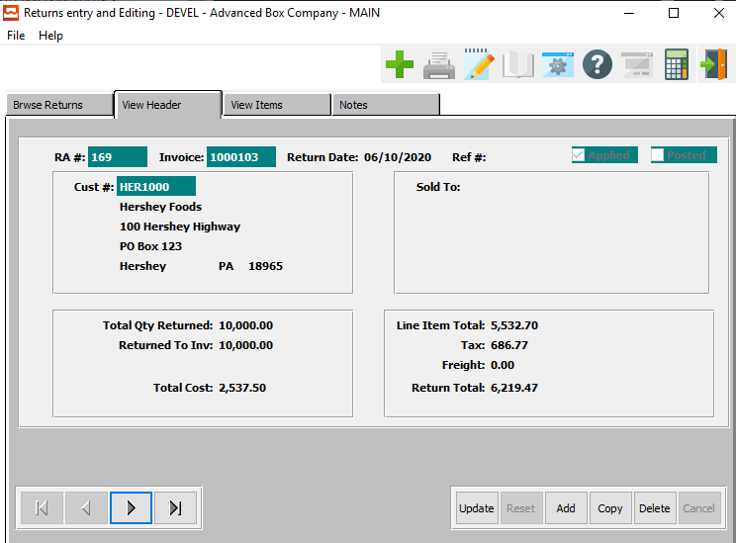

#### UPDATE

Click the ***“Update”*** button to make changes to the current Return Header.

#### ADD

Click the ***“Add”*** button to add a new Return Header.

#### COPY

Click the ***“Copy”*** button to copy information from the current Return Header.

#### DELETE

Click the ***“Delete”*** button to delete the current return header.

#### NEXT

Press ***"N"*** (Next) to find next Return to view or modify. Alternatively, press the ***“Right Arrow”*** on the screen.

#### PREVIOUS

Press ***"P"*** (Previous) to find previous Return to view or modify. Alternatively, press the ***“Left Arrow”*** on the screen.

### Add/Update Header

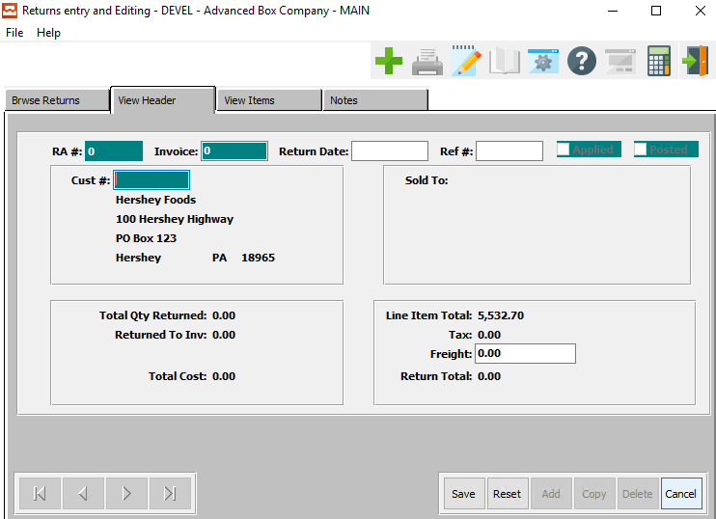

#### SAVE

Click the ***“Save”*** button to save all changes to the return header.

#### RESET

Click the ***“Reset”*** button to reset all fields back to their original state.

#### CANCEL

Click the ***“Cancel”*** button to cancel all changes to the return header without saving.

### Add/Update Header File Definitions

#### Invoice

Enter the invoice number for the merchandise being returned.

#### Return Date

Enter the date on which the merchandise is to be returned.

#### Reference #

This field will specify the location from which the release quantity is to be shipped. The warehouse-specific allocation quantity reflects the quantity of releases to be shipped from each specific warehouse.

The Ship From field can also be used as a matching criterion for automatically merging of releases. See N-K-1 RELMERGE. The value of this field will also be the default the inventory location for actual releases and bills of lading.

#### Customer #

Enter the number of the customer that the return is from.

#### Freight

Enter the total amount of the freight being returned.

### View Items

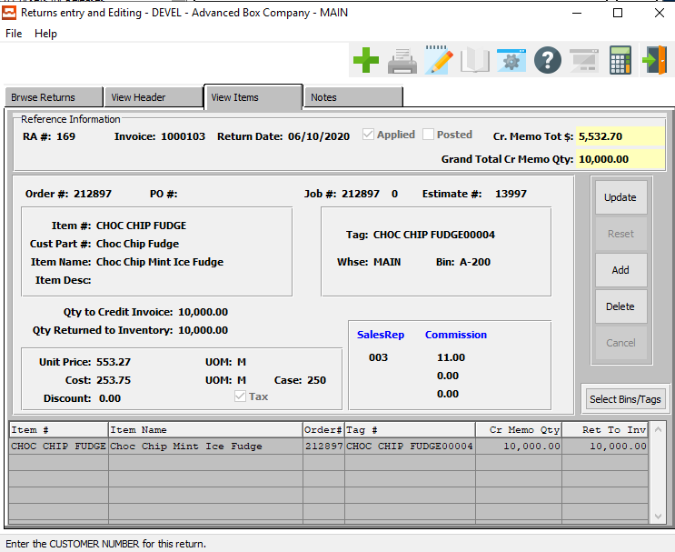

#### UPDATE

Click the ***“Update”*** button to make changes to the current return item.

#### ADD

Click the ***“Add”*** button to add a new item to the return.

#### DELETE

Click the ***“Delete”*** button to delete the current item from the return.

#### SELECT BIN/TAGS

Click the ***“Bins/Tags”*** button to select bins for all jobs.

### Update Items

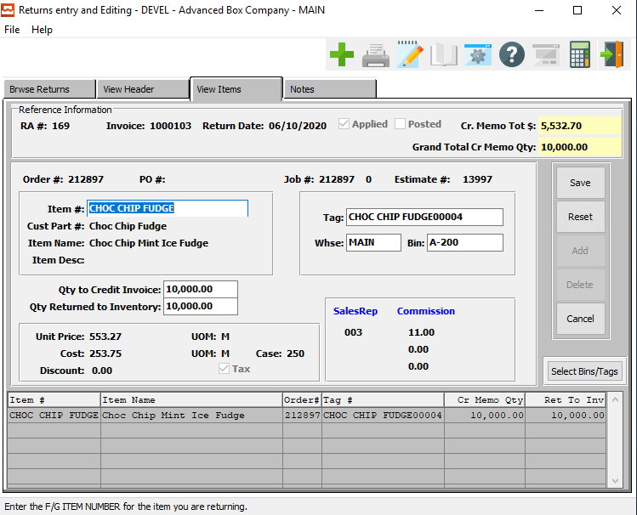

#### SAVE

Click the ***“Save”*** button to save all changes to the current item.

#### RESET

Click the ***“Reset”*** button to revert all fields to their original state.

#### CANCEL

Click the ***“Cancel”*** button to cancel all changes to the current item without saving.

#### SELECT BIN/TAGS

Click the ***“Bins/Tags”*** button to select bins for all jobs.

### Add Items

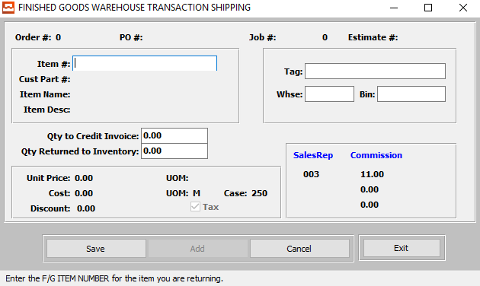

#### SAVE

Click the ***“Save”*** button to save all changes to the item.

#### CANCEL

Click the ***“Cancel”*** button to cancel all changes to the item.

#### EXIT

Click the ***“Exit”*** button to exit the Add Item screen.

Please Note: If the information has not been saved, the user will be asked if they wish to save the information before they can entirely exit the screen.

### Add/Update Items Field Definitions

#### Item #

Enter the Finished Goods item number for the item you are returning.

#### Tag

Enter the tag number for this item.

#### Warehouse

Enter the warehouse Location Code for this item.

#### Bin

Enter the bin location for this item.

#### Qty to Credit Invoice

Enter the total quantity returned for this item.

#### Qty Returned to Inventory

Enter the quantity to return to inventory for this item.

### Notes

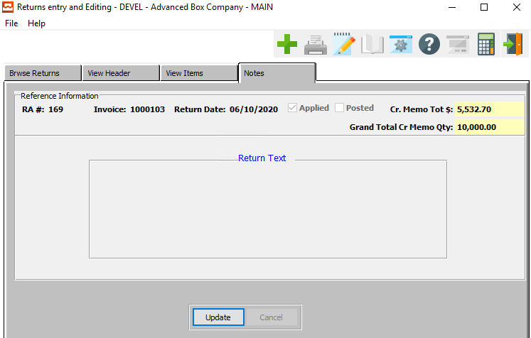

#### UPDATE

Click the ***“Update”*** button to make changes to the return notes text.

### Update Notes

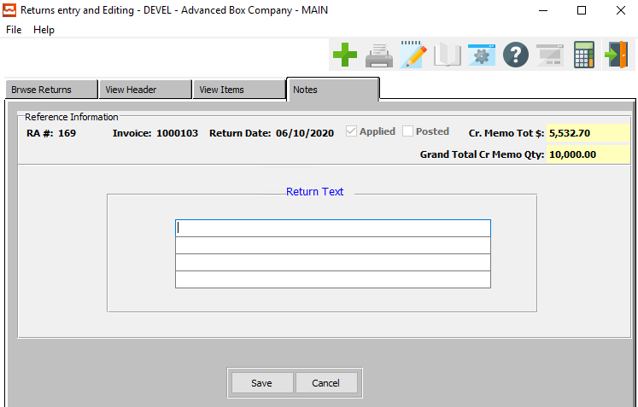

#### SAVE

Click the ***“Save”*** button to save all changes to the return text.

#### CANCEL

Click the ***“Cancel”*** button to cancel all changes to the return text without saving.

#### Return Text

The return text fields are a place for the user to enter information such as the reason for the return, or any other information that is deemed important to this particular return.

## Returns Edit List [OL2]

The *Returns Edit List* screen will print a report for the user according to the parameters they set in this function.

### Selection Parameters

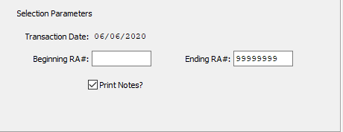

#### Beginning RA# / Ending RA#

Enter the beginning and ending RA Number.

#### Print Notes? – Toggle Box

To print the return notes with each return, make sure that the Print Notes toggle box is checked.

### Output Destination

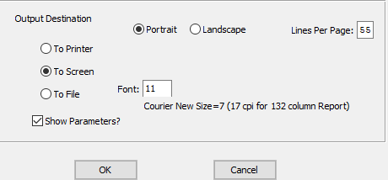

#### Destination Choice

To choose the destination where the document should be printed, please make sure that desired output destination choice bubble is toggled.

#### Layout Choice

To choose the preferred layout of Landscape vs. Portrait, please make sure the desired option choice bubble is toggled.

#### Font

Enter the font number to use with this report (Font 11 is default).

#### Show Parameters? – Toggle Box

To show parameters, make sure that the toggle box is ‘ticked’ with a checkmark.

## Post Returns [OL3]

The *Post Returns* screen will print a report for the user according to the parameters they set in this function.

### Selection Parameters

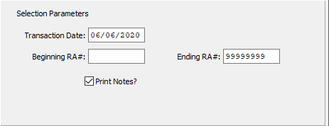

#### Transaction Date

Enter the transaction date to post and all Order Entries will print up to and including that date.

#### Beginning RA# / Ending RA#

Enter the beginning and ending RA number.

#### Print Notes? – Toggle Box

To print the return notes with each return, make sure that the Print Notes toggle box is checked.

### Output Destination

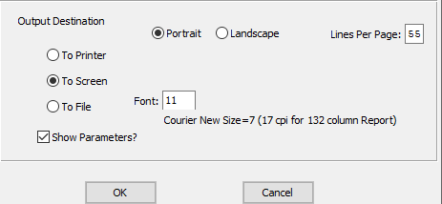

#### Destination Choice

To choose the destination where the document should be printed, please make sure that desired output destination choice bubble is toggled.

#### Layout Choice

To choose the preferred layout of Landscape vs. Portrait, please make sure the desired option choice bubble is toggled.

#### Show Parameters? – Toggle Box

To show parameters, make sure that the toggle box is ‘ticked’ with a checkmark.

# **Credit Hold / Approve Orders [OC]**

## Overview

If the order value combined with the customers outstanding balance exceeds either the customer's order limit or credit limit, the order is placed on credit Hold as indicated by the ***"H"*** status flag at the top of the order header screen. The order processing control file has several credit-hold fields which prevent further processing of the order. The credit control fields control the printing of the factory ticket, release ticket and Bill of Lading, hence credit control for the order is accomplished by preventing production, releases or shipments.

Orders for customers on credit hold cannot be processed unless the order/s have been approved. To release an order from credit hold, press the ***"A"*** (Approve) credit key. To replace the order on credit hold, press the ***"A"*** key again. To release the order for further processing, the credit manager must release credit held orders by changing the order status flag from an ***"H"*** to an ***"A"***.

To release a credit held order, simple press the ***"A"*** (Approved) key and the status flag will be change to ***"A"*** (Approved).

If the order is on Hold and the flag is set to ***"Y"*** (Yes), then that form will not print. To put the order on hold, press ***"A"*** key again and the order will be placed on Hold.

The control file has credit held flags for printing the factory ticket, release ticket or Bill of Lading.

The credit limit will be exceeded if the order value exceeded the order limit set in the customer or the total open order balance and open invoice balance exceeds the total credit limit set in the customer file. Orders that have exceeded the customer’s credit limit or order limit are set to Hold as noted by the ***"H"*** status on the order.

## Browse Order

The browser screen shows all the order numbers, dates, customer numbers, estimate numbers, job numbers and item numbers in the system starting with the most recent and descending to the oldest. To view the first/last, press the ***“End”*** key or ***“Home”*** key or click the icon with the circling arrows to sort ascending, then descending.

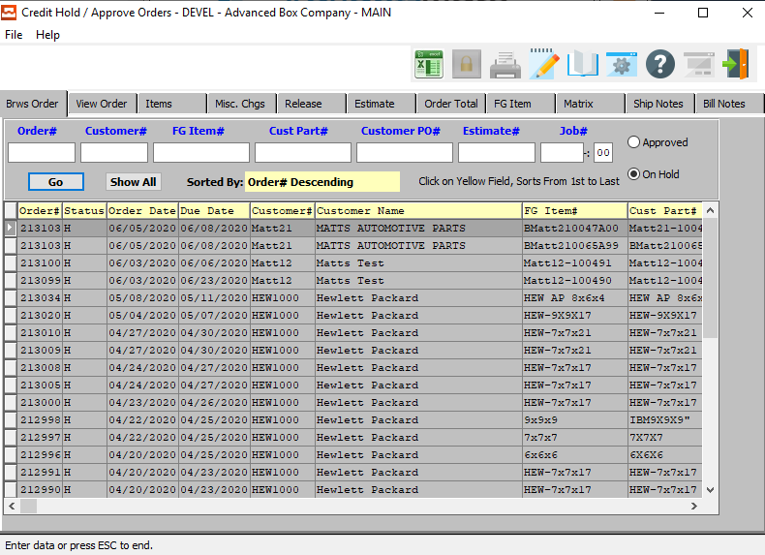

### Browse Order Field Definitions

#### Order #

Enter order number or you may use the ***“F1”*** look-up. A partial description may be typed into any field or data may be entered into multiple fields followed by pressing the ***“Go”*** button to sort the fields by the criteria that was entered. Once the data is presented on the screen, the YELLOW column heading may be clicked to sort that specific column in ascending or descending order.

#### Customer #

Enter customer number or you may use the ***“F1”*** look-up. A partial description may be typed into any field or data may be entered into multiple fields followed by pressing the ***“Go”*** button to sort the fields by the criteria that was entered. Once the data is presented on the screen, the YELLOW column heading may be clicked to sort that specific column in ascending or descending order.

#### FG Item #

Enter the FG item number or you may use the ***“F1”*** look-up. A partial description may be typed into any field or data may be entered into multiple fields followed by pressing the ***“Go”*** button to sort the fields by the criteria that was entered. Once the data is presented on the screen, the YELLOW column heading may be clicked to sort that specific column in ascending or descending order.

#### Customer Part #

Enter the customer part number. A partial description may be typed into any field or data may be entered into multiple fields followed by pressing the ***“Go”*** button to sort the fields by the criteria that was entered. Once the data is presented on the screen, the YELLOW column heading may be clicked to sort that specific column in ascending or descending order.

#### Customer PO #

Enter the customer PO number. A partial description may be typed into any field or data may be entered into multiple fields followed by pressing the ***“Go”*** button to sort the fields by the criteria that was entered. Once the data is presented on the screen, the YELLOW column heading may be clicked to sort that specific column in ascending or descending order.

The order entry browser will show only OPEN orders. The Closed Order Browser will show open or closed orders. To show only OPEN customer orders, check the box labeled Open. To show only closed orders, then check the box labeled Closed. To see both closed and open orders, click both boxes.

#### Estimate #

Enter the estimate number or you may use the ***“F1”*** look-up. A partial description may be typed into any field or data may be entered into multiple fields followed by pressing the ***“Go”*** button to sort the fields by the criteria that was entered. Once the data is presented on the screen, the YELLOW column heading may be clicked to sort that specific column in ascending or descending order.

Please note, the estimate will appear on the VIEW ORDER screen if the N-K-1 CEMENU logical is NO and the character value = CORRWARE.

#### Job #

Enter the job number or you can do a ***“F1”*** look-up from list. A partial description may be typed into any field or data may be entered into multiple fields followed by pressing the ***“Go”*** button to sort the fields by the criteria that was entered. Once the data is presented on the screen, the YELLOW column heading may be clicked to sort that specific column in ascending or descending order.

The purchase order browser will show only OPEN orders. The Closed Order Browser will show open or closed orders. To show only OPEN customer orders, check the box labeled Open. To show only closed orders, then check the box labeled Closed. To see both closed and open orders, click both boxes.

#### Job # - 00

Enter the sequential starting/finishing number for the job.

#### Approved / On Hold

To choose the preferred type of order to browse through of Approved vs. On-Hold orders, please make sure the desired option choice bubble is toggled.

## View Order

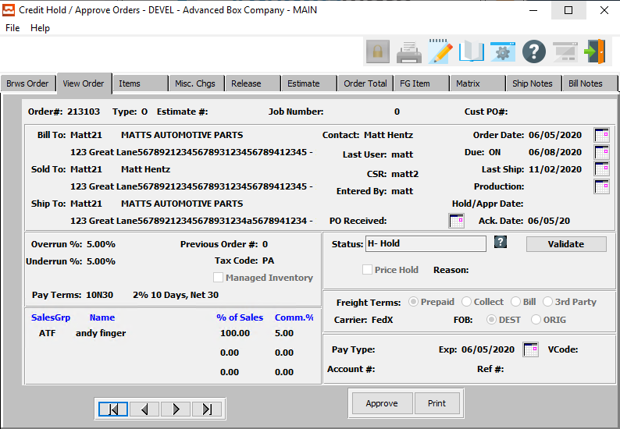

#### APPROVE

Click the ***“Approve”*** button to approve the order currently in the View screen.

#### PRINT

Click the ***“Print”*** button to print the order currently in the View screen.

#### NEXT

Press ***"N"*** (Next) to find next order to view or modify. Alternatively, press the ***“Right Arrow”*** on the screen.

#### PREVIOUS

Press ***"P"*** (Previous) to find previous order to view or modify. Alternatively, press the ***“Left Arrow”*** on the screen.

### Print Order

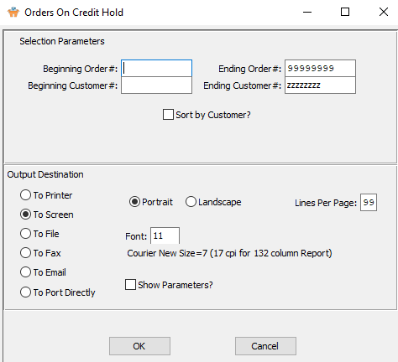

### Print Order Field Definitions

#### Beginning Order # / Ending Order #

Enter the starting and ending order number.

#### Beginning Customer # / Ending Customer #

Enter the starting and ending customer number.

#### Sort by Customer? – Toggle Box

To sort the printout by customer number, make sure that the Sort by Customer # toggle box is checked.

#### Destination Choice

To choose the destination where the document should be printed, please make sure that desired output destination choice bubble is toggled.

#### Layout Choice

To choose the preferred layout of Landscape vs. Portrait, please make sure the desired option choice bubbled is toggled.

#### Font

Enter the font number to use with this report (Font 11 is default).

#### Show Parameters? – Toggle Box

To show parameters, make sure that the toggle box is ‘ticked’ with a checkmark.

## Items

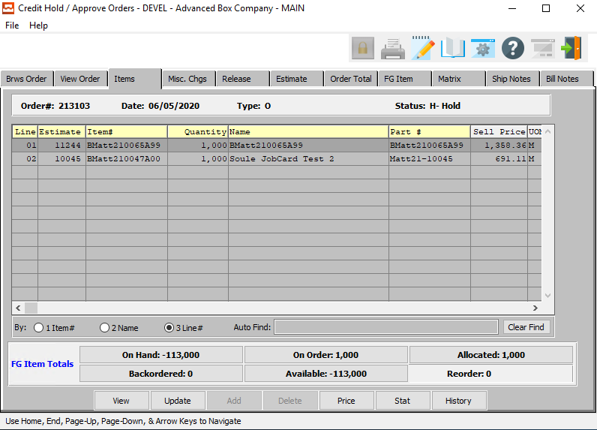

#### VIEW

Click the ***“View”*** button to view detailed information about the selected item.

#### UPDATE

Click the ***“Update”*** button to update information about the currently selected item.

#### PRICE

Click the ***“Price”*** button to choose the price level that the currently selected item should be priced at.

#### STAT

Click the ***“Stat”*** button to view the current customer’s credit history.

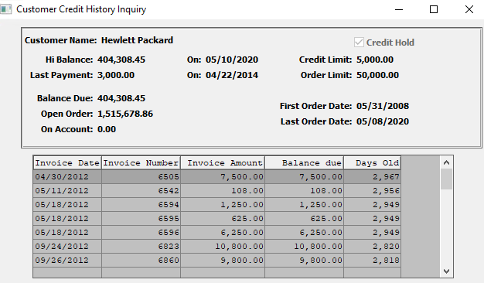

#### HISTORY

Click the ***“History”*** button to view detailed sales analysis for the current customer.

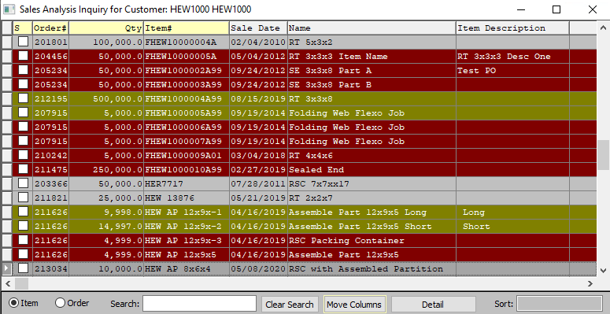

### View Items

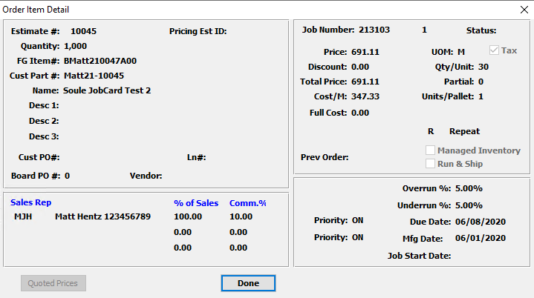

#### DONE

Click the ***“Done”*** button to exit the item detail popup screen.

### Update Items

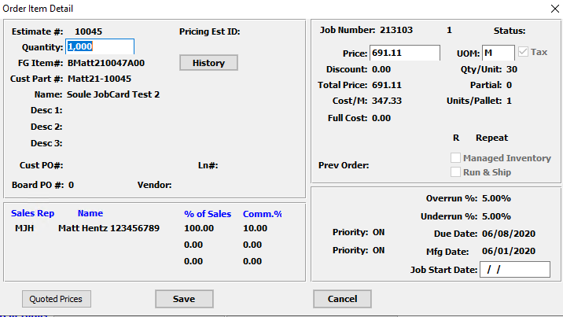

#### QUOTED PRICES

Click the ***“Quoted Prices”*** button to view the quoted prices for the current customer.

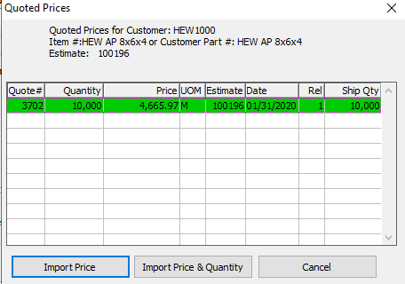

#### SAVE

Click the ***“Save”*** button to save all changes to the item.

#### CANCEL

Click the ***“Cancel”*** button to cancel all changes to the item without saving.

### Update Items Field Definitions

#### Quantity

This defaults to the quantity ordered for the item. It may be modified here.

#### Price

Enter the sell price per unit of measure.

#### UOM

The sell price unit of measure defaults to *M* for per thousand, however this may be modified. Each unit of measure will yield the same total extended price. However, different quantities and different selling price must be defined for each unit of measure.

Valid Units of Measure are:

|  |  |
| --- | --- |
| C | Per Hundred |
| CS | Per Case |
| EA | Per Each |
| L | Per Lot |
| M | Per Thousand |

#### Job Start Date

Current Job Tickets print the Production Date from the View Order Tab. The Production Date prints on the Job Ticket. However, many orders do not have an estimate or job on the View Order Tab. Each Estimate on the *Items* tab may have a unique Job Start Date.

## Misc. Charges

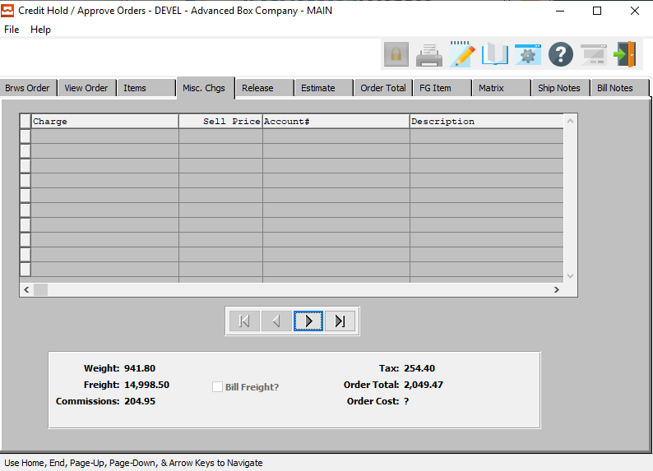

#### NEXT

Press ***"N"*** (Next) to find next miscellaneous charge to view or modify. Alternatively, press the ***“Right Arrow”*** on the screen.

#### PREVIOUS

Press ***"P"*** (Previous) to find previous miscellaneous charge to view or modify. Alternatively, press the ***“Left Arrow”*** on the screen.

## Release

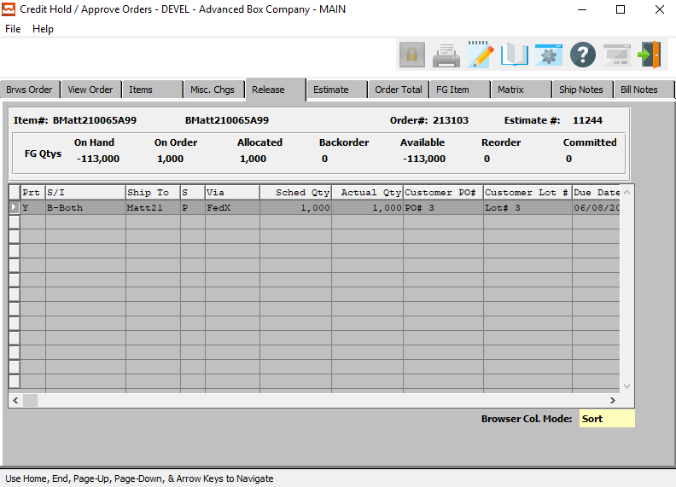

## Estimate

Clicking the ***Estimate*** tab will bring up a popup screen of the Estimation system.

To learn more about how the ***Estimating*** system works, please refer to the “Corrugated” or “Folding” Estimating Manuals.

## Order Total

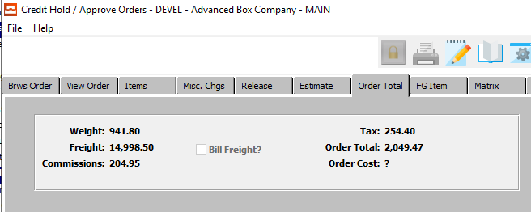

## FG Item

Clicking the ***FG Item*** tab will bring up a popup screen of the Finished Goods system.

To learn more about how the ***Finished Goods*** system works, please refer to the “Finished Goods” Manual.

## Matrix

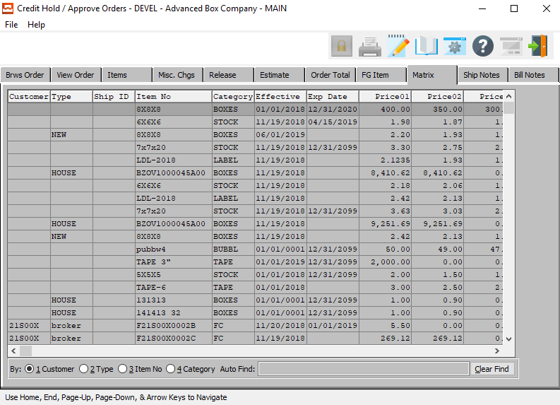

## Ship Notes

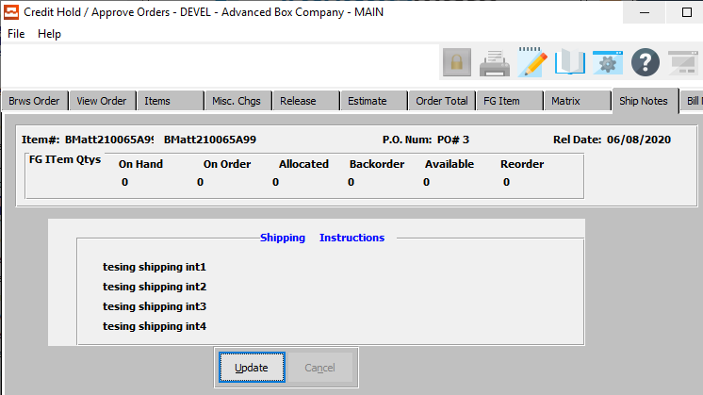

#### UPDATE

Click the ***“Update”*** button to update the shipping instructions.

### Update Ship Notes

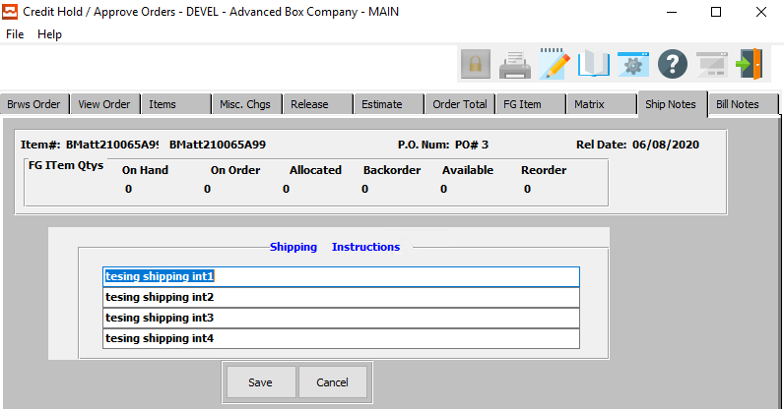

#### SAVE

Click the ***“Save”*** button to save all changes to the shipping instructions.

#### CANCEL

Click the ***“Cancel”*** button to cancel all changes to the shipping instructions without saving.

#### Shipping Instructions

Shipping instructions defined in the customers Ship To file will default for each Ship To defined on the Planned Release screen. To change simply position the cursor next to the Release Ship To location, press ***“T”*** (Text) and *Yes* to modify.

## Bill Notes

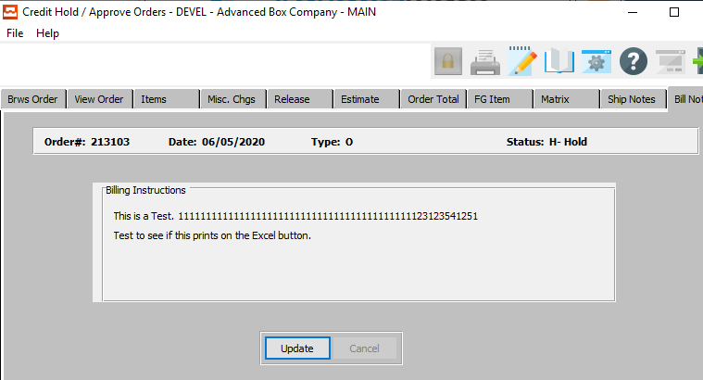

#### UPDATE

Click the ***“Update”*** button to update the billing instructions.

### Update Bill Notes

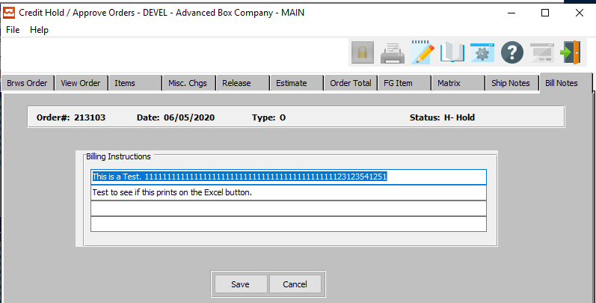

#### SAVE

Click the ***“Save”*** button to save all changes to the billing instructions.

#### CANCEL

Click the ***“Cancel”*** button to cancel all changes to the billing instructions without saving.

#### Billing Instructions

Enter special billing instructions to aid sales service for internal matters. This is not printed on any document that is sent to the customer, but provides a reference for internal personnel. For example, you may want to write a note to collect money prior to shipping within these special billing instructions.

# **Web Orders Transfer / Approve [OW]**

## Browse Order

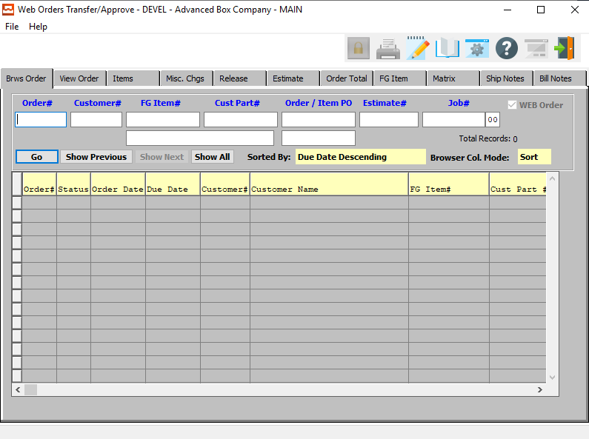

The browser screen shows all the order numbers, dates, customer numbers, estimate numbers, job numbers and item numbers in the system starting with the most recent and descending to the oldest. To view the first/last, press the ***“End”*** key or ***“Home”*** key or click the icon with the circling arrows to sort ascending, then descending.

### Browse Order Field Definitions

#### Order #

Enter order number or you may use the ***“F1”*** key look-up. A partial description may be typed into any field or data may be entered into multiple fields followed by pressing the ***“Go”*** button to sort the fields by the criteria that was entered. Once the data is presented on the screen, the YELLOW column heading may be clicked to sort that specific column in ascending or descending order.

#### Customer #

Enter customer number or you may use the ***“F1”*** look-up. A partial description may be typed into any field or data may be entered into multiple fields followed by pressing the ***“Go”*** button to sort the fields by the criteria that was entered. Once the data is presented on the screen the YELLOW column heading may be clicked to sort that specific column in ascending or descending order.

#### FG Item #

Enter the FG item number or you may use the ***“F1”*** look-up. A partial description may be typed into any field or data may be entered into multiple fields followed by pressing the ***“Go”*** button to sort the fields by the criteria that was entered. Once the data is presented on the screen, the YELLOW column heading may be clicked to sort that specific column in ascending or descending order.

#### FG Item Name

Enter the Finished Goods Item name that you want to search for.

#### Customer Part #

Enter the customer part number. A partial description may be typed into any field or data may be entered into multiple fields followed by pressing the ***“Go”*** button to sort the fields by the criteria that was entered. Once the data is presented on the screen, the YELLOW column heading may be clicked to sort that specific column in ascending or descending order.

#### Order / Item PO

A partial description may be typed into any field or data may be entered into multiple fields followed by pressing the ***“Go”*** button to sort the fields by the criteria that was entered. Once the data is presented on the screen, the YELLOW column heading may be clicked to sort that specific column in ascending or descending order.

#### Estimate #

Enter the estimate number or you may use the ***“F1”*** look-up. A partial description may be typed into any field or data may be entered into multiple fields followed by pressing the ***“Go”*** button to sort the fields by the criteria that was entered. Once the data is presented on the screen, the YELLOW column heading may be clicked to sort that specific column in ascending or descending order.

Please Note: The estimate will appear on the *View Order* screen if the N-K-1 CEMENU logical is *‘No’* and the character value = CORRWARE.

#### Job #

Enter the job number or you can do a ***“F1”*** look-up from list. A partial description may be typed into any field or data may be entered into multiple fields followed by pressing the ***“Go”*** button to sort the fields by the criteria that was entered. Once the data is presented on the screen, the YELLOW column heading may be clicked to sort that specific column in ascending or descending order.

## View Order

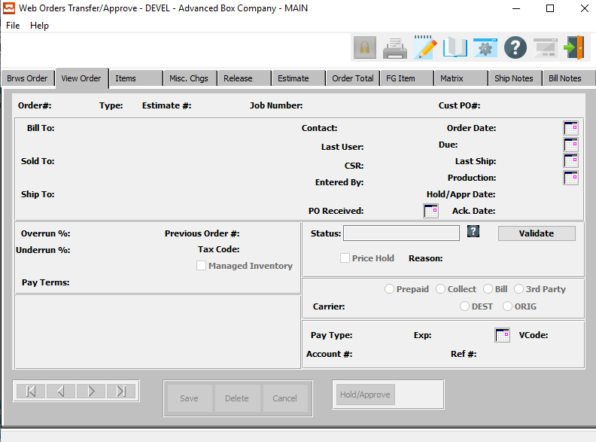

#### NEXT

Press ***"N"*** (Next) to find next order to view or modify. Alternatively, press the ***“Right Arrow”*** on the screen.

#### PREVIOUS

Press ***"P"*** (Previous) to find previous order to view or modify. Alternatively, press the ***“Left Arrow”*** on the screen.

## Items

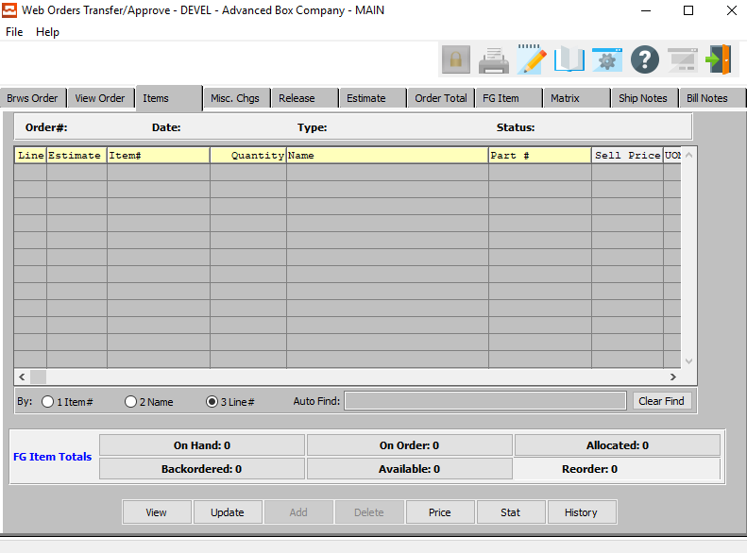

#### VIEW

Click the ***“View”*** button to view detailed information about the selected item.

#### UPDATE

Click the ***“Update”*** button to update information about the selected item.

#### PRICE

Click the ***“Price”*** button to change the Price Level that the selected item should be priced at.

#### STAT

Click the ***“Stat”*** button to view the customer’s credit history.

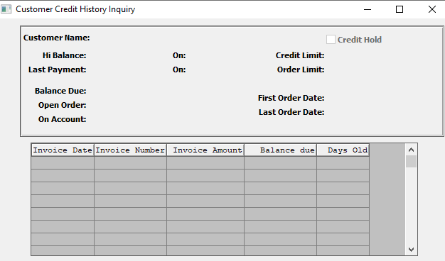

#### HISTORY

Click the ***“History”*** button to view the sales history of the selected item.

## Misc. Charges

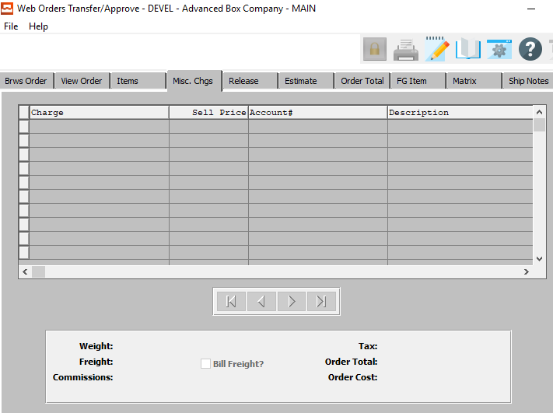

#### NEXT

Press ***"N"*** (Next) to find next miscellaneous charge to view or modify. Alternatively, press the ***“Right Arrow”*** on the screen.

#### PREVIOUS

Press ***"P"*** (Previous) to find previous miscellaneous charge to view or modify. Alternatively, press the ***“Left Arrow”*** on the screen.

## Release

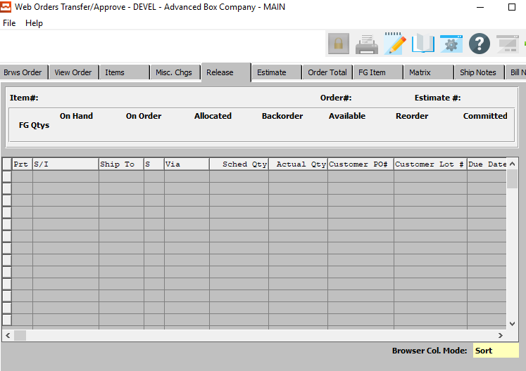

## Estimate

Clicking the ***Estimate*** tab will bring up a popup screen of the Estimation system.

To learn more about how the ***Estimating*** system works, please refer to the “Corrugated” or “Folding” Estimating Manuals.

## Order Total

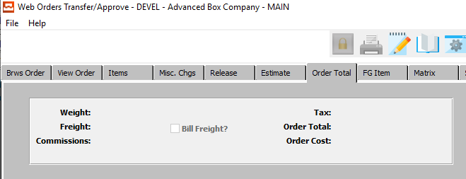

## FG Item

Clicking the ***FG Item*** tab will bring up a popup screen of the Finished Goods system.

To learn more about how the ***Finished Goods*** system works, please refer to the “Finished Goods” Manual.

## Matrix

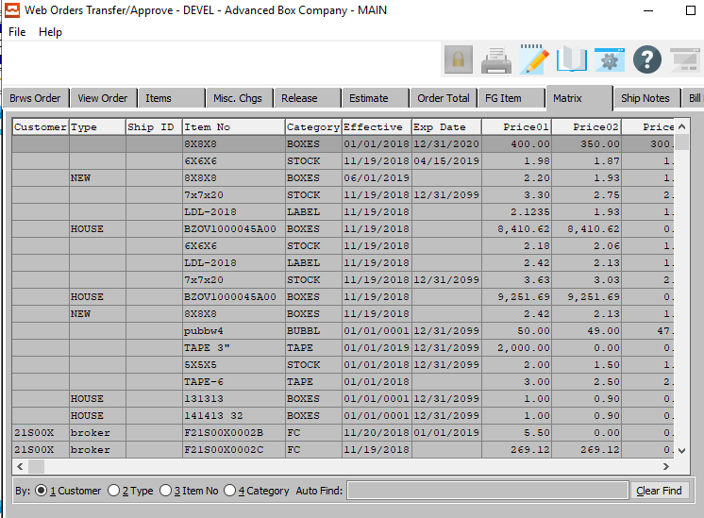

## Ship Notes

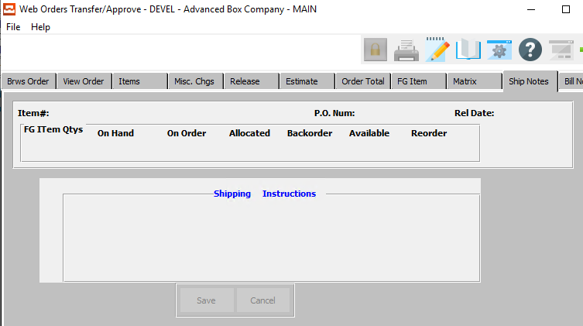

#### SAVE

Click the ***“Save”*** button to save all changes to the shipping instructions.

#### CANCEL

Click the ***“Cancel”*** button to cancel all changes to the shipping instructions without saving.

#### Shipping Instructions

Shipping instructions defined in the customers Ship To file will default for each Ship To defined on the Planned Release screen. To change simply position the cursor next to the Release Ship To location, press ***“T”*** (Text) and *Yes* to modify.

## Bill Notes

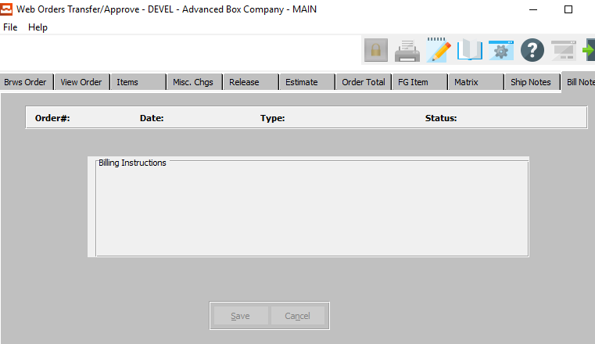

#### SAVE

Click the ***“Save”*** button to save all changes to the billing instructions.

#### CANCEL

Click the ***“Cancel”*** button to cancel all changes to the billing instructions without saving.

#### Billing Instructions

Enter special billing instructions to aid sales service for internal matters. This is not printed on any document that is sent to the customer, but provides a reference for internal personnel. For example, you may want to write a note to collect money prior to shipping within these special billing instructions.

# **Query Orders [OQ]**

## Overview

When a customer has inquiries about their order, our system's integration shines. User friendly look-up’s by customer's part number, customer's purchase order number, estimate number or customers name display the orders for that customer. In seconds, you find the customer’s order information showing the order quantity, release dates, release quantities, inventory levels and status of production for each operation.

In seconds, the customer’s order displays information for all items including the sold to, Ship To, date entered, date required, quantity ordered and shipped, purchase order number and selling price. Program function keys show more detail such as release dates, release quantities, inventory levels and status of production for each operation.

The inventory inquiry displays all transactions for that item including receipts, shipments, billings, adjustments, credits and transfers. The date, warehouse, bin, ticket number, invoice number, total cases, carton per case and partial cases is listed. A help key shows valid inventory transaction types in this audit trail file.

Numerous inquiries are available regarding the status of the order, releases, shipments, production, invoices and Finished Goods. To find an order or list of orders press ***"I"***, then select an inquiry method. Press the ***“Enter”*** or ***“Tab”*** key to sort by customer, PO, item, etc. Press the ***arrow*** key to view a particular order for details such as shipped quantity, Bill of Lading number, etc.

## Order Status [OQ1]

### Overview

When first accessing the order inquiry, the screen will import a list of open orders with each finished good item on the order sorted by the due date with the first due date listed first. The system administration control parameter (N-K-ORINQ) allows changing the sort option. When the logical value is YES, the cost does not display on the screen and is replaced in sequential order due date for each line item. In addition, the finished goods history button on this screen is sorted by descending transaction date with the most current date first. This option allows customer service to quickly discuss multiple open orders with a customer. If the logical value is NO, the inquiry is listed ascending by order number and shows the cost in place of the due date.

INQUIRY FIELDS: The customer service representative has the option to search by Order number, Customer number, FG Item number, Customer Part number, Customer PO number, Estimate number and Job number. Simply click in one or more fields and enter as much data as possible.

For Example: To view all open orders for ABC company with a part number that begins with PN number 888, enter the Customer ABC, then click in the Part# field and type PN# 888 and only those orders will show. The inquiry will show order numbers, order date due date, customer numbers, estimates numbers, job numbers, item numbers and status in the system starting with the most recent and descending to the oldest. To view the first/last, click in the order section, then press the  ***End”*** key or ***“Home”*** key or click the icon with the circling arrows to sort ascending, then descending. Click on any field and the list will list ascending.

Click again and the list will show descending. In seconds, the customer’s order displays information for all items including the sold to, Ship To, date entered, date required, quantity ordered and shipped, purchase order number and selling price. Program function keys show more detail such as release dates, release quantities, inventory levels and status of production for each operation.

The inventory inquiry displays all transactions for that item including receipts, shipments, billings, adjustments, credits and transfers. The date, warehouse, bin, ticket number, invoice number, total cases, carton per case and partial cases is listed. A help key shows valid inventory transaction types in this audit trail file.

#### Sort Options

The order inquiry may sort on any heading listed on the browser. Once the browser lists the orders, click on any column heading. Each click will sort the file alternating between ascending then descending. To limit the search criteria, enter information in one of the sort fields including Order number, Customer number, FG Item number, CustPart number, Customer PO number, Estimate number and Job number. The order number requires an exact match.

If you enter an invalid number, nothing will appear on the browser. The other field such as FG Item number and Customer Part number will limit the search as you type more characters. Type in 8x8 and all part numbers straiten with 8x8 will appear. Type 8x8x8 and only 8x8x8 items will appear.

To further limit the search, you many enter multiple fields. To limit the search to a single customer and a part number that begins with a few letters, enter information in both fields before press ***“Enter”*** or ***“Go”***. Every time you press the ***“Enter”*** or ***“Go”*** key, the system will import the new search criteria.

#### Regarding Customer Purchase Order Numbers

We can have multiple Purchase Orders for each item on an order. We have the Header PO number which becomes a default for each line item added to the order. However, each line item could be a different PO number and may be changed when adding line items. The Line Item PO number serves as a default to the Release PO number, but may be changed on the Release Folder.

Finally, each shipment, which we call a release could be a different PO number. In effect, our order entry system supports blanket orders, whereby the customer may provide a separate PO number for each delivery, which we call a Release in our system. The RELEASE folder for each line item can house a separate PO number for each delivery.

Please Note: If the user changes the release PO number, the system will prompt to change all PO numbers for all items. This would make them all the same.

### Order Status Codes

|  |  |
| --- | --- |
| A | Approved from Credit Hold |
| C | Closed Order |
| D | Deleted Order |
| H | Credit Held Order |
| I | Invoice Created from Bill of Lading (Ready to Print) |
| N | New Order |
| O | Original Invoice Created from Order (Ready to Print) |
| P | Partially Invoiced Order |
| R | Ready to Release or Ship via Bill of Lading |
| S | Ship Only Invoice |
| U | Updated Order |
| X | Invoice Printed |

### Browse Order

The Browse folder shows the list of orders that were selected based on the inquiry field information entered. After viewing individual orders via the other folders, press the BROWSE folder to access data on other orders.

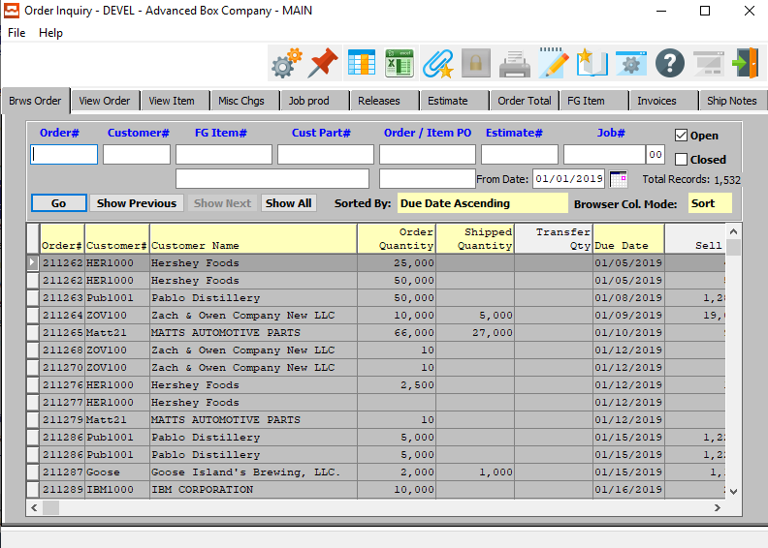

#### Overview

The *Browse* folder shows the list of orders that were selected based on the inquiry field information entered. After viewing individual orders via the other folders, press the *Browse* folder to access data on other orders.

When first accessing the order inquiry, the screen will import a list of open orders with each finished good item on the order sorted by the due date with the first due date listed first. The system administration control parameter (N-K-ORINQ) allows changing the sort option.

When the logical value is *‘Yes’*, the cost does not display on the screen and is replaced in sequential order due date for each line item. In addition, the finished goods history button on this screen is sorted by descending transaction date with the most current date first. This option allows customer service to quickly discuss multiple open orders with a customer.

If the logical value is *‘No’*, the inquiry is listed ascending by order number and shows the cost in place of the due date.

#### Inquiry Fields

The customer service representative has the option to search by Order#, Customer#, FG Item#, Customer Part#, Customer PO#, Estimate# and Job#. Simply click in one or more fields and enter as much data as possible.

For example, to view all open orders for ABC company with a part# that begins with PN# 888, enter the Customer ABC, then click in the Part# field and type PN# 888 and only those orders will show. The inquiry will show order numbers, order date due date, customer numbers, estimates numbers, job numbers, item numbers and status in the system starting with the most recent and descending to the oldest.

To view the first/last, click in the order section, then press the ***“End”*** key or ***“Home”*** key or click the icon with the circling arrows to sort ascending, then descending. Click on any field and the list will list ascending. Click again and the list will show descending. In seconds, the customer’s order displays information for all items including the sold to, Ship To, date entered, date required, quantity ordered and shipped, purchase order number and selling price.

Program function keys show more detail such as release dates, release quantities, inventory levels and status of production for each operation. The inventory inquiry displays all transactions for that item including receipts, shipments, billings, adjustments, credits and transfers. The date, warehouse, bin, ticket number, invoice number, total cases, carton per case and partial cases is listed. A help key shows valid inventory transaction types in this audit trail file.

### Browse Order Field Definitions

#### Order #

Enter order number.

#### Customer #

Enter customer number.

#### FG Item #

Enter item number.

#### Customer Part #

Enter customer part number.

#### Order / Item PO

Enter order or item PO number.

#### Estimate #

Enter estimate number.

#### Job #

Enter job number.

#### From Date

The user may enter a date here, and only orders created on or after that date will be displayed.

#### Open – Toggle Box

To browse for open orders, make sure that the Open toggle box is checked.

Please Note: The user may browse through both open and closed orders by making sure that both toggle boxes are checked.

#### Closed – Toggle Box

To browse for closed orders, make sure that the Closed toggle box is checked.

Please Note: The user may browse through both open and closed orders by making sure that both toggle boxes are checked.

### View Order

The View Order folder shows the header information for the highlighted order number from the list of orders on the browser. This will show the customer, salesman, purchase order number and more.

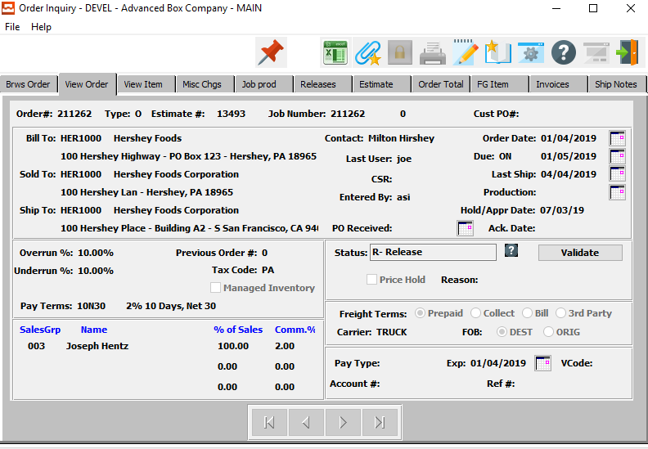

#### NEXT

Press ***"N"*** (Next) to find next order to view. Alternatively, press the ***“Right Arrow”*** on the screen.

#### PREVIOUS

Press ***"P"*** (Previous) to find previous order to view. Alternatively, press the ***“Left Arrow”*** on the screen.

### View Item

The View Item folder will show the details of the line items for the highlighted order number and finished goods item number. This will show the quantity ordered, sell price, cost, discount, salesman and more.

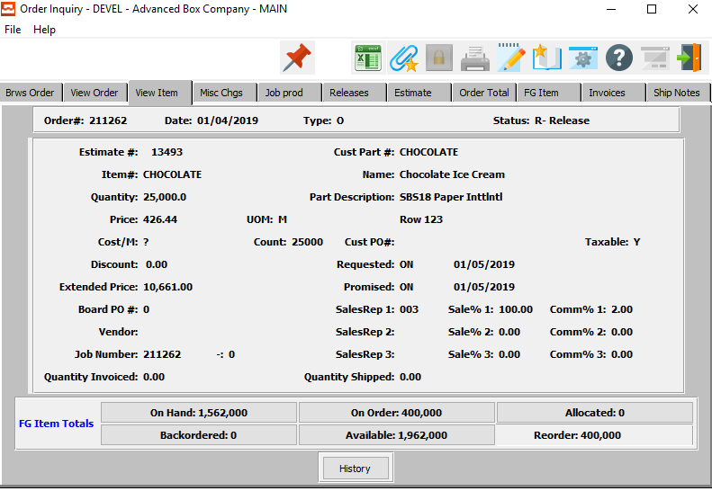

#### HISTORY

Click the ***“History”*** button to view the Sales Analysis Inquiry for the current customer.

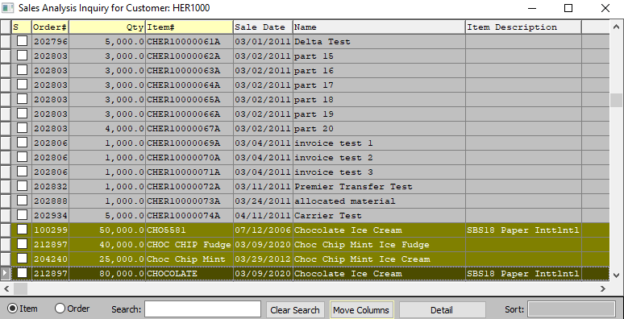

### Misc. Charges

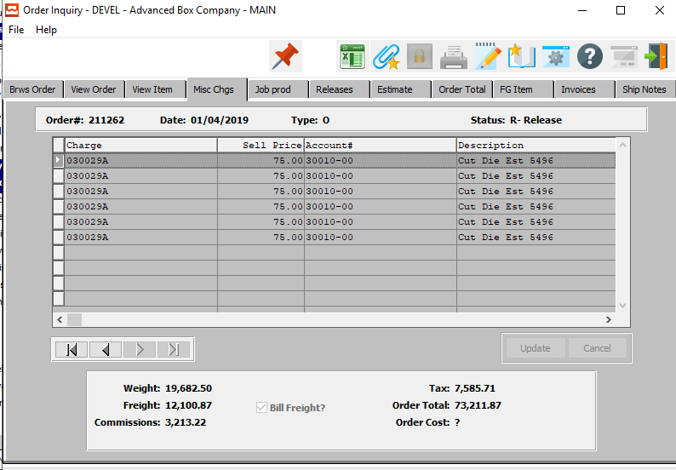

#### UPDATE

Click the ***“Update”*** button to update the selected miscellaneous charge.

#### NEXT

Press ***"N"*** (Next) to find next order to view or modify. Alternatively, press the ***“Right Arrow”*** on the screen.

#### PREVIOUS

Press ***"P"*** (Previous) to find previous order to view or modify. Alternatively, press the ***“Left Arrow”*** on the screen.

### Job Production for Order Line Item

The Job Prod folder shows all the job cost and production information for the order, if the order was manufactured. Additional folders are available to show actual versus estimated materials, machine hours, machined speeds, production quantities, machine waste and costs for direct labor, fixed overhead and variable overhead.

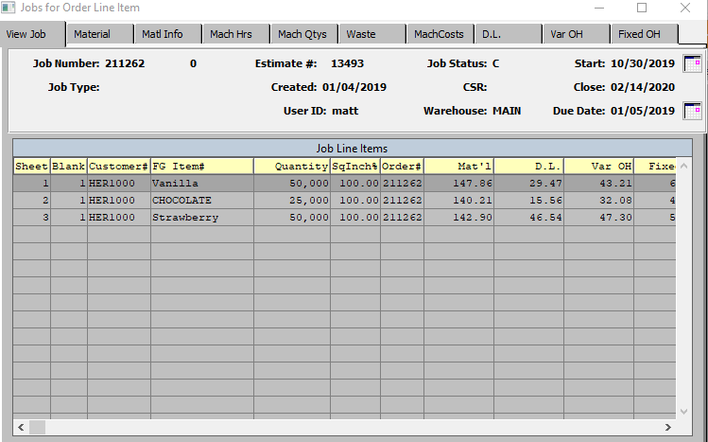

### Releases

The Release folder will show the scheduled deliveries for the highlighted order number and finished goods item number. This will show the ship date, release quantity, release purchase order number, and ship-to address.

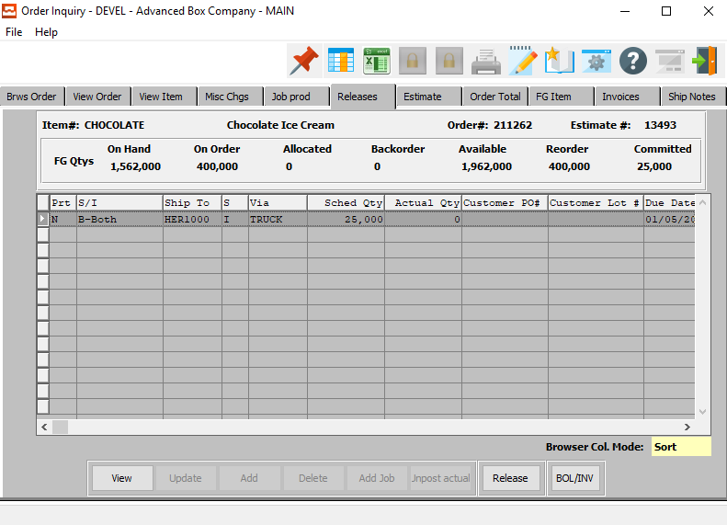

#### VIEW

Click the ***“View***” button to view detailed information about the selected item.

#### RELEASE

Click the ***“Release”*** button to create a new release for the selected item.

#### BOL/INV

Click the ***“BOL/INV”*** button to create and Bill of Lading for the selected item.

### View Release

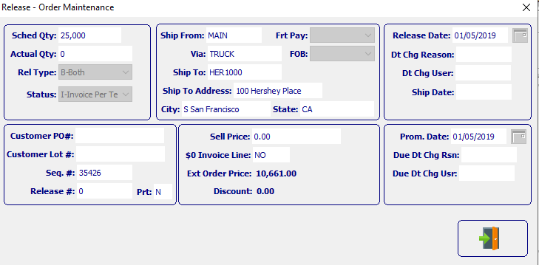

#### EXIT

Click the ***“Exit Door Icon”*** to exit the release detail popup screen.

### Estimate

Clicking the ***Estimate*** tab will bring up a popup screen of the Estimation system.

To learn more about how the ***Estimating*** system works, please refer to the “Corrugated” or “Folding” Estimating Manuals.

The ***Estimate*** folder will transfer to the estimating maintenance for the line item selected, providing the item was manufactured.

### Order Total

The Order Total folder shows the total for the selected order number along with tax amounts, freight costs.

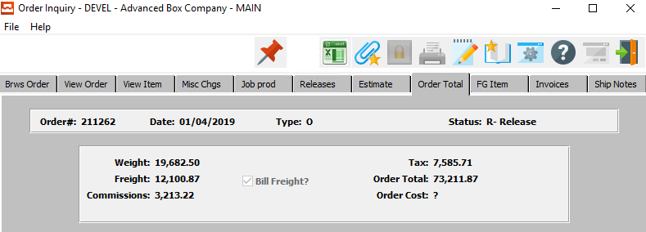

### FG Item

The Finished Goods Items folder shows the details for the finished good item number selected including, costs, sell prices, quantities per warehouse location, die number, plate number, inventory balances and transaction history of receipts, shipments, transfers, returns, adjustments and physical counts.

Clicking the ***FG Item*** tab will bring up a popup screen of the Finished Goods system.

To learn more about how the ***Finished Goods*** system works, please refer to the “Finished Goods” Manual.

### Invoices: Browse Invoices

The Invoices folder lists all the invoices posted for this particular finished good item for the selected order number. This folder provides additional folders to view all paid and unpaid invoices, credit history, payments and more.

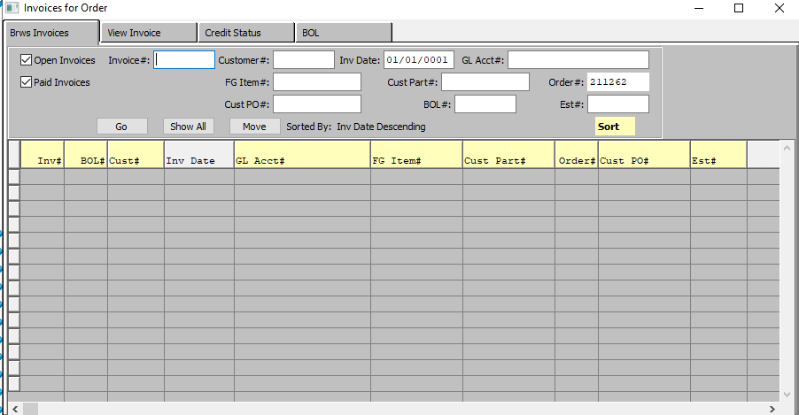

### Browse Invoices Field Definitions

#### Open Invoices – Toggle Box

To browse for open invoices, make sure that the Open Invoices toggle box is checked.

Please Note: The user may browse through both open and paid invoices by making sure that both toggle boxes are checked.

#### Paid Invoices – Toggle Box

To browse for paid invoices, make sure that the Paid Invoices toggle box is checked.

Please Note: The user may browse through both open and paid invoices by making sure that both toggle boxes are checked.

#### Invoice #

Enter an invoice number to search for.

#### Customer #

Enter a customer number to search for.

#### FG Item #

Enter a Finished Goods item number to search for.

#### Customer PO #

Enter a customer purchase order number to search for.

#### Inventory Date

Enter an inventory date to search for.

#### GL Account #

Enter a General Ledger account number to search for.

#### Customer Part #

Enter a customer part number to search for.

#### Order #

Enter an order number to search for.

#### BOL #

Enter a bill of lading number to search for.

#### Estimate #

Enter an estimate number to search for.

### Invoices: View Invoice

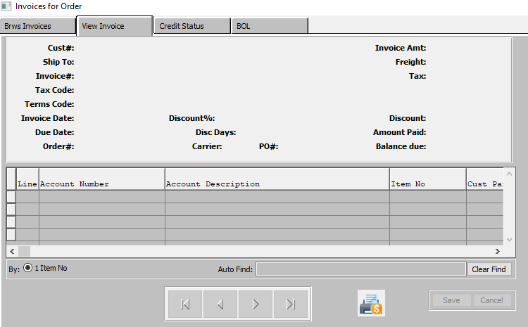

#### NEXT

Press ***"N"*** (Next) to find next invoice to view. Alternatively, press the ***“Right Arrow”*** on the screen.

#### PREVIOUS

Press ***"P"*** (Previous) to find previous invoice to view. Alternatively, press the ***“Left Arrow”*** on the screen.

#### PRINTER ICON

Click the ***“Printer Icon”*** at the bottom of the page to print the selected invoice.

### Invoices: Credit Status

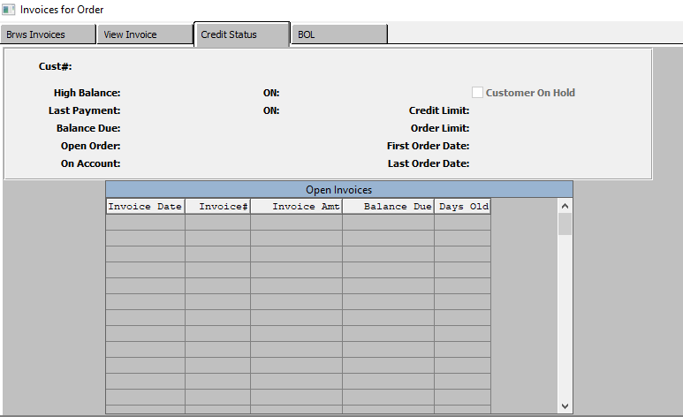

### Invoices: BOL

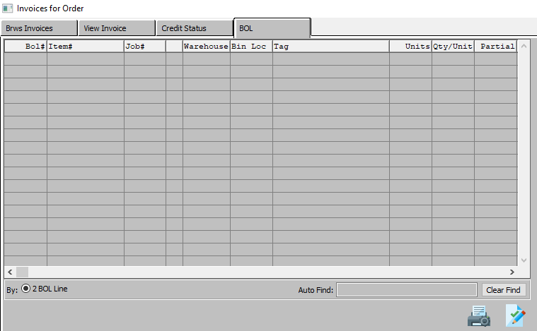

#### PRINTER ICON

Click the ***“Printer Icon”*** to print the selected Bill of Lading.

#### PAPER ICON

Click the ***“Paper and Pencil Icon”*** to print a selected Signed Bill of Lading”

From this screen, the signed Bill of Lading can be printed or displayed. Hence, invoice payment cannot be delayed because the customer cannot find the Bill of Lading or the inventory. Someone from their company signed, which means they received the goods.

### Ship Notes

The Ship Notes folder will show the notes for each scheduled delivery from the RELEASE folder.

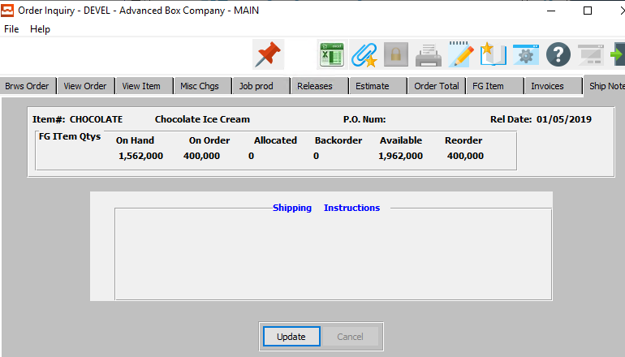

#### UPDATE

Click the ***“Update”*** button to update the shipping notes.

### Update Ship Notes

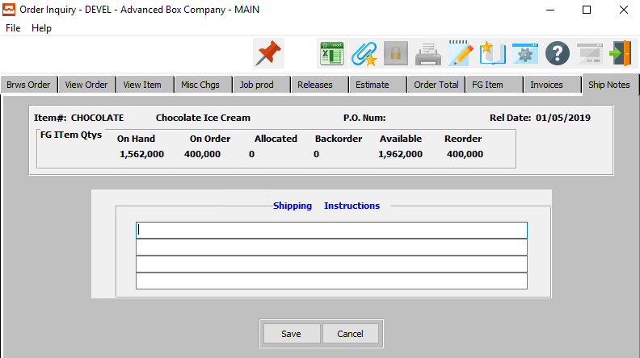

#### SAVE

Click the ***“Save”*** button to save all changes to the shipping instructions.

#### CANCEL

Click the ***“Cancel”*** button to cancel all changes to the shipping instructions without saving.

#### Shipping Instructions

Shipping instructions defined in the customers Ship To file will default for each Ship To defined on the Planned Release screen. To change simply position the cursor next to the Release Ship To location, press ***“T”*** (Text) and *Yes* to modify.

# **Reports for Orders [OR]**

## Overview

Numerous reports are available regarding the status of the order, releases, shipments, production, invoices and Finished Goods.

## Order Backlog [OR1]

The *Order Backlog* screen will print a report for the user according to the parameters they set in this function.

### Selection Parameters

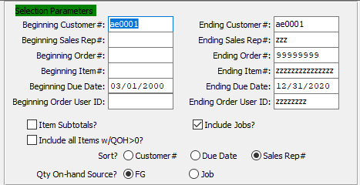

#### Beginning Customer # / Ending Customer #

Enter starting and ending customer number.

#### Beginning Sales Rep # / Ending Sales Rep #

Enter a starting and ending sales rep number.

#### Beginning Order # / Ending Order #

Enter starting and ending order number.

#### Beginning Item # / Ending Item #

Enter starting and ending item number.

#### Beginning Due Date / Ending Due Date

Enter starting and ending due date.

#### Beginning User ID / Ending User ID

Enter starting and ending user ID.

#### Item Subtotals? – Toggle Box

To include item subtotals, make sure that the Item Subtotals toggle box is checked.

#### Include Jobs? – Toggle Box

To include jobs, make sure that the Include Jobs toggle box is checked.

#### Include all Items w/ QOH > 0? – Toggle Box

To include all items with a quantity on-hand that is more than nothing, make sure that this toggle box is checked.

#### Sort? (Choice)

To choose the preferred sort option, please make sure the desired option choice bubble is toggled.

#### Qty On-Hand Source? (Choice)

To choose the preferred quantity on-hand source of FG vs. Job, please make sure the desired option choice bubble is toggled.

### Available and Selected Order Columns

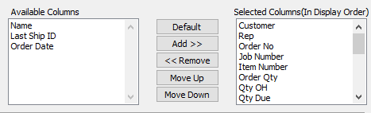

#### Available Columns

The user may choose which columns they wish to have on the report printout. As the user selects their choices, they will appear on the ‘*Selected Columns’* list.

#### Selected Columns (In Display Order)

The columns that the user has chosen from the ‘*Available Columns’* list. The order that these columns are displayed in here is the order in which they will print on the report.

#### Default

Click the ***“Default****”* button to sort the ‘*Selected Columns’* list by the default system parameters.

#### Add >>

Click on the selected item from the ‘*Available Columns’* list to highlight it, then click the ***“Add”*** button to add the selected column to the ‘*Selected Columns’* list.

#### << Remove

Click on the selected item from the ‘*Selected Columns’* list to highlight it, then click the ***“Remove”*** button to remove the selected column to the ‘*Selected Columns’* list.

#### Move Up

Within the ‘*Selected Columns’* list, the user may choose the order they wish the selected columns to print in. In order to change the order of the columns, the user can click on a selection to highlight it. By then clicking the ***“Move Up***” button, the user can change its position on the report.

#### Move Down

Within the ‘*Selected Columns’* list, the user may choose the order they wish the selected columns to print in. In order to change the order of the columns, the user can click on a selection to highlight it. By then clicking the ***“Move Down***” button, the user can change its position on the report.

### Output Destination

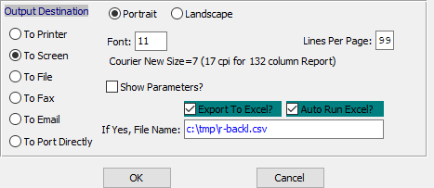

#### Destination Choice

To choose the destination where the document should be printed, please make sure that desired output destination choice bubble is toggled.

#### Layout Choice

To choose the preferred layout of Landscape vs. Portrait, please make sure the desired option choice bubble is toggled.

#### Lines Per Page

Lines per page on the report when printing.

#### Font

Enter the font number to use with this report (Font 11 is default).

#### Show Parameters? – Toggle Box

To show parameters, make sure that the toggle box is ‘ticked’ with a checkmark.

#### Export to Excel? – Toggle Box

To export the printed file to an excel document, make sure that the Export to Excel toggle box is checked.

#### Auto Run Excel? – Toggle Box

To automatically open the new excel document, make sure that the Auto Run Excel toggle box is checked.

#### If Yes, File Name

If exporting the file to Excel, enter the desired file name.

## Scheduled Releases [OR2]

The *Scheduled Releases* screen will print a report for the user according to the parameters they set in this function.

### Selection Parameters

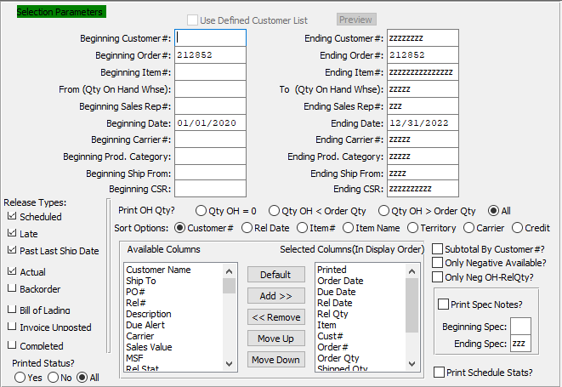

#### Use Defined Customer List – Toggle Box

To use a User Defined Customer List, make sure that this toggle box is checked.

#### Beginning Order # / Ending Order #

Enter a starting and ending order number.

#### Beginning Item # / Ending Item #

Enter a starting and ending item number.

#### From (Qty On Hand Whse) / To (Qty On Hand Whse)

Enter a starting and ending quantity on-hand warehouse.

#### Beginning Sales Rep # / Ending Sales Rep #

Enter a starting and ending sales rep number.

#### Beginning Date / Ending Date

Enter a starting and ending date.

#### Beginning Carrier # / Ending Carrier #

Enter a starting and ending carrier number.

#### Beginning Product Category / Ending Product Category

Enter a starting and ending product category.

#### Beginning Ship From / Ending Ship From

Enter a starting and ending ship-from.

#### Beginning CSR / Ending CSR

Enter a starting and ending CSR.

#### Release Types – Toggle Box

To choose the preferred release types to print on the Hot List, please make sure the desired toggle boxes are checked.

#### Print OH Qty? (Choice)

To choose the preferred on-hand quantity to print, please make sure the desired option choice bubble is toggled.

#### Sort Options

To choose the preferred sort option of Customer Number vs. Release Date, please make sure the desired option choice bubble is toggled.

#### Available Columns

The user may choose which columns they wish to have on the report printout. As the user selects their choices, they will appear on the ‘*Selected Columns’* list.

#### Selected Columns (In Display Order)

The columns that the user has chosen from the ‘*Available Columns’* list. The order that these columns are displayed in here is the order in which they will print on the report.

#### Default

Click the ***“Default****”* button to sort the ‘*Selected Columns’* list by the default system parameters.

#### Add >>

Click on the selected item from the ‘*Available Columns’* list to highlight it, then click the ***“Add”*** button to add the selected column to the ‘*Selected Columns’* list.

#### << Remove

Click on the selected item from the ‘*Selected Columns’* list to highlight it, then click the ***“Remove”*** button to remove the selected column to the ‘*Selected Columns’* list.

#### Move Up

Within the ‘*Selected Columns’* list, the user may choose the order they wish the selected columns to print in. In order to change the order of the columns, the user can click on a selection to highlight it. By then clicking the ***“Move Up***” button, the user can change its position on the report.

#### Move Down

Within the ‘*Selected Columns’* list, the user may choose the order they wish the selected columns to print in. In order to change the order of the columns, the user can click on a selection to highlight it. By then clicking the ***“Move Down***” button, the user can change its position on the report.

#### Subtotal by Customer #? – Toggle Box

To print subtotals by customer number, make sure that the Subtotal by Customer # toggle box is checked.

#### Only Negative Available? – Toggle Box

To print only negative available releases, make sure that this toggle box is checked.

#### Only Neg OH-Rel Qty? – Toggle Box

To print only negative on-hand release quantities, make sure that this toggle box is checked.

#### Print Spec Notes? – Toggle Box

To print Spec notes, make sure that the Print Spec Notes toggle box is checked.

#### Beginning Spec / Ending Spec

Enter a starting and ending Spec Code.

#### Print Schedule Stats? – Toggle Box

To printed schedule statistics, make sure that the Print Schedule Stats toggle box is checked.

### Output Destination

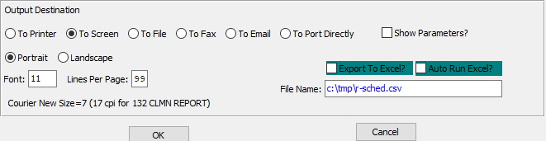

#### Destination Choice

To choose the destination where the document should be printed, please make sure that desired output destination choice bubble is toggled.

#### Layout Choice

To choose the preferred layout of Landscape vs. Portrait, please make sure the desired option choice bubble is toggled.

#### Lines Per Page

Lines per page on the report when printing.

#### Font

Enter the font number to use with this report (Font 11 is default).

#### Show Parameters? – Toggle Box

To show parameters, make sure that the toggle box is ‘ticked’ with a checkmark.

#### Export to Excel? – Toggle Box

To export the printed file to an excel document, make sure that the Export to Excel toggle box is checked.

#### Auto Run Excel? – Toggle Box

To automatically open the new excel document, make sure that the Auto Run Excel toggle box is checked.

#### If Yes, File Name

If exporting the file to Excel, enter the desired file name.

## Job Log [OR3]

The *Job Log* screen will print a report for the user according to the parameters they set in this function.

### Selection Parameters

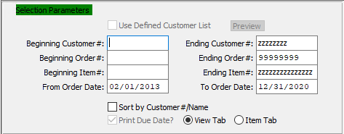

#### Use Defined Customer List – Toggle Box

To use a User Defined Customer List, make sure that this toggle box is checked.

#### Beginning Customer # / Ending Customer #

Enter starting and ending customer number.

#### Beginning Order # / Ending Order #

Enter a starting and ending order number.

#### Beginning Item # / Ending Item #

Enter a starting and ending item number.

#### Beginning Order Date / Ending Order Date

Enter a starting and ending order date.

#### Sort by Customer # / Name – Toggle Box

To sort by customer, make sure that this toggle box is checked.

#### Print Due Date? – Toggle Box

To print the due date, make sure that the Print Due Date toggle box is checked.

#### Tab (Choice)

To choose the preferred tab of View vs. Item, please make sure the desired option choice bubble is toggled.

### Available and Selected Job Columns

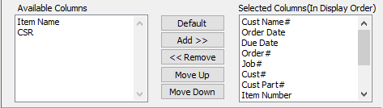

#### Available Columns

The user may choose which columns they wish to have on the report printout. As the user selects their choices, they will appear on the ‘*Selected Columns’* list.

#### Selected Columns (In Display Order)

The columns that the user has chosen from the ‘*Available Columns’* list. The order that these columns are displayed in here is the order in which they will print on the report.

#### Default

Click the ***“Default****”* button to sort the ‘*Selected Columns’* list by the default system parameters.

#### Add >>

Click on the selected item from the ‘*Available Columns’* list to highlight it, then click the ***“Add”*** button to add the selected column to the ‘*Selected Columns’* list.

#### << Remove

Click on the selected item from the ‘*Selected Columns’* list to highlight it, then click the ***“Remove”*** button to remove the selected column to the ‘*Selected Columns’* list.

#### Move Up

Within the ‘*Selected Columns’* list, the user may choose the order they wish the selected columns to print in. In order to change the order of the columns, the user can click on a selection to highlight it. By then clicking the ***“Move Up***” button, the user can change its position on the report.

#### Move Down

Within the ‘*Selected Columns’* list, the user may choose the order they wish the selected columns to print in. In order to change the order of the columns, the user can click on a selection to highlight it. By then clicking the ***“Move Down***” button, the user can change its position on the report.

### Output Destination

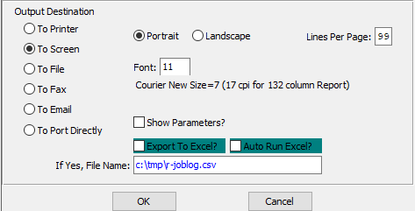

#### Destination Choice

To choose the destination where the document should be printed, please make sure that desired output destination choice bubble is toggled.

#### Layout Choice

To choose the preferred layout of Landscape vs. Portrait, please make sure the desired option choice bubble is toggled.

#### Lines Per Page

Lines per page on the report when printing.

#### Font

Enter the font number to use with this report (Font 11 is default).

#### Show Parameters? – Toggle Box

To show parameters, make sure that the toggle box is ‘ticked’ with a checkmark.

#### Export to Excel? – Toggle Box

To export the printed file to an excel document, make sure that the Export to Excel toggle box is checked.

#### Auto Run Excel? – Toggle Box

To automatically open the new excel document, make sure that the Auto Run Excel toggle box is checked.

#### If Yes, File Name

If exporting the file to Excel, enter the desired file name.

## Sales Rep Performance [OR4]

The *Sales Rep Performance* screen will print a report for the user according to the parameters they set in this function.

### Selection Parameters

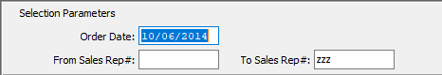

#### Order Date

Enter the date of the order.

#### From Sales Rep # / To Sales Rep #

Enter the beginning and ending sales rep number.

### Available and Selected Sales Rep Columns

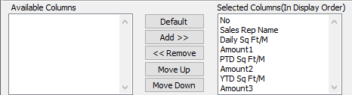

#### Available Columns

The user may choose which columns they wish to have on the report printout. As the user selects their choices, they will appear on the ‘*Selected Columns’* list.

#### Selected Columns (In Display Order)

The columns that the user has chosen from the ‘*Available Columns’* list. The order that these columns are displayed in here is the order in which they will print on the report.

#### Add >>

Click on the selected item from the ‘*Available Columns’* list to highlight it, then click the ***“Add”*** button to add the selected column to the ‘*Selected Columns’* list.

#### << Remove

Click on the selected item from the ‘*Selected Columns’* list to highlight it, then click the ***“Remove”*** button to remove the selected column to the ‘*Selected Columns’* list.

#### Move Up

Within the ‘*Selected Columns’* list, the user may choose the order they wish the selected columns to print in. In order to change the order of the columns, the user can click on a selection to highlight it. By then clicking the ***“Move Up***” button, the user can change its position on the report.

#### Move Down

Within the ‘*Selected Columns’* list, the user may choose the order they wish the selected columns to print in. In order to change the order of the columns, the user can click on a selection to highlight it. By then clicking the ***“Move Down***” button, the user can change its position on the report.

### Output Destination

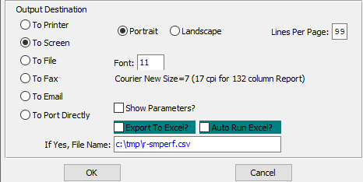

#### Destination Choice

To choose the destination where the document should be printed, please make sure that desired output destination choice bubble is toggled.

#### Layout Choice

To choose the preferred layout of Landscape vs. Portrait, please make sure the desired option choice bubble is toggled.

#### Lines Per Page

Lines per page on the report when printing.

#### Font

Enter the font number to use with this report (Font 11 is default).

#### Show Parameters? – Toggle Box

To show parameters, make sure that the toggle box is ‘ticked’ with a checkmark.

#### Export to Excel? – Toggle Box

To export the printed file to an excel document, make sure that the Export to Excel toggle box is checked.

#### Auto Run Excel? – Toggle Box

To automatically open the new excel document, make sure that the Auto Run Excel toggle box is checked.

#### If Yes, File Name

If exporting the file to Excel, enter the desired file name.

## Orders Booked [OR5]

The *Orders Booked* screen will print a report for the user according to the parameters they set in this function.

### Selection Parameters

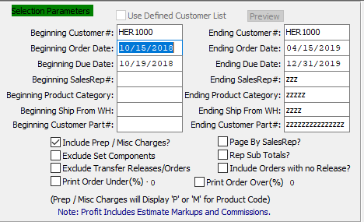

#### Beginning Customer #

Enter starting customer number.

#### Ending Customer #

Enter the ending customer number.

#### Beginning Order Date

Enter the beginning order date.

#### Ending Order Date

Enter the ending order date.

#### Beginning Due Date

Enter the beginning due date.

#### Ending Due Date

Enter the ending due date.

#### Beginning Sales Rep #

Enter the beginning sales rep number.

#### Ending Sales Rep #

Enter the ending sales rep number.

#### Beginning Product Category

Enter the beginning product category.

#### Ending Product Category

Enter the ending product category.

#### Beginning Ship From WH

Enter the beginning ship-from warehouse.

#### Ending Ship From WH

Enter the ending ship-from warehouse.

#### Beginning Customer Part #

Enter the beginning customer part number.

#### Ending Customer Part #

Enter the ending customer part number.

#### Include Prep / Misc. Charges? – Toggle Box

To include preparation and miscellaneous charges, make sure that this toggle box is checked.

#### Exclude Set Components – Toggle Box

To exclude set components, make sure that the Exclude Set Components toggle box is checked.

#### Exclude Transfer Releases/Orders – Toggle Box

To exclude transfer releases and orders, make sure that this toggle box is checked.

#### Page by Sales Rep? – Toggle Box

To print pages by sales rep, make sure that the Page by Sales Rep toggle box is checked.

#### Rep Sub Totals? – Toggle Box

To print sub totals, make sure that the Rep Sub Totals toggle box is checked.

#### Include Orders with no Release? – Toggle Box

To include orders that have no release, make sure that this toggle box is checked.

#### Print Order Under (%) – Toggle Box

To print orders under a certain percentage, make sure that this toggle box is checked.

#### Print Order Over (%) – Toggle Box

To print orders over a certain percentage, make sure that this toggle box is checked.

### Available and Selected Order Columns

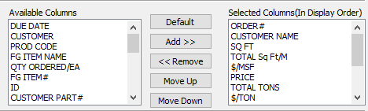

#### Available Columns

The user may choose which columns they wish to have on the report printout. As the user selects their choices, they will appear on the ‘*Selected Columns’* list.

#### Selected Columns (In Display Order)

The columns that the user has chosen from the ‘*Available Columns’* list. The order that these columns are displayed in here is the order in which they will print on the report.

#### Default

Click the ***“Default****”* button to sort the ‘*Selected Columns’* list by the default system parameters.

#### Add >>

Click on the selected item from the ‘*Available Columns’* list to highlight it, then click the ***“Add”*** button to add the selected column to the ‘*Selected Columns’* list.

#### << Remove

Click on the selected item from the ‘*Selected Columns’* list to highlight it, then click the ***“Remove”*** button to remove the selected column to the ‘*Selected Columns’* list.

#### Move Up

Within the ‘*Selected Columns’* list, the user may choose the order they wish the selected columns to print in. In order to change the order of the columns, the user can click on a selection to highlight it. By then clicking the ***“Move Up***” button, the user can change its position on the report.

#### Move Down

Within the ‘*Selected Columns’* list, the user may choose the order they wish the selected columns to print in. In order to change the order of the columns, the user can click on a selection to highlight it. By then clicking the ***“Move Down***” button, the user can change its position on the report.

### Output Destination

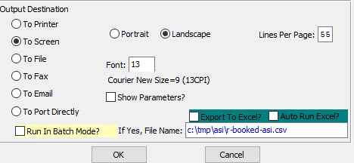

#### Destination Choice

To choose the destination where the document should be printed, please make sure that desired output destination choice bubble is toggled.

#### Layout Choice

To choose the preferred layout of Landscape vs. Portrait, please make sure the desired option choice bubble is toggled.

#### Lines Per Page

Lines per page on the report when printing.

#### Font

Enter the font number to use with this report (Font 11 is default).

#### Show Parameters? – Toggle Box

To show parameters, make sure that the toggle box is ‘ticked’ with a checkmark.

#### Export to Excel? – Toggle Box

To export the printed file to an excel document, make sure that the Export to Excel toggle box is checked.

#### Auto Run Excel? – Toggle Box

To automatically open the new excel document, make sure that the Auto Run Excel toggle box is checked.

#### If Yes, File Name

If exporting the file to Excel, enter the desired file name.

## Commissions [OR6]

The *Commissions* screen will print a report for the user according to the parameters they set in this function.

### Selection Parameters

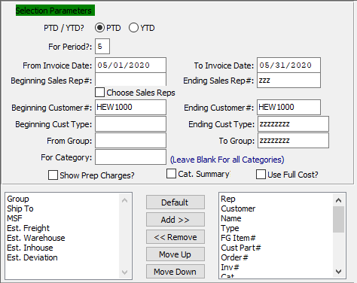

#### PTD / YTD?

To choose the preferred financial values of Period to Date vs. Year to Date, please make sure the desired option choice bubble is toggled.

#### For Period?

Choose the financial period to search through

#### From Invoice Date / To Invoice Date

Enter the starting and ending invoice date.

#### Beginning Sales Rep # / Ending Sales Rep #

Enter the starting and ending sales rep number.

#### Choose Sales Reps – Toggle Box

To choose sales reps, make sure that the Choose Sales Reps toggle box is checked.

#### Beginning Customer # / Ending Customer #

Enter starting and ending customer number.

#### Beginning Customer Type / Ending Customer Type

Enter the beginning and ending customer type.

#### From Group / To Group

Enter the starting and ending group.

#### For Category

If only searching for one category of item, enter it here.

Please Note: Leave this section blank to select all categories.

#### Show Prep Charges? – Toggle Box

To show preparation charges, make sure that the Show Prep Charges toggle box is checked.

#### Cat. Summary – Toggle Box

To print a category summary, make sure that this toggle box is checked.

#### Use Full Cost? – Toggle Box

To the full cost of commissions, make sure that the Use Full Cost toggle box is checked.

#### Available Columns

The user may choose which columns they wish to have on the report printout. As the user selects their choices, they will appear on the ‘*Selected Columns’* list.

#### Selected Columns (In Display Order)

The columns that the user has chosen from the ‘*Available Columns’* list. The order that these columns are displayed in here is the order in which they will print on the report.

#### Default

Click the ***“Default****”* button to sort the ‘*Selected Columns’* list by the default system parameters.

#### Add >>

Click on the selected item from the ‘*Available Columns’* list to highlight it, then click the ***“Add”*** button to add the selected column to the ‘*Selected Columns’* list.

#### << Remove

Click on the selected item from the ‘*Selected Columns’* list to highlight it, then click the ***“Remove”*** button to remove the selected column to the ‘*Selected Columns’* list.

#### Move Up

Within the ‘*Selected Columns’* list, the user may choose the order they wish the selected columns to print in. In order to change the order of the columns, the user can click on a selection to highlight it. By then clicking the ***“Move Up***” button, the user can change its position on the report.

#### Move Down

Within the ‘*Selected Columns’* list, the user may choose the order they wish the selected columns to print in. In order to change the order of the columns, the user can click on a selection to highlight it. By then clicking the ***“Move Down***” button, the user can change its position on the report.

### Output Destination

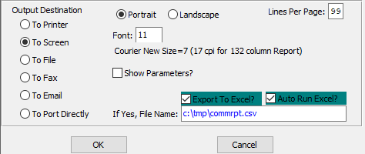

#### Destination Choice

To choose the destination where the document should be printed, please make sure that desired output destination choice bubble is toggled.

#### Layout Choice

To choose the preferred layout of Landscape vs. Portrait, please make sure the desired option choice bubble is toggled.

#### Lines Per Page

Lines per page on the report when printing.

#### Font

Enter the font number to use with this report (Font 11 is default).

#### Show Parameters? – Toggle Box

To show parameters, make sure that the toggle box is ‘ticked’ with a checkmark.

#### Export to Excel? – Toggle Box

To export the printed file to an excel document, make sure that the Export to Excel toggle box is checked.

#### Auto Run Excel? – Toggle Box

To automatically open the new excel document, make sure that the Auto Run Excel toggle box is checked.

#### If Yes, File Name

If exporting the file to Excel, enter the desired file name.

## Order Balance by PO# [OR8]

The *Order Balance by PO Number* screen will print a report for the user according to the parameters they set in this function.

### Selection Parameters

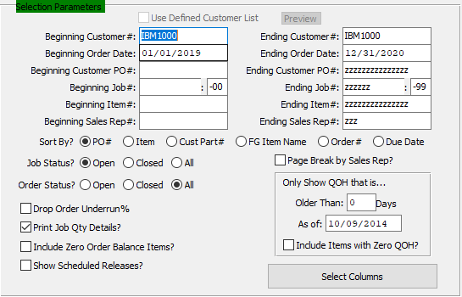

#### Use Defined Customer List – Toggle Box

To use a User Defined Customer List, make sure that this toggle box is checked.

#### Beginning Customer # / Ending Customer #

Enter the beginning and ending customer number.

#### Beginning Order Date / Ending Order Date

Enter the starting and ending order date.

#### Beginning Customer PO # / Ending Customer PO #

Enter the beginning and ending customer PO #.

#### Beginning Job # / Ending Job #

Enter the starting and ending job number.

#### Beginning Item # / Ending Item #

Enter the starting and ending item number.

#### Beginning Sales Rep # / Ending Sales Rep #

Enter the starting and ending sales rep number.

#### Sort By? (Choice)

To choose the preferred sorting method, please make sure the desired option choice bubble is toggled.

#### Job Status? (Choice)

To choose the preferred job status of Open vs. Closed (Or All), please make sure the desired option choice bubble is toggled.

#### Order Status? (Choice)

To choose the preferred order status of Open vs. Closed (Or All), please make sure the desired option choice bubble is toggled.

#### Drop Order Underrun% – Toggle Box

To drop the order underrun percentage, make sure that this toggle box is checked.

#### Print Job Qty Details? – Toggle Box

To print job quantity details, make sure that the Print Job Qty Details toggle box is checked.

#### Include Zero Order Balance Items? – Toggle Box

To include zero quantity balance items, make sure that this toggle box is checked.

#### Show Scheduled Releases? – Toggle Box

To show scheduled releases, make sure that the Show Scheduled Releases toggle box is checked.

#### Page Breakup by Sales Rep? – Toggle Box

To break up the pages by Sales Rep, make sure that this toggle box is checked.

#### Only Show QOH that is… (Older Than)

Enter an amount of days.

#### Only Show QOH that is… (As of: )

Enter a date to show quantity on hand.

#### Only Show QOH that is… (Include Items with Zero QOH?) – Toggle Box

To include items with no on-hand quantities, make sure that this toggle box is checked.

### Output Destination

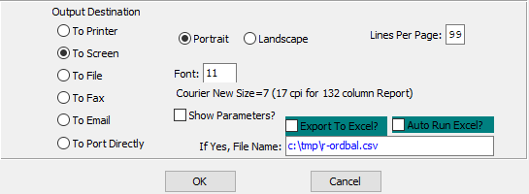

#### Destination Choice

To choose the destination where the document should be printed, please make sure that desired output destination choice bubble is toggled.

#### Layout Choice

To choose the preferred layout of Landscape vs. Portrait, please make sure the desired option choice bubble is toggled.

#### Lines Per Page

Lines per page on the report when printing.

#### Font

Enter the font number to use with this report (Font 11 is default).

#### Show Parameters? – Toggle Box

To show parameters, make sure that the toggle box is ‘ticked’ with a checkmark.

#### Export to Excel? – Toggle Box

To export the printed file to an excel document, make sure that the Export to Excel toggle box is checked.

#### Auto Run Excel? – Toggle Box

To automatically open the new excel document, make sure that the Auto Run Excel toggle box is checked.

#### If Yes, File Name

If exporting the file to Excel, enter the desired file name.

## Scheduled Release w/ Job [OR9]

The *Scheduled Release with Job* screen will print a report for the user according to the parameters they set in this function.

### Selection Parameters

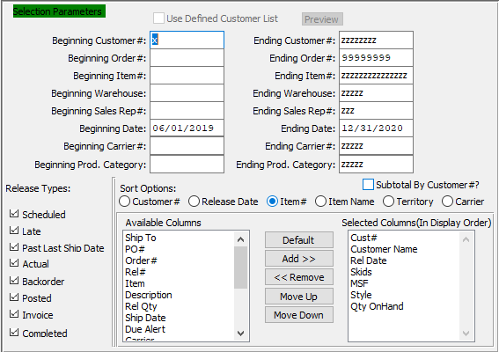

#### Use Defined Customer List – Toggle Box

To use a User Defined Customer List, make sure that this toggle box is checked.

#### Beginning Customer # / Ending Customer #

Enter the beginning and ending customer number.

#### Beginning Order # / Ending Order #

Enter the starting and ending order number.

#### Beginning Item # / Ending Item #

Enter the starting and ending item number.

#### Beginning Warehouse / Ending Warehouse

Enter the starting and ending warehouse.

#### Beginning Sales Rep # / Ending Sales Rep #

Enter the starting and ending sales rep number.

#### Beginning Date / Ending Date

Enter the starting and ending date.

#### Beginning Carrier # / Ending Carrier #

Enter the starting and ending carrier number.

#### Beginning Product Category / Ending Product Category

Enter the starting and ending product category.

#### Release Types – Toggle Box

To choose the preferred release types to print on the Hot List, please make sure the desired toggle boxes are checked.

#### Sort Options

To choose the preferred sort option of Customer Number vs. Release Date, please make sure the desired option choice bubble is toggled.

#### Subtotal by Customer #? – Toggle Box

To print subtotals by the customer number, make sure that this toggle box is checked.

#### Available Columns

The user may choose which columns they wish to have on the report printout. As the user selects their choices, they will appear on the ‘*Selected Columns’* list.

#### Selected Columns (In Display Order)

The columns that the user has chosen from the ‘*Available Columns’* list. The order that these columns are displayed in here is the order in which they will print on the report.

#### Default

Click the ***“Default****”* button to sort the ‘*Selected Columns’* list by the default system parameters.

#### Add >>

Click on the selected item from the ‘*Available Columns’* list to highlight it, then click the ***“Add”*** button to add the selected column to the ‘*Selected Columns’* list.

#### << Remove

Click on the selected item from the ‘*Selected Columns’* list to highlight it, then click the ***“Remove”*** button to remove the selected column to the ‘*Selected Columns’* list.

#### Move Up

Within the ‘*Selected Columns’* list, the user may choose the order they wish the selected columns to print in. In order to change the order of the columns, the user can click on a selection to highlight it. By then clicking the ***“Move Up***” button, the user can change its position on the report.

#### Move Down

Within the ‘*Selected Columns’* list, the user may choose the order they wish the selected columns to print in. In order to change the order of the columns, the user can click on a selection to highlight it. By then clicking the ***“Move Down***” button, the user can change its position on the report.

### Output Destination

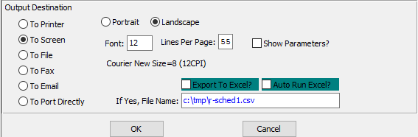

#### Destination Choice

To choose the destination where the document should be printed, please make sure that desired output destination choice bubble is toggled.

#### Layout Choice

To choose the preferred layout of Landscape vs. Portrait, please make sure the desired option choice bubble is toggled.

#### Lines Per Page

Lines per page on the report when printing.

#### Font

Enter the font number to use with this report (Font 11 is default).

#### Show Parameters? – Toggle Box

To show parameters, make sure that the toggle box is ‘ticked’ with a checkmark.

#### Export to Excel? – Toggle Box

To export the printed file to an excel document, make sure that the Export to Excel toggle box is checked.

#### Auto Run Excel? – Toggle Box

To automatically open the new excel document, make sure that the Auto Run Excel toggle box is checked.

#### If Yes, File Name

If exporting the file to Excel, enter the desired file name.

## Orders Booked by Due Date [OR)]

The *Orders Booked by Due Date* screen will print a report for the user according to the parameters they set in this function.

### Selection Parameters

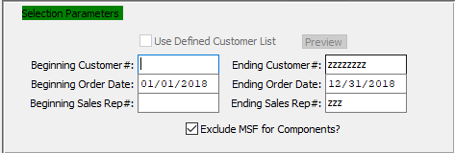

#### Beginning Customer # / Ending Customer #

Enter the beginning and ending customer number.

#### Beginning Order Date / Ending Order Date

Enter the starting and ending order date.

#### Beginning Sales Rep # / Ending Sales Rep #

Enter the starting and ending sales rep number.

#### Use Defined Customer List – Toggle Box

To use a User Defined Customer List, make sure that this toggle box is checked.

#### Exclude MSF for Components? – Toggle Box

To exclude the MSF for components, make sure that this toggle box is checked.

### Available and Selected Order Columns

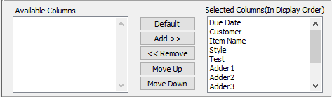

#### Available Columns

The user may choose which columns they wish to have on the report printout. As the user selects their choices, they will appear on the ‘*Selected Columns’* list.

#### Selected Columns (In Display Order)

The columns that the user has chosen from the ‘*Available Columns’* list. The order that these columns are displayed in here is the order in which they will print on the report.

#### Default

Click the ***“Default****”* button to sort the ‘*Selected Columns’* list by the default system parameters.

#### Add >>

Click on the selected item from the ‘*Available Columns’* list to highlight it, then click the ***“Add”*** button to add the selected column to the ‘*Selected Columns’* list.

#### << Remove

Click on the selected item from the ‘*Selected Columns’* list to highlight it, then click the ***“Remove”*** button to remove the selected column to the ‘*Selected Columns’* list.

#### Move Up

Within the ‘*Selected Columns’* list, the user may choose the order they wish the selected columns to print in. In order to change the order of the columns, the user can click on a selection to highlight it. By then clicking the ***“Move Up***” button, the user can change its position on the report.

#### Move Down

Within the ‘*Selected Columns’* list, the user may choose the order they wish the selected columns to print in. In order to change the order of the columns, the user can click on a selection to highlight it. By then clicking the ***“Move Down***” button, the user can change its position on the report.

### Output Destination

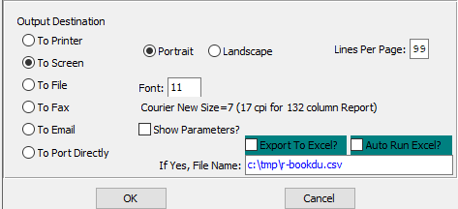

#### Destination Choice

To choose the destination where the document should be printed, please make sure that desired output destination choice bubble is toggled.

#### Layout Choice

To choose the preferred layout of Landscape vs. Portrait, please make sure the desired option choice bubble is toggled.

#### Show Parameters? – Toggle Box

To show parameters, make sure that the toggle box is ‘ticked’ with a checkmark.

#### Export to Excel? – Toggle Box

To export the printed file to an excel document, make sure that the Export to Excel toggle box is checked.

#### Auto Run Excel? – Toggle Box

To automatically open the new excel document, make sure that the Auto Run Excel toggle box is checked.

#### If Yes, File Name

If exporting the file to Excel, enter the desired file name.

## Orders Booked by Order No. [OR!]

The *Orders Booked by Order Number* screen will print a report for the user according to the parameters they set in this function.

### Selection Parameters

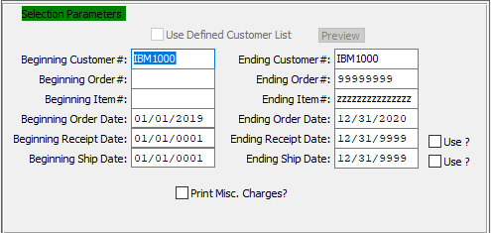

#### Beginning Customer # / Ending Customer #

Enter the beginning and ending customer number.

#### Beginning Order # / Ending Order #

Enter a starting and ending order number.

#### Beginning Item # / Ending Item #

Enter a starting and ending item number.

#### Beginning Order Date / Ending Order Date

Enter a starting and ending order date.

#### Beginning Receipt Date / Ending Receipt Date

Enter a starting and ending receipt date.

#### Use? – Toggle Box

To use the receipt date on the printout, make sure that the Use toggle box next to the Ending Receipt Date is checked.

#### Beginning Ship Date / Ending Ship Date

Enter a starting and ending ship date.

#### Use? – Toggle Box

To use the ship date on the printout, make sure that the Use toggle box next to the Ending Ship Date is checked.

#### Print Misc. Charge? – Toggle Box

To print miscellaneous charges, make sure that the Print Misc. Charge toggle box is checked.

### Available and Selected Order Columns

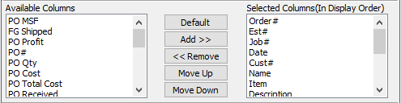

#### Available Columns

The user may choose which columns they wish to have on the report printout. As the user selects their choices, they will appear on the ‘*Selected Columns’* list.

#### Selected Columns (In Display Order)

The columns that the user has chosen from the ‘*Available Columns’* list. The order that these columns are displayed in here is the order in which they will print on the report.

#### Default

Click the ***“Default****”* button to sort the ‘*Selected Columns’* list by the default system parameters.

#### Add >>

Click on the selected item from the ‘*Available Columns’* list to highlight it, then click the ***“Add”*** button to add the selected column to the ‘*Selected Columns’* list.

#### << Remove

Click on the selected item from the ‘*Selected Columns’* list to highlight it, then click the ***“Remove”*** button to remove the selected column to the ‘*Selected Columns’* list.

#### Move Up

Within the ‘*Selected Columns’* list, the user may choose the order they wish the selected columns to print in. In order to change the order of the columns, the user can click on a selection to highlight it. By then clicking the ***“Move Up***” button, the user can change its position on the report.

#### Move Down

Within the ‘*Selected Columns’* list, the user may choose the order they wish the selected columns to print in. In order to change the order of the columns, the user can click on a selection to highlight it. By then clicking the ***“Move Down***” button, the user can change its position on the report.

### Output Destination

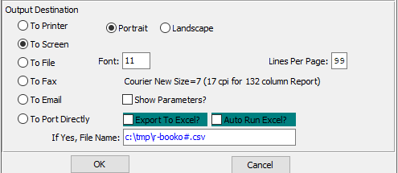

#### Destination Choice

To choose the destination where the document should be printed, please make sure that desired output destination choice bubble is toggled.

#### Layout Choice

To choose the preferred layout of Landscape vs. Portrait, please make sure the desired option choice bubble is toggled.

#### Lines Per Page

Lines per page on the report when printing.

#### Font

Enter the font number to use with this report (Font 11 is default).

#### Show Parameters? – Toggle Box

To show parameters, make sure that the toggle box is ‘ticked’ with a checkmark.

#### Export to Excel? – Toggle Box

To export the printed file to an excel document, make sure that the Export to Excel toggle box is checked.

#### Auto Run Excel? – Toggle Box

To automatically open the new excel document, make sure that the Auto Run Excel toggle box is checked.

#### If Yes, File Name

If exporting the file to Excel, enter the desired file name.

## Scheduled Releases by Ship [OR@]

The *Scheduled Releases by Ship* screen will print a report for the user according to the parameters they set in this function.

### Selection Parameters

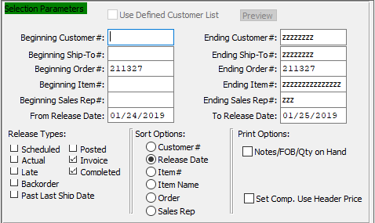

#### Beginning Customer # / Ending Customer #

Enter the beginning customer number.

#### Beginning Ship-To # / Ending Ship-To #

Enter a starting and ending ship-to number.

#### Beginning Order # / Ending Order #

Enter a starting and ending order number.

#### Beginning Item # / Ending Item #

Enter a starting and ending item number.

#### Beginning Sales Rep # / Ending Sales Rep #

Enter a starting and ending sales rep number.

#### From Release Date / To Release Date

Enter a starting and ending release date.

#### Release Types – Toggle Box

To choose the preferred release types to print on the Hot List, please make sure the desired toggle boxes are checked.

#### Sort Options

To choose the preferred sort option of Customer Number vs. Release Date, please make sure the desired option choice bubble is toggled.

#### Notes/FOB/Qty on Hand – Toggle Box

To print notes, FOB, and quantity on-hands, make sure that this toggle box is checked.

#### Set Comp. Use Header Price – Toggle Box

To use a header price, make sure that this toggle box is checked.

### Available and Selected Release Columns

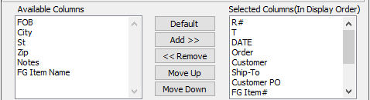

#### Available Columns

The user may choose which columns they wish to have on the report printout. As the user selects their choices, they will appear on the ‘*Selected Columns’* list.

#### Selected Columns (In Display Order)

The columns that the user has chosen from the ‘*Available Columns’* list. The order that these columns are displayed in here is the order in which they will print on the report.

#### Default

Click the ***“Default****”* button to sort the ‘*Selected Columns’* list by the default system parameters.

#### Add >>

Click on the selected item from the ‘*Available Columns’* list to highlight it, then click the ***“Add”*** button to add the selected column to the ‘*Selected Columns’* list.

#### << Remove

Click on the selected item from the ‘*Selected Columns’* list to highlight it, then click the ***“Remove”*** button to remove the selected column to the ‘*Selected Columns’* list.

#### Move Up

Within the ‘*Selected Columns’* list, the user may choose the order they wish the selected columns to print in. In order to change the order of the columns, the user can click on a selection to highlight it. By then clicking the ***“Move Up***” button, the user can change its position on the report.

#### Move Down

Within the ‘*Selected Columns’* list, the user may choose the order they wish the selected columns to print in. In order to change the order of the columns, the user can click on a selection to highlight it. By then clicking the ***“Move Down***” button, the user can change its position on the report.

### Output Destination

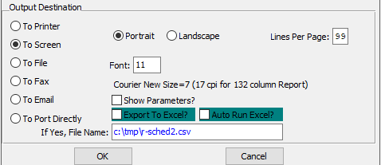

#### Destination Choice

To choose the destination where the document should be printed, please make sure that desired output destination choice bubble is toggled.

#### Layout Choice

To choose the preferred layout of Landscape vs. Portrait, please make sure the desired option choice bubble is toggled.

#### Lines Per Page

Lines per page on the report when printing.

#### Font

Enter the font number to use with this report (Font 11 is default).

#### Show Parameters? – Toggle Box

To show parameters, make sure that the toggle box is ‘ticked’ with a checkmark.

#### Export to Excel? – Toggle Box

To export the printed file to an excel document, make sure that the Export to Excel toggle box is checked.

#### Auto Run Excel? – Toggle Box

To automatically open the new excel document, make sure that the Auto Run Excel toggle box is checked.

#### If Yes, File Name

If exporting the file to Excel, enter the desired file name.

## Order Backlog by Part Number [OR#]

The *Order Backlog by Part Number* screen will print a report for the user according to the parameters they set in this function.

### Selection Parameters

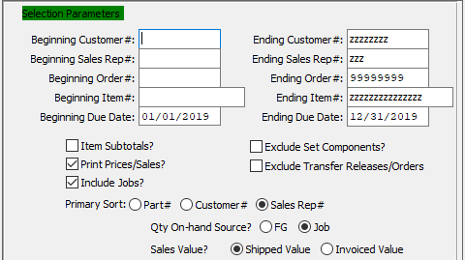

#### Beginning Customer # / Ending Customer #

Enter the beginning and ending customer number.

#### Beginning Sales Rep # / Ending Sales Rep #

Enter a starting and ending sales rep number.

#### Beginning Order # / Ending Order #

Enter a starting and ending order number.

#### Beginning Item # / Ending Item #

Enter a starting and ending item number.

#### Beginning Due Date / Ending Due Date

Enter a starting and ending due date.

#### Item Subtotals? – Toggle Box

To print item subtotals, make sure that the Item Subtotals toggle box is checked.

#### Print Prices/Sales? – Toggle Box

To print prices and sales, make sure that this toggle box is checked.

#### Include Jobs? – Toggle Box

To include jobs, make sure that the Include Jobs toggle box is checked.

#### Exclude Set Components? – Toggle Box

To exclude set components, make sure that the Exclude Set Components toggle box is checked.

#### Exclude Transfer Releases/Order – Toggle Box

To exclude transfer releases or orders, make sure that this toggle box is checked.

#### Primary Sort (Choice)

To choose the preferred primary sorting method, please make sure the desired option choice bubble is toggled.

#### Qty On-Hand Source? (Choice)

To choose the preferred Quantity On-Hand source of FG vs. Job, please make sure the desired option choice bubble is toggled.

#### Sales Value? (Choice)

To choose the preferred Sales Value of Shipped vs. Invoiced, please make sure the desired option choice bubble is toggled.

### Available and Selected Order Columns

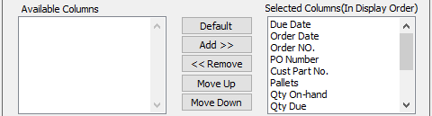

#### Available Columns

The user may choose which columns they wish to have on the report printout. As the user selects their choices, they will appear on the ‘*Selected Columns’* list.

#### Selected Columns (In Display Order)

The columns that the user has chosen from the ‘*Available Columns’* list. The order that these columns are displayed in here is the order in which they will print on the report.

#### Default

Click the ***“Default****”* button to sort the ‘*Selected Columns’* list by the default system parameters.

#### Add >>

Click on the selected item from the ‘*Available Columns’* list to highlight it, then click the ***“Add”*** button to add the selected column to the ‘*Selected Columns’* list.

#### << Remove

Click on the selected item from the ‘*Selected Columns’* list to highlight it, then click the ***“Remove”*** button to remove the selected column to the ‘*Selected Columns’* list.

#### Move Up

Within the ‘*Selected Columns’* list, the user may choose the order they wish the selected columns to print in. In order to change the order of the columns, the user can click on a selection to highlight it. By then clicking the ***“Move Up***” button, the user can change its position on the report.

#### Move Down

Within the ‘*Selected Columns’* list, the user may choose the order they wish the selected columns to print in. In order to change the order of the columns, the user can click on a selection to highlight it. By then clicking the ***“Move Down***” button, the user can change its position on the report.

### Output Destination

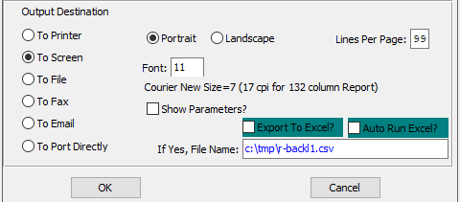

#### Destination Choice

To choose the destination where the document should be printed, please make sure that desired output destination choice bubble is toggled.

#### Layout Choice

To choose the preferred layout of Landscape vs. Portrait, please make sure the desired option choice bubble is toggled.

#### Lines Per Page

Lines per page on the report when printing.

#### Font

Enter the font number to use with this report (Font 11 is default).

#### Show Parameters? – Toggle Box

To show parameters, make sure that the toggle box is ‘ticked’ with a checkmark.

#### Export to Excel? – Toggle Box

To export the printed file to an excel document, make sure that the Export to Excel toggle box is checked.

#### Auto Run Excel? – Toggle Box

To automatically open the new excel document, make sure that the Auto Run Excel toggle box is checked.

#### If Yes, File Name

If exporting the file to Excel, enter the desired file name.

## On-Time Deliveries [OR$]

The *On-Time Deliveries* screen will print a report for the user according to the parameters they set in this function.

### Selection Parameters

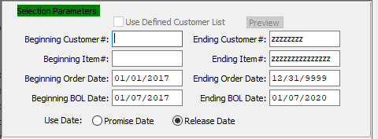

#### Beginning Customer #

Enter the beginning customer number.

#### Ending Customer #

Enter the ending customer number.

#### Beginning Item #

Enter a starting item number.

#### Ending Item #

Enter an ending item number.

#### Beginning Order Date

Enter a starting order date.

#### Ending Order Date

Enter an ending order date.

#### Beginning BOL Date

Enter a starting bill of lading date.

#### Ending BOL Date

Enter an ending bill of lading date.

#### Use Date (Choice)

To choose the preferred date of Promise vs. Release, please make sure the desired option choice bubble is toggled.

### Available and Selected Delivery Columns

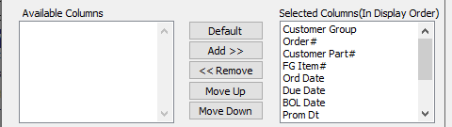

#### Available Columns

The user may choose which columns they wish to have on the report printout. As the user selects their choices, they will appear on the ‘*Selected Columns’* list.

#### Selected Columns (In Display Order)

The columns that the user has chosen from the ‘*Available Columns’* list. The order that these columns are displayed in here is the order in which they will print on the report.

#### Default

Click the ***“Default****”* button to sort the ‘*Selected Columns’* list by the default system parameters.

#### Add >>

Click on the selected item from the ‘*Available Columns’* list to highlight it, then click the ***“Add”*** button to add the selected column to the ‘*Selected Columns’* list.

#### << Remove

Click on the selected item from the ‘*Selected Columns’* list to highlight it, then click the ***“Remove”*** button to remove the selected column to the ‘*Selected Columns’* list.

#### Move Up

Within the ‘*Selected Columns’* list, the user may choose the order they wish the selected columns to print in. In order to change the order of the columns, the user can click on a selection to highlight it. By then clicking the ***“Move Up***” button, the user can change its position on the report.

#### Move Down

Within the ‘*Selected Columns’* list, the user may choose the order they wish the selected columns to print in. In order to change the order of the columns, the user can click on a selection to highlight it. By then clicking the ***“Move Down***” button, the user can change its position on the report.

### Output Destination

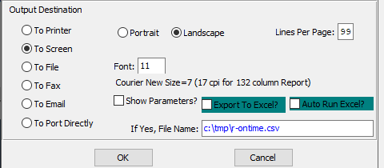

#### Destination Choice

To choose the destination where the document should be printed, please make sure that desired output destination choice bubble is toggled.

#### Layout Choice

To choose the preferred layout of Landscape vs. Portrait, please make sure the desired option choice bubble is toggled.

#### Lines Per Page

Lines per page on the report when printing.

#### Font

Enter the font number to use with this report (Font 11 is default).

#### Show Parameters? – Toggle Box

To show parameters, make sure that the toggle box is ‘ticked’ with a checkmark.

#### Export to Excel? – Toggle Box

To export the printed file to an excel document, make sure that the Export to Excel toggle box is checked.

#### Auto Run Excel? – Toggle Box

To automatically open the new excel document, make sure that the Auto Run Excel toggle box is checked.

#### If Yes, File Name

If exporting the file to Excel, enter the desired file name.

## Freight Report [OR%]

The *Freight Report* screen will print a report for the user according to the parameters they set in this function.

### Selection Parameters

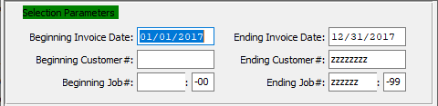

#### Beginning Invoice Date / Ending Invoice Date

Enter a starting and ending invoice date.

#### Beginning Customer # / Ending Customer #

Enter the beginning and ending customer number.

#### Beginning Job # / Ending Job #

Enter a starting and ending job number.

#### Beginning Job #: 00 / Ending Job #: 00

Enter a starting and ending sequential job number.

### Available and Selected Report Columns

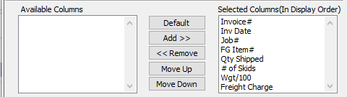

#### Available Columns

The user may choose which columns they wish to have on the report printout. As the user selects their choices, they will appear on the ‘*Selected Columns’* list.

#### Selected Columns (In Display Order)

The columns that the user has chosen from the ‘*Available Columns’* list. The order that these columns are displayed in here is the order in which they will print on the report.

#### Default

Click the ***“Default****”* button to sort the ‘*Selected Columns’* list by the default system parameters.

#### Add >>

Click on the selected item from the ‘*Available Columns’* list to highlight it, then click the ***“Add”*** button to add the selected column to the ‘*Selected Columns’* list.

#### << Remove

Click on the selected item from the ‘*Selected Columns’* list to highlight it, then click the ***“Remove”*** button to remove the selected column to the ‘*Selected Columns’* list.

#### Move Up

Within the ‘*Selected Columns’* list, the user may choose the order they wish the selected columns to print in. In order to change the order of the columns, the user can click on a selection to highlight it. By then clicking the ***“Move Up***” button, the user can change its position on the report.

#### Move Down

Within the ‘*Selected Columns’* list, the user may choose the order they wish the selected columns to print in. In order to change the order of the columns, the user can click on a selection to highlight it. By then clicking the ***“Move Down***” button, the user can change its position on the report.

### Output Destination

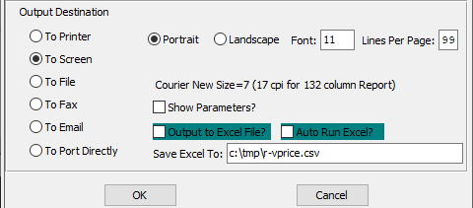

#### Destination Choice

To choose the destination where the document should be printed, please make sure that desired output destination choice bubble is toggled.

#### Layout Choice

To choose the preferred layout of Landscape vs. Portrait, please make sure the desired option choice bubble is toggled.

#### Show Parameters? – Toggle Box

To show parameters, make sure that the toggle box is ‘ticked’ with a checkmark.

#### Export to Excel? – Toggle Box

To export the printed file to an excel document, make sure that the Export to Excel toggle box is checked.

#### Auto Run Excel? – Toggle Box

To automatically open the new excel document, make sure that the Auto Run Excel toggle box is checked.

#### If Yes, File Name

If exporting the file to Excel, enter the desired file name.

## Machine Orders by Due Date [OR&]

### Screen-Specific Icons

|  |  |  |
| --- | --- | --- |
|  | Save |  |
|  | Web Browser | Export the Machine Order parameters to a web browser doc. |
|  | Excel CSV | Export the Machine Order parameters to an Excel CSV document. |
|  | Excel XLS | Export the Machine Order parameters to an Excel XLS document. |
|  | Word DocX | Export the Machine Order parameters to a Word document. |
|  | PDF | Export the Machine Order parameters to a PDF document. |
|  | HTML | Export the Machine Order parameters to an HTML document. |
|  | Print | Print the Machine Order parameters to the default printer. |
|  | Jasper Viewer | View the Machine Order parameters in the Jasper Viewer. |
|  | Tasks | Run the machine Order jasper files. |

### Parameters

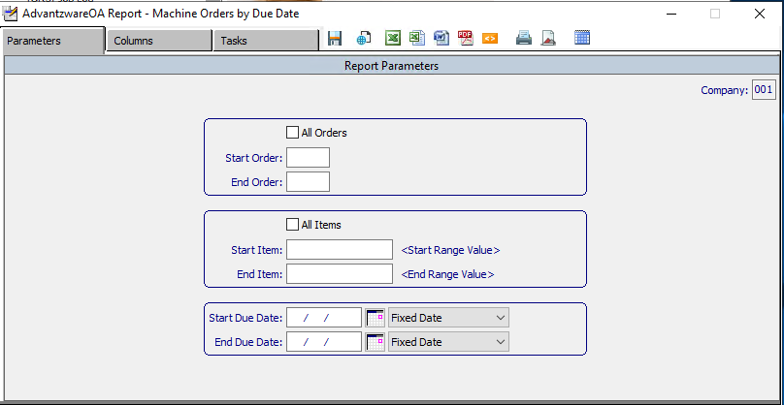

#### Company

Enter a unique company number.

#### All Orders – Toggle Box

To apply these parameters to all orders within a user-determined sequential order, make sure that the All Orders toggle box is checked.

#### Start Order / End Order

Enter a starting and ending order number.

#### All Items – Toggle Box

To apply the report parameters to all items within a user-determined value range.

#### Start Item / End Item

Enter a starting and ending item.

#### Start Due Date / End Due Date

Enter a starting and ending due date.

### Columns

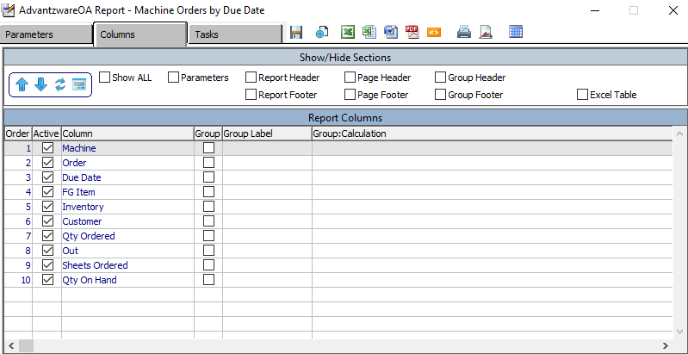

The user should choose all of their desired columns for their parameters.

### Tasks

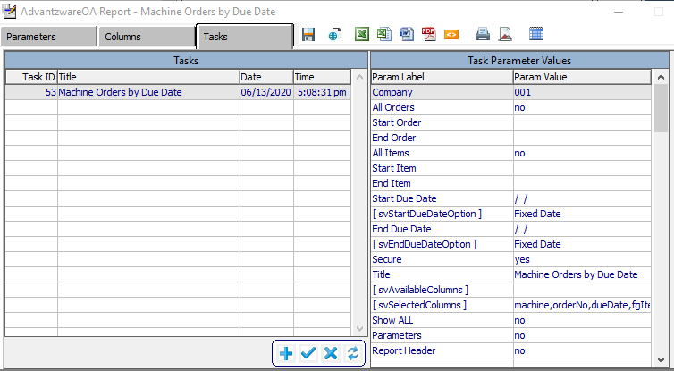

#### ADD

Click the ***“Blue + Icon”*** button at the bottom of the page to add a new task.

#### SAVE

Click the ***“Blue Check Mark Icon”*** button at the bottom of the page to save parameter values to the task ID.

#### DELETE

Click the ***“Blue X Icon”*** button at the bottom of the page to delete the selected task.

#### APPLY

Click the ***“Blue Refresh Icon”*** button at the bottom of the page to apply task values to the parameter values.

## Open Order Report [OR^]

The *Open Order Report* screen will print a report of open orders for the user according to the parameters they set in this function.

### Selection Parameters

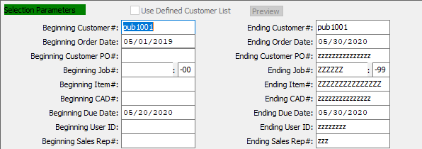

#### Used Defined Customer List – Toggle Box

To use a User Defined Customer List, make sure that this toggle box is checked.

#### Beginning Customer # / Ending Customer #

Enter the beginning and ending customer number.

#### Beginning Order Date / Ending Order Date

Enter a starting and ending order date.

#### Beginning Customer PO # / Ending Customer PO #

Enter the beginning and ending customer PO #.

#### Beginning Job # / Ending Job #

Enter a starting and ending job number.

#### Beginning Item # / Ending Item #

Enter a starting and ending item number.

#### Beginning CAD # / Ending CAD #

Enter a starting and ending CAD number.

#### Beginning Due Date / Ending Due Date

Enter a starting and ending due date.

#### Beginning User ID / Ending User ID

Enter a starting and ending user ID.

#### Beginning Sales Rep # / Ending Sales Rep #

Enter a starting and ending sales rep number.

### Sort By

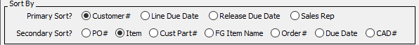

#### Primary Sort?

To choose the preferred primary sorting option, please make sure the desired option choice bubble is toggled.

#### Secondary Sort?

To choose the preferred secondary sorting option, please make sure the desired option choice bubble is toggled.

### Print Selections

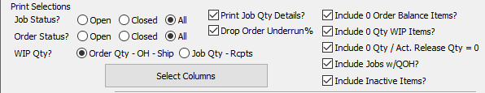

#### Job Status? (Choice)

To choose the preferred Job Status of Open vs. Closed (Or All), please make sure the desired option choice bubble is toggled.

#### Order Status? (Choice)

To choose the preferred Order Status of Open vs. Closed (Or All), please make sure the desired option choice bubble is toggled.

#### WIP Qty? (Choice)

To choose the preferred Work in Process Quantity of On-Hand vs. Job Quantity Receipts, please make sure the desired option choice bubble is toggled.

#### Print Job Qty Details – Toggle Box

To print the job quantity details, make sure that the Print Job Qty Details toggle box is checked.

#### Drop Order Underrun % – Toggle Box

To drop the order underrun percentage from the open order report, make sure that this toggle box is checked.

#### Include 0 Order Balance Items? – Toggle Box

To include orders with zero balance items on the open order report, make sure that this toggle box is checked.

#### Include 0 Qty WIP Items? – Toggle Box

To include orders with zero work in progress items on the open order report, make sure that this toggle box is checked.

#### Include 0 Qty / Act. Release Qty = 0 – Toggle Box

To include orders with zero actual release quantity on the open order report, make sure that this toggle box is checked.

#### Include Jobs w/QOH? – Toggle Box

To include jobs with quantities on hand on the open order report, make sure that this toggle box is checked.

#### Include Inactive Items? – Toggle Box

To include inactive items, make sure that the Include Inactive Items toggle box is checked.

### Output Destination

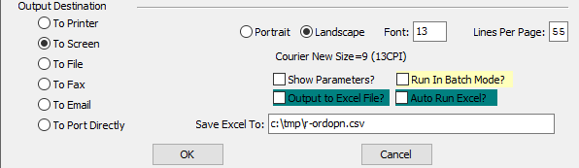

#### Destination Choice

To choose the destination where the document should be printed, please make sure that desired output destination choice bubble is toggled.

#### Layout Choice

To choose the preferred layout of Landscape vs. Portrait, please make sure the desired option choice bubble is toggled.

#### Font

Enter the font number to use with this report (Font 11 is default).

#### Show Parameters? – Toggle Box

To show parameters, make sure that the toggle box is ‘ticked’ with a checkmark.

#### Run in Batch Mode? – Toggle Box

To run the open orders in batch mode, make sure that the Run in Batch Mode toggle box is checked.

#### Export to Excel? – Toggle Box

To export the printed file to an excel document, make sure that the Export to Excel toggle box is checked.

#### Auto Run Excel? – Toggle Box

To automatically open the new excel document, make sure that the Auto Run Excel toggle box is checked.

#### If Yes, File Name

If exporting the file to Excel, enter the desired file name.

# **Z. More Lists for Orders [OZ]**

## Hots List [OZ1]

The *Hots List* screen will print a report for the user according to the parameters they set in this function.

### Selection Parameters

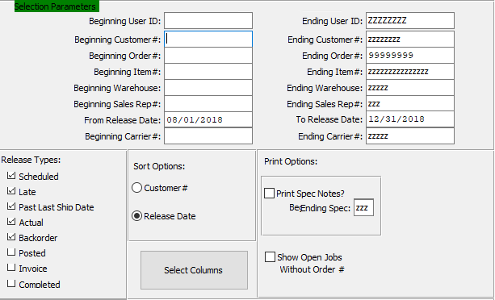

#### Beginning User ID

Enter a starting user ID.

#### Ending User ID

Enter an ending user ID.

#### Beginning Customer #

Enter the beginning customer number.

#### Ending Customer #

Enter the ending customer number.

#### Beginning Order #

Enter a starting order number.

#### Ending Order #

Enter an ending order number.

#### Beginning Item #

Enter a starting item number.

#### Ending Item #

Enter an ending item number.

#### Beginning Warehouse

Enter a starting warehouse.

#### Ending Warehouse

Enter an ending warehouse.

#### Beginning Sales Rep #

Enter a starting sales rep number.

#### Ending Sales Rep #

Enter an ending sales rep number.

#### From Release Date

Enter a starting release date.

#### To Release Date

Enter an ending release date.

#### Beginning Carrier #

Enter a starting carrier number.

#### Ending Carrier #

Enter an ending carrier number.

#### Release Types – Toggle Box

To choose the preferred release types to print on the Hot List, please make sure the desired toggle boxes are checked.

#### Sort Options

To choose the preferred sort option of Customer Number vs. Release Date, please make sure the desired option choice bubble is toggled.

#### Print Spec Notes? – Toggle Box

To print spec notes on the Hots List, make sure that the Print Spec Notes toggle box is checked.

#### Ending Spec

If printing the Spec notes, enter the ending Spec code.

#### Show Open Jobs Without Order # - Toggle Box

To show open jobs without their order number on the Hots List, make sure that this toggle box is checked.

### Output Destination

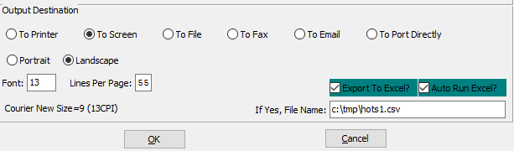

#### Destination Choice

To choose the destination where the document should be printed, please make sure that desired output destination choice bubble is toggled.

#### Layout Choice

To choose the preferred layout of Landscape vs. Portrait, please make sure the desired option choice bubble is toggled.

#### Lines Per Page

Lines per page on the report when printing.

#### Font

Enter the font number to use with this report (Font 11 is default).

#### Show Parameters? – Toggle Box

To show parameters, make sure that the toggle box is ‘ticked’ with a checkmark.

#### Export to Excel? – Toggle Box

To export the printed file to an excel document, make sure that the Export to Excel toggle box is checked.

#### Auto Run Excel? – Toggle Box

To automatically open the new excel document, make sure that the Auto Run Excel toggle box is checked.

#### If Yes, File Name

If exporting the file to Excel, enter the desired file name.

## Job Tick w/ Order Printed? [OZ2]

The *Job Ticket with Order Printed* screen will print a job ticket for a printed order for the user according to the parameters they set in this function.

### Selection Parameters

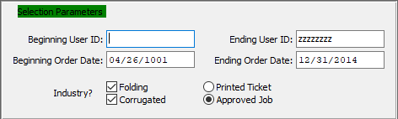

#### Beginning User ID

Enter a starting user ID.

#### Ending User ID

Enter an ending user ID.

#### Beginning Order Date

Enter a starting order date.

#### Ending Order Date

Enter an ending order date.

#### Industry? Folding – Toggle Box

To print Folding boxes, make sure that the Folding toggle box is checked.

#### Industry? Corrugated – Toggle Box

To print Corrugated boxes, make sure that the Corrugated toggle box is checked.

#### Ticket vs Job (Choice)

To choose whether the user prefers to print a ticket or just to approve the job, please make sure the desired option choice bubble is toggled.

### Output Destination

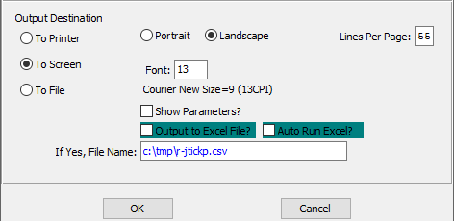

#### Destination Choice

To choose the destination where the document should be printed, please make sure that desired output destination choice bubble is toggled.

#### Layout Choice

To choose the preferred layout of Landscape vs. Portrait, please make sure the desired option choice bubble is toggled.

#### Lines Per Page

Lines per page on the report when printing.

#### Font

Enter the font number to use with this report (Font 11 is default).

#### Show Parameters? – Toggle Box

To show parameters, make sure that the toggle box is ‘ticked’ with a checkmark.

#### Export to Excel? – Toggle Box

To export the printed file to an excel document, make sure that the Export to Excel toggle box is checked.

#### Auto Run Excel? – Toggle Box

To automatically open the new excel document, make sure that the Auto Run Excel toggle box is checked.

#### If Yes, File Name

If exporting the file to Excel, enter the desired file name.

## Summary Invoice Cost [OZ3]

The *Summary Invoice Cost* screen will print a report for the user according to the parameters they set in this function.

### Selection Parameters

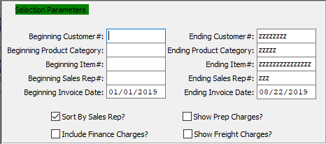

#### Beginning Customer # / Ending Customer #

Enter the beginning and ending customer number.

#### Beginning Product Category / Ending Product Category

Enter a starting and ending product category.

#### Beginning Item # / Ending Item #

Enter a starting and ending item number.

#### Beginning Sales Rep # / Ending Sales Rep #

Enter a starting and ending sales rep number.

#### Beginning Invoice Date / Ending Invoice Date

Enter a starting and ending invoice date.

#### Sort by Sales Rep? – Toggle Box

To sort the summary invoice cost by sales rep, make sure that the Sort by Sales Rep toggle box is checked.

#### Include Finance Charges? – Toggle Box

To include finance charges on the summary invoice cost, make sure that the Include Finance Charges toggle box is checked.

#### Show Prep Charges? – Toggle Box

To show preparation charges on the summary invoice cost, make sure that the Show Prep Charges toggle box is checked.

#### Show Freight Charges? – Toggle Box

To show freight charges on the summary invoice cost, make sure that the Show Freight Charges toggle box is checked.

### Available and Selected Invoice Columns

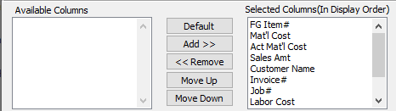

#### Available Columns

The user may choose which columns they wish to have on the report printout. As the user selects their choices, they will appear on the ‘*Selected Columns’* list.

#### Selected Columns (In Display Order)

The columns that the user has chosen from the ‘*Available Columns’* list. The order that these columns are displayed in here is the order in which they will print on the report.

#### Default

Click the ***“Default****”* button to sort the ‘*Selected Columns’* list by the default system parameters.

#### Add >>

Click on the selected item from the ‘*Available Columns’* list to highlight it, then click the ***“Add”*** button to add the selected column to the ‘*Selected Columns’* list.

#### << Remove

Click on the selected item from the ‘*Selected Columns’* list to highlight it, then click the ***“Remove”*** button to remove the selected column to the ‘*Selected Columns’* list.

#### Move Up

Within the ‘*Selected Columns’* list, the user may choose the order they wish the selected columns to print in. In order to change the order of the columns, the user can click on a selection to highlight it. By then clicking the ***“Move Up***” button, the user can change its position on the report.

#### Move Down

Within the ‘*Selected Columns’* list, the user may choose the order they wish the selected columns to print in. In order to change the order of the columns, the user can click on a selection to highlight it. By then clicking the ***“Move Down***” button, the user can change its position on the report.

### Output Destination

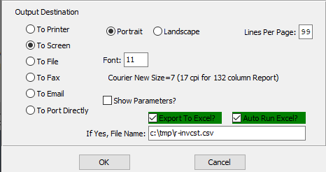

#### Destination Choice

To choose the destination where the document should be printed, please make sure that desired output destination choice bubble is toggled.

#### Layout Choice

To choose the preferred layout of Landscape vs. Portrait, please make sure the desired option choice bubble is toggled.

#### Lines Per Page

Lines per page on the report when printing.

#### Font

Enter the font number to use with this report (Font 11 is default).

#### Show Parameters? – Toggle Box

To show parameters, make sure that the toggle box is ‘ticked’ with a checkmark.

#### Export to Excel? – Toggle Box

To export the printed file to an excel document, make sure that the Export to Excel toggle box is checked.

#### Auto Run Excel? – Toggle Box

To automatically open the new excel document, make sure that the Auto Run Excel toggle box is checked.

#### If Yes, File Name

If exporting the file to Excel, enter the desired file name.

## Actual Release [OZ4]

The *Actual Release* screen will print a report for the user according to the parameters they set in this function.

### Selection Parameters

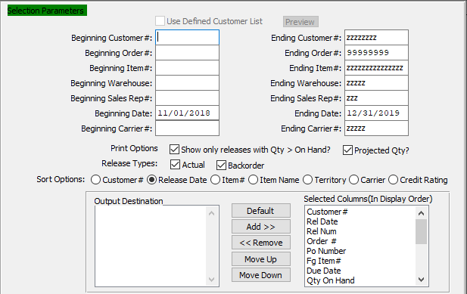

#### Beginning Customer # / Ending Customer #

Enter the beginning and ending customer number.

#### Beginning Order # / Ending Order #

Enter a starting and ending order number.

#### Beginning Item # / Ending Item #

Enter a starting and ending item number.

#### Beginning Warehouse / Ending Warehouse

Enter a starting and ending warehouse.

#### Beginning Sales Rep # / Ending Sales Rep #

Enter a starting and ending sales rep number.

#### Beginning Date / Ending Date

Enter a starting and ending date.

#### Beginning Carrier # / Ending Carrier #

Enter a starting and ending carrier number.

#### Show only Releases with Qty > On Hand? – Toggle Box

To show only releases with a quantity that is larger than the current on-hand numbers, make sure that this toggle box is checked.

#### Projected Qty? – Toggle Box

To print the projected quantity, make sure that the Projected Qty toggle box is checked.

#### Release Types: Actual – Toggle Box

To print actual releases, make sure that this toggle box is checked.

#### Release Types: Backorder – Toggle Box

To print backordered releases, make sure that this toggle box is checked.

#### Sort Options

To choose the preferred sort option of Customer Number vs. Release Date, please make sure the desired option choice bubble is toggled.

#### Output Destination

The user may choose which columns they wish to have on the report printout. As the user selects their choices, they will appear on the ‘*Selected Columns’* list.

#### Selected Columns (In Display Order)

The columns that the user has chosen from the ‘*Available Columns’* list. The order that these columns are displayed in here is the order in which they will print on the report.

#### Default

Click the ***“Default****”* button to sort the ‘*Selected Columns’* list by the default system parameters.

#### Add >>

Click on the selected item from the ‘*Available Columns’* list to highlight it, then click the ***“Add”*** button to add the selected column to the ‘*Selected Columns’* list.

#### << Remove

Click on the selected item from the ‘*Selected Columns’* list to highlight it, then click the ***“Remove”*** button to remove the selected column to the ‘*Selected Columns’* list.

#### Move Up

Within the ‘*Selected Columns’* list, the user may choose the order they wish the selected columns to print in. In order to change the order of the columns, the user can click on a selection to highlight it. By then clicking the ***“Move Up***” button, the user can change its position on the report.

#### Move Down

Within the ‘*Selected Columns’* list, the user may choose the order they wish the selected columns to print in. In order to change the order of the columns, the user can click on a selection to highlight it. By then clicking the ***“Move Down***” button, the user can change its position on the report.

### Available Columns

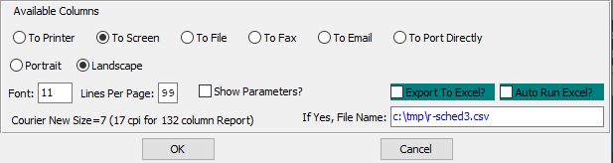

#### Destination Choice

To choose the destination where the document should be printed, please make sure that desired output destination choice bubble is toggled.

#### Layout Choice

To choose the preferred layout of Landscape vs. Portrait, please make sure the desired option choice bubble is toggled.

#### Lines Per Page

Lines per page on the report when printing.

#### Font

Enter the font number to use with this report (Font 11 is default).

#### Show Parameters? – Toggle Box

To show parameters, make sure that the toggle box is ‘ticked’ with a checkmark.

#### Export to Excel? – Toggle Box

To export the printed file to an excel document, make sure that the Export to Excel toggle box is checked.

#### Auto Run Excel? – Toggle Box

To automatically open the new excel document, make sure that the Auto Run Excel toggle box is checked.

#### If Yes, File Name

If exporting the file to Excel, enter the desired file name.

## Commission by Item Cost [OZ5]

The *Commission by Item Cost* screen will print a report for the user according to the parameters they set in this function.

### Selection Parameters

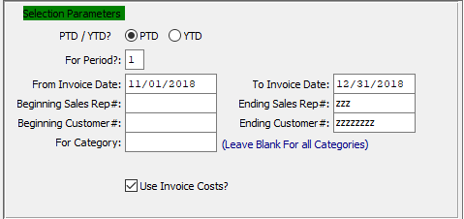

#### PTD / YTD?

To choose the preferred financial values of Period to Date vs. Year to Date, please make sure the desired option choice bubble is toggled.

#### For Period?

Choose the financial period to search through

#### From Invoice Date? / To Invoice Date?

Enter a starting and ending invoice date.

#### Beginning Sales Rep # / Ending Sales Rep #

Enter a starting and ending sales rep number.

#### Beginning Customer # / Ending Customer #

Enter the beginning and ending customer number.

#### For Category

If only searching for one category of item, enter it here.

Please Note: Leave this section blank to select all categories.

#### Use Invoice Costs? – Toggle Box

To use Invoice Costs for the commission, make sure that the Use Invoice Costs toggle box is checked.

### Available and Selected Commission Columns

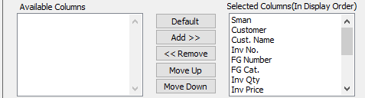

#### Available Columns

The user may choose which columns they wish to have on the report printout. As the user selects their choices, they will appear on the ‘*Selected Columns’* list.

#### Selected Columns (In Display Order)

The columns that the user has chosen from the ‘*Available Columns’* list. The order that these columns are displayed in here is the order in which they will print on the report.

#### Default

Click the ***“Default****”* button to sort the ‘*Selected Columns’* list by the default system parameters.

#### Add >>

Click on the selected item from the ‘*Available Columns’* list to highlight it, then click the ***“Add”*** button to add the selected column to the ‘*Selected Columns’* list.

#### << Remove

Click on the selected item from the ‘*Selected Columns’* list to highlight it, then click the ***“Remove”*** button to remove the selected column to the ‘*Selected Columns’* list.

#### Move Up

Within the ‘*Selected Columns’* list, the user may choose the order they wish the selected columns to print in. In order to change the order of the columns, the user can click on a selection to highlight it. By then clicking the ***“Move Up***” button, the user can change its position on the report.

#### Move Down

Within the ‘*Selected Columns’* list, the user may choose the order they wish the selected columns to print in. In order to change the order of the columns, the user can click on a selection to highlight it. By then clicking the ***“Move Down***” button, the user can change its position on the report.

### Output Destination

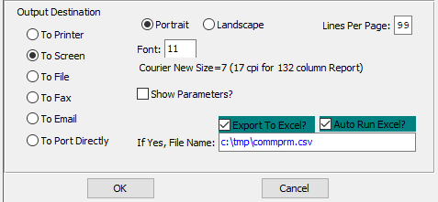

#### Destination Choice

To choose the destination where the document should be printed, please make sure that desired output destination choice bubble is toggled.

#### Layout Choice

To choose the preferred layout of Landscape vs. Portrait, please make sure the desired option choice bubble is toggled.

#### Lines Per Page

Lines per page on the report when printing.

#### Font

Enter the font number to use with this report (Font 11 is default).

#### Show Parameters? – Toggle Box

To show parameters, make sure that the toggle box is ‘ticked’ with a checkmark.

#### Export to Excel? – Toggle Box

To export the printed file to an excel document, make sure that the Export to Excel toggle box is checked.

#### Auto Run Excel? – Toggle Box

To automatically open the new excel document, make sure that the Auto Run Excel toggle box is checked.

#### If Yes, File Name

If exporting the file to Excel, enter the desired file name.

## Hots List by Release Number [OZ6]

The *Hots List by Release Number* screen will print a report for the user according to the parameters they set in this function.

### Selection Parameters

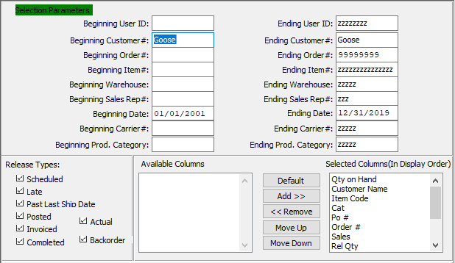

#### Beginning User ID / Ending User ID

Enter a starting and ending user ID.

#### Beginning Customer # / Ending Customer #

Enter the beginning and ending customer number.

#### Beginning Order # / Ending Order #

Enter a starting and ending order number.

#### Beginning Item # / Ending Item #

Enter a starting and ending item number.

#### Beginning Warehouse / Ending Warehouse

Enter a starting and ending warehouse.

#### Beginning Sales Rep # / Ending Sales Rep #

Enter a starting and ending sales rep number.

#### Beginning Date / Ending Date

Enter a starting and ending date.

#### Beginning Carrier # / Ending Carrier #

Enter a starting and ending carrier number.

#### Beginning Product Category / Ending Product Category

Enter a starting and ending product category.

#### Release Types – Toggle Box

To choose the preferred release types to print on the Hot List, please make sure the desired toggle boxes are checked.

#### Available Columns

The user may choose which columns they wish to have on the report printout. As the user selects their choices, they will appear on the ‘*Selected Columns’* list.

#### Selected Columns (In Display Order)

The columns that the user has chosen from the ‘*Available Columns’* list. The order that these columns are displayed in here is the order in which they will print on the report.

#### Default

Click the ***“Default****”* button to sort the ‘*Selected Columns’* list by the default system parameters.

#### Add >>

Click on the selected item from the ‘*Available Columns’* list to highlight it, then click the ***“Add”*** button to add the selected column to the ‘*Selected Columns’* list.

#### << Remove

Click on the selected item from the ‘*Selected Columns’* list to highlight it, then click the ***“Remove”*** button to remove the selected column to the ‘*Selected Columns’* list.

#### Move Up

Within the ‘*Selected Columns’* list, the user may choose the order they wish the selected columns to print in. In order to change the order of the columns, the user can click on a selection to highlight it. By then clicking the ***“Move Up***” button, the user can change its position on the report.

#### Move Down

Within the ‘*Selected Columns’* list, the user may choose the order they wish the selected columns to print in. In order to change the order of the columns, the user can click on a selection to highlight it. By then clicking the ***“Move Down***” button, the user can change its position on the report.

### Output Destination

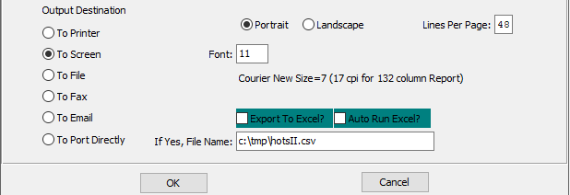

#### Destination Choice

To choose the destination where the document should be printed, please make sure that desired output destination choice bubble is toggled.

#### Layout Choice

To choose the preferred layout of Landscape vs. Portrait, please make sure the desired option choice bubble is toggled.

#### Lines Per Page

Lines per page on the report when printing.

#### Font

Enter the font number to use with this report (Font 11 is default).

#### Show Parameters? – Toggle Box

To show parameters, make sure that the toggle box is ‘ticked’ with a checkmark.

#### Export to Excel? – Toggle Box

To export the printed file to an excel document, make sure that the Export to Excel toggle box is checked.

#### Auto Run Excel? – Toggle Box

To automatically open the new excel document, make sure that the Auto Run Excel toggle box is checked.

#### If Yes, File Name

If exporting the file to Excel, enter the desired file name.

## Hots List by Open Order [OZ7]

The *Hots List by Open Order (Hots Report by Open Order)* screen will print a report for the user according to the parameters they set in this function.

### Selection Parameters

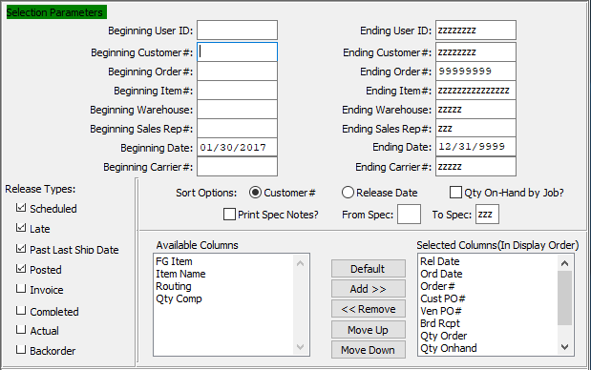

#### Beginning User ID / Ending User ID

Enter a starting and ending user ID.

#### Beginning Customer # / Ending Customer #

Enter the beginning and ending customer number.

#### Beginning Order # / Ending Order #

Enter a starting and ending order number.

#### Beginning Item # / Ending Item #

Enter a starting and ending item number.

#### Beginning Warehouse / Ending Warehouse

Enter a starting and ending warehouse.

#### Beginning Sales Rep # / Ending Sales Rep #

Enter a starting and ending sales rep number.

#### Beginning Date / Ending Date

Enter a starting and ending date.

#### Beginning Carrier # / Ending Carrier #

Enter a starting and ending carrier number.

#### Sort Options

To choose the preferred sort option of Customer Number vs. Release Date, please make sure the desired option choice bubble is toggled.

#### Print Spec Notes? – Toggle Box

To print spec notes on the Hot List, make sure that the Print Spec Notes toggle box is checked.

#### From Spec / To Spec

Enter a starting and ending spec code.

#### Release Types – Toggle Box

To choose the preferred release types to print on the Hot List, please make sure the desired toggle boxes are checked.

#### Available Columns

The user may choose which columns they wish to have on the report printout. As the user selects their choices, they will appear on the ‘*Selected Columns’* list.

#### Selected Columns (In Display Order)

The columns that the user has chosen from the ‘*Available Columns’* list. The order that these columns are displayed in here is the order in which they will print on the report.

#### Default

Click the ***“Default****”* button to sort the ‘*Selected Columns’* list by the default system parameters.

#### Add >>

Click on the selected item from the ‘*Available Columns’* list to highlight it, then click the ***“Add”*** button to add the selected column to the ‘*Selected Columns’* list.

#### << Remove

Click on the selected item from the ‘*Selected Columns’* list to highlight it, then click the ***“Remove”*** button to remove the selected column to the ‘*Selected Columns’* list.

#### Move Up

Within the ‘*Selected Columns’* list, the user may choose the order they wish the selected columns to print in. In order to change the order of the columns, the user can click on a selection to highlight it. By then clicking the ***“Move Up***” button, the user can change its position on the report.

#### Move Down

Within the ‘*Selected Columns’* list, the user may choose the order they wish the selected columns to print in. In order to change the order of the columns, the user can click on a selection to highlight it. By then clicking the ***“Move Down***” button, the user can change its position on the report.

### Output Destination

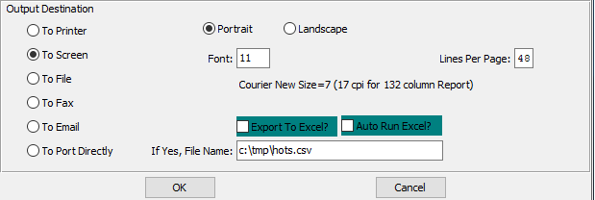

#### Destination Choice

To choose the destination where the document should be printed, please make sure that desired output destination choice bubble is toggled.

#### Layout Choice

To choose the preferred layout of Landscape vs. Portrait, please make sure the desired option choice bubble is toggled.

#### Lines Per Page

Lines per page on the report when printing.

#### Font

Enter the font number to use with this report (Font 11 is default).

#### Show Parameters? – Toggle Box

To show parameters, make sure that the toggle box is ‘ticked’ with a checkmark.

#### Export to Excel? – Toggle Box

To export the printed file to an excel document, make sure that the Export to Excel toggle box is checked.

#### Auto Run Excel? – Toggle Box

To automatically open the new excel document, make sure that the Auto Run Excel toggle box is checked.

#### If Yes, File Name

If exporting the file to Excel, enter the desired file name.

## Hots List2 by Open Order [OZ8]

The *Hots List2 by Open Order (Open Jobs Hot List)* screen will print a report for the user according to the parameters they set in this function.

### Selection Parameters

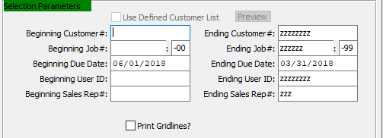

#### Used Defined Customer List – Toggle Box

To use a User Defined Customer List, make sure that this toggle box is checked.

#### Beginning Customer # / Ending Customer #

Enter the beginning and ending customer number.

#### Beginning Job # / Ending Job #

Enter a starting and ending job number.

#### Beginning Due Date / Ending Due Date

Enter a starting and ending due date.

#### Beginning User ID / Ending User ID

Enter a starting and ending user ID.

#### Beginning Sales Rep # / Ending Sales Rep #

Enter a starting and ending sales rep number.

#### Print Gridlines – Toggle Box

To print gridlines on the Hot List, make sure that the Print Gridlines toggle box is checked.

### Available and Selected Job Columns

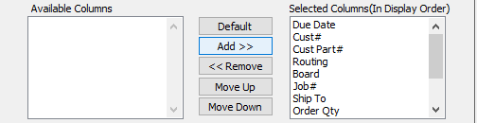

#### Available Columns

The user may choose which columns they wish to have on the report printout. As the user selects their choices, they will appear on the ‘*Selected Columns’* list.

#### Selected Columns (In Display Order)

The columns that the user has chosen from the ‘*Available Columns’* list. The order that these columns are displayed in here is the order in which they will print on the report.

#### Default

Click the ***“Default****”* button to sort the ‘*Selected Columns’* list by the default system parameters.

#### Add >>

Click on the selected item from the ‘*Available Columns’* list to highlight it, then click the ***“Add”*** button to add the selected column to the ‘*Selected Columns’* list.

#### << Remove

Click on the selected item from the ‘*Selected Columns’* list to highlight it, then click the ***“Remove”*** button to remove the selected column to the ‘*Selected Columns’* list.

#### Move Up

Within the ‘*Selected Columns’* list, the user may choose the order they wish the selected columns to print in. In order to change the order of the columns, the user can click on a selection to highlight it. By then clicking the ***“Move Up***” button, the user can change its position on the report.

#### Move Down

Within the ‘*Selected Columns’* list, the user may choose the order they wish the selected columns to print in. In order to change the order of the columns, the user can click on a selection to highlight it. By then clicking the ***“Move Down***” button, the user can change its position on the report.

### Output Destination

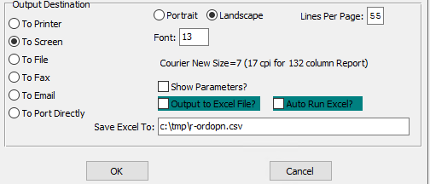

#### Destination Choice

To choose the destination where the document should be printed, please make sure that desired output destination choice bubble is toggled.

#### Layout Choice

To choose the preferred layout of Landscape vs. Portrait, please make sure the desired option choice bubble is toggled.

#### Lines Per Page

Lines per page on the report when printing.

#### Font

Enter the font number to use with this report (Font 11 is default).

#### Show Parameters? – Toggle Box

To show parameters, make sure that the toggle box is ‘ticked’ with a checkmark.

#### Export to Excel? – Toggle Box

To export the printed file to an excel document, make sure that the Export to Excel toggle box is checked.

#### Auto Run Excel? – Toggle Box

To automatically open the new excel document, make sure that the Auto Run Excel toggle box is checked.

#### If Yes, File Name

If exporting the file to Excel, enter the desired file name.

## Order Balance by PO / Job [OZ9]

The *Order Balance by PO* screen will print a report for the user according to the parameters they set in this function.

### Selection Parameters

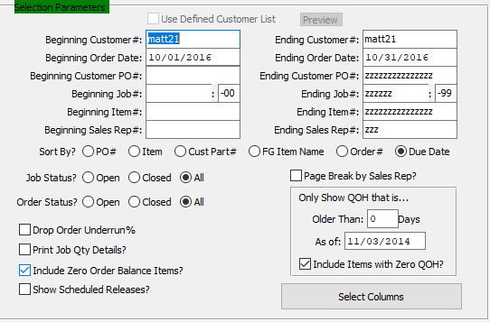

#### Used Defined Customer List – Toggle Box

To use a User Defined Customer List, make sure that this toggle box is checked.

#### Beginning Customer # / Ending Customer #

Enter the beginning and ending customer number.

#### Beginning Order Date / Ending Order Date

Enter a starting and ending order date.

#### Beginning Customer PO # / Ending Customer PO #

Enter the beginning and ending customer PO number.

#### Beginning Job # / Ending Job #

Enter a starting and ending job number.

#### Beginning Item # / Ending Item #

Enter a starting and ending item number.

#### Beginning Sales Rep # / Ending Sales Rep #

Enter a starting and ending sales rep number.

#### Sort By? (Choice)

To choose the preferred sorting option of the order balances, please make sure the desired option choice bubble is toggled.

#### Job Status (Choice)

To choose the preferred Job Status of Open vs. Closed (Or All statuses), please make sure the desired option choice bubble is toggled.

#### Order Status (Choice)

To choose the preferred order status of Open vs. Closed (Or All), please make sure the desired option choice bubble is toggled.

#### Drop Order Underrun % – Toggle Box

To drop the order underrun percentage, make sure that this toggle box is checked.

#### Print Job Qty Details? – Toggle Box

To print the job quantity details, make sure that the Print Job Qty Details toggle box is checked.

#### Include Zero Order Balance Items? – Toggle Box

To include zero order balance items, make sure that this toggle box is checked.

#### Show Scheduled Releases? – Toggle Box

To show scheduled releases, make sure that the Show Scheduled Releases toggle box is checked.

#### Page Break by Sales Rep? – Toggle Box

To page break by sales representative, make sure that this toggle box is checked.

#### Only Show QOH that is… (Older Than)

Enter an amount of days.

#### Only Show QOH that is… (As of: )

Enter a date to show quantity on hand.

#### Only Show QOH that is… Include Items with Zero QOH? – Toggle Box

To include items with no quantity on hand, make sure that this toggle box is checked.

### Output Destination

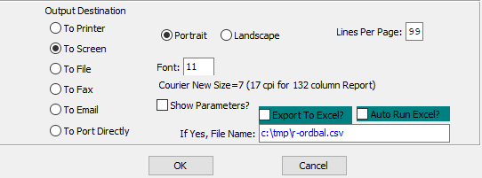

#### Destination Choice

To choose the destination where the document should be printed, please make sure that desired output destination choice bubble is toggled.

#### Layout Choice

To choose the preferred layout of Landscape vs. Portrait, please make sure the desired option choice bubble is toggled.

#### Lines Per Page

Lines per page on the report when printing.

#### Font

Enter the font number to use with this report (Font 11 is default).

#### Show Parameters? – Toggle Box

To show parameters, make sure that the toggle box is ‘ticked’ with a checkmark.

#### Export to Excel? – Toggle Box

To export the printed file to an excel document, make sure that the Export to Excel toggle box is checked.

#### Auto Run Excel? – Toggle Box

To automatically open the new excel document, make sure that the Auto Run Excel toggle box is checked.

#### If Yes, File Name

If exporting the file to Excel, enter the desired file name.

## Sq. Ft Totals Shipped [OZ)]

The *Square Foot Totals Shipped* will print a report for the user according to the parameters they set in this function.

### Selection Parameters

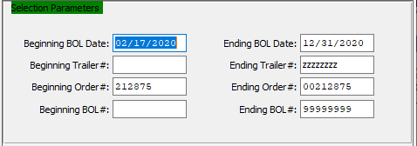

#### Beginning BOL Date

Enter a starting bill of lading date.

#### Ending BOL Date

Enter an ending bill of lading date.

#### Beginning Trailer #

Enter a starting trailer number.

#### Ending Trailer #

Enter an ending trailer number.

#### Beginning Order #

Enter a starting order number.

#### Ending Order #

Enter an ending order number.

#### Beginning BOL #

Enter a starting bill of lading number.

#### Ending BOL #

Enter an ending bill of lading number.

### Available and Selected Total Columns

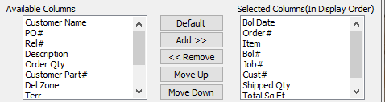

#### Available Columns

The user may choose which columns they wish to have on the report printout. As the user selects their choices, they will appear on the ‘*Selected Columns’* list.

#### Selected Columns (In Display Order)

The columns that the user has chosen from the ‘*Available Columns’* list. The order that these columns are displayed in here is the order in which they will print on the report.

#### Default

Click the ***“Default****”* button to sort the ‘*Selected Columns’* list by the default system parameters.

#### Add >>

Click on the selected item from the ‘*Available Columns’* list to highlight it, then click the ***“Add”*** button to add the selected column to the ‘*Selected Columns’* list.

#### << Remove

Click on the selected item from the ‘*Selected Columns’* list to highlight it, then click the ***“Remove”*** button to remove the selected column to the ‘*Selected Columns’* list.

#### Move Up

Within the ‘*Selected Columns’* list, the user may choose the order they wish the selected columns to print in. In order to change the order of the columns, the user can click on a selection to highlight it. By then clicking the ***“Move Up***” button, the user can change its position on the report.

#### Move Down

Within the ‘*Selected Columns’* list, the user may choose the order they wish the selected columns to print in. In order to change the order of the columns, the user can click on a selection to highlight it. By then clicking the ***“Move Down***” button, the user can change its position on the report.

### Output Destination

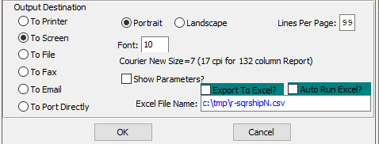

#### Destination Choice

To choose the destination where the document should be printed, please make sure that desired output destination choice bubble is toggled.

#### Layout Choice

To choose the preferred layout of Landscape vs. Portrait, please make sure the desired option choice bubble is toggled.

#### Lines Per Page

Lines per page on the report when printing.

#### Font

Enter the font number to use with this report (Font 11 is default).

#### Show Parameters? – Toggle Box

To show parameters, make sure that the toggle box is ‘ticked’ with a checkmark.

#### Export to Excel? – Toggle Box

To export the printed file to an excel document, make sure that the Export to Excel toggle box is checked.

#### Auto Run Excel? – Toggle Box

To automatically open the new excel document, make sure that the Auto Run Excel toggle box is checked.

#### If Yes, File Name

If exporting the file to Excel, enter the desired file name.

# **File Maintenance for Orders [OF]**

## Order Entry Control [OF2]

When utilizing the order processing system, the control file sets defaults such as the starting order, invoice, receiving ticket and Bill of Lading numbers. Many user defined switches / flags particular to your company may be defined in this file so that desired results are achieved.

For example, you have the option of reducing inventory levels either at Bill of Lading or invoicing time. Credit control flags prevent processing credit held orders and tax flags define tax status for prep and freight charges.

#### UPDATE

Click the ***“Update”*** button to update the Order Processing Control hold actions.

#### CLOSE

Click the ***“Close”*** button exit the Order Entry Control popup screen.

#### SAVE

Click the ***“Save”*** button save all changes.

#### CANCEL

Click the ***“Cancel”*** button exit making changes without saving.

### Processing Numbers

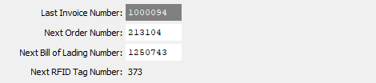

#### Last Invoice Number

This number is not changeable.

#### Next Order Number

This number becomes the order number when an order is added. As an alternative, the order number may be manually typed in to override the computer-generated order number. To activate this option, press “***ALT”*** and ***"O"***. When the add mode, this feature is very useful when converting from another software package.

#### Next Bill of Lading Number

This number becomes the Bill of Lading number when a Bill of Lading is added.

#### Next RFID Tag Number

The user may enter their choice of the next RFID Tag number.

### When Order is on Hold

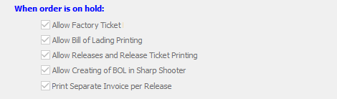

#### Allow Factory Ticket – Toggle Box

To allow the job / factory ticket to print if the customer is on credit hold, make sure that the toggle box is ‘checked’.

#### Allow Bill of Lading Printing – Toggle Box

To allow the Bill of Lading to be processed if the customer is on credit hold, make sure that the toggle box is ‘checked’.

#### Allow Releases and Release Ticket Printing – Toggle Box

To allow the release to be processed if the customer is on credit hold, make sure that the toggle box is ‘checked’. If no is chosen and if the customer is over their credit limit, the ticket will not print.

#### Allow Creating of BOL in Sharp Shooter – Toggle Box

To allow the Bill of Lading to be created in Sharp Shooter, make sure that the toggle box is ‘checked’.

#### Print Separate Invoice per Release – Toggle Box

To print a separate invoice for each release, make sure that the toggle box is ‘checked’.

### Order Hold Tests

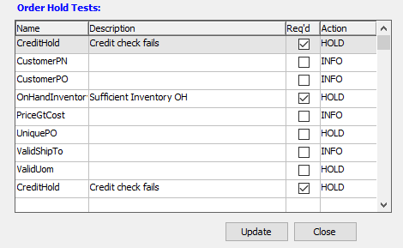

#### Req’d

In order to get an order out of a credit hold, the user must decide which tests an order must go through. To choose tests, please make sure that their individual toggle boxes are checked. The user can choose as many tests as they wish.

## Sales Price Matrix [OF3]

### Overview

Finished Goods that are sold to more than one customer are called stock items. Stock Items must be coded as ***"S"*** type item codes in the Finished Goods file. The sales price for Stock Items are transferred from the Finished Goods record or from the Stock Item matrix, which allows special pricing or discounting by customer, customer type, product category and item.

The Stock Item price matrix may be defined by price or discount. If discounting is used, the sell price in the Finished Goods file will be used as a list price for calculating the net discounted sell price. If a sell price is defined in the Stock Item matrix, the matrix's sell price is used.

The priority for determining the Stock Item price is as follows:

|  |  |
| --- | --- |
| A | Price by Customer/Item |
| B | Price by Customer by Category |
| C | Price by Customer Type by Item |
| D | Price by Customer Price by Product Category |
| E | Sell Price in the Finished Goods file |

The system will search through the matrix file in ascending order to find a sell price.

For example, part number: Flower Box has a sell price of $100 per case in the Finished Goods file and a sell price of $80 per case in the Stock Item matrix defined for Customer XYZ. No other matrixes are defined. Whenever any customer other than XYZ company ordered Flower boxes, the price would be $100 per case, however when XYZ ordered Flower Boxes, the sell price would be $80.

Obviously, we could also define a price for specific customer types: For example, we could define customer types as Jobbers, House, and Retail so that each customer type would receive different discounts for the Flower Box. Jobbers get 20% off, Retail 5% and House 10%.

Please Note: Each customer in the Accounts Receivable file must have a customer type defined first. Suppose XYZ company was a House Account. Since we search the price matrix by customer/item, the system would find his $80 per case, however, all other House Accounts would pay $90 per case. ($100 less 10%).

When using the Stock Item matrix, we recommend using the discount method for ease of maintenance, since changing only the sell price in the Finished Goods file will change customers pricing defined in the matrix. If you use the pricing method, each price matrix defined, must be modified separately.

### Browse

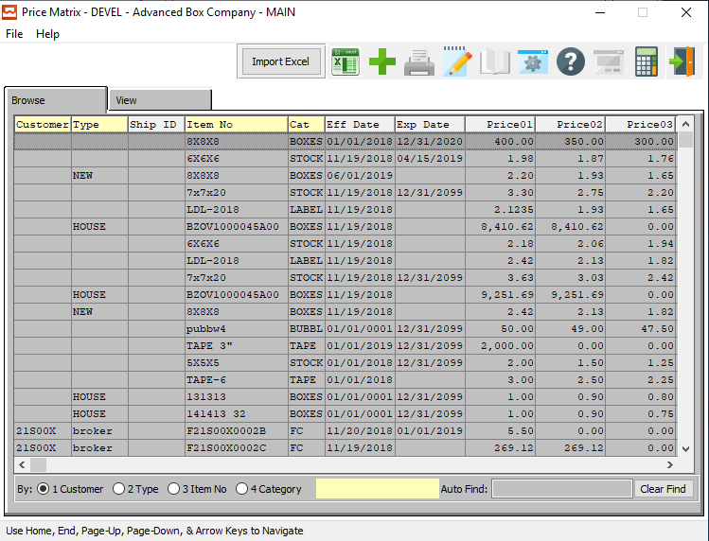

#### IMPORT EXCEL

Click on the ***“Import Excel”*** button to choose an excel file of an item to import into the system.

### View

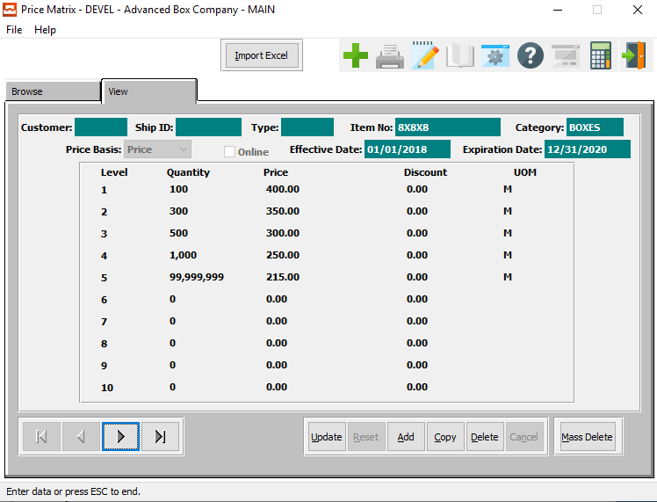

#### IMPORT EXCEL

Click on the ***“Import Excel”*** button to choose an excel file of an item to import into the system.

#### UPDATE

Click the ***“Update”*** button to update the current price matrix.

#### ADD

Click the ***“Add”*** button to add a new price matrix.

#### COPY

Click the ***“Copy”*** button to copy information from the current price matrix.

#### DELETE

Click the ***“Delete”*** button to delete the current price matrix.

#### MASS DELETE

Click the ***“Mass Delete”*** button to delete multiple price matrixes.

#### NEXT

Press ***"N"*** (Next) to find next Price Matrix to view or modify. Alternatively, press the ***“Right Arrow”*** on the screen.

#### PREVIOUS

Press ***"P"*** (Previous) to find previous Price Matrix to view or modify. Alternatively, press the ***“Left Arrow”*** on the screen.

### Update Price Matrix

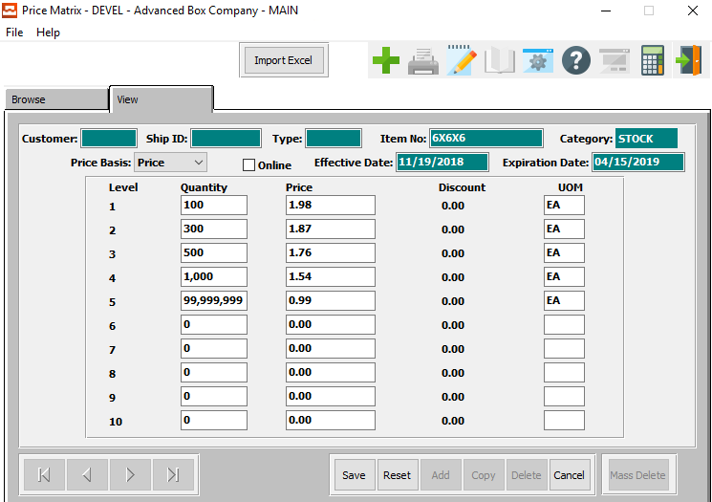

#### IMPORT EXCEL

Click on the ***“Import Excel”*** button to choose an excel file of an item to import into the system.

#### SAVE

Click the ***“Save”*** button to save the updates to the Price Matrix.

#### RESET

Click the ***“Reset”*** button to reset all fields to their original state.

#### CANCEL

Click the ***“Cancel”*** button to cancel the updates to the Price Matrix without saving.

#### NEXT

Press ***"N"*** (Next) to find next Price Matrix to view or modify. Alternatively, press the ***“Right Arrow”*** on the screen.

#### PREVIOUS

Press ***"P"*** (Previous) to find previous Price Matrix to view or modify. Alternatively, press the ***“Left Arrow”*** on the screen.

### Add Price Matrix

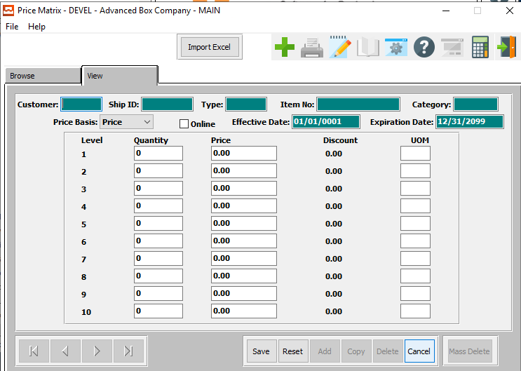

#### IMPORT EXCEL

Click on the ***“Import Excel”*** button to choose an excel file of an item to import into the system.

#### SAVE

Click the ***“Save”*** button to save the new Price Matrix.

#### RESET

Click the ***“Reset”*** button to reset all fields.

#### CANCEL

Click the ***“Cancel”*** button to cancel the new Price Matrix without saving.

### Add/Update Price Matrix Field Definitions

#### Customer #

To define special pricing for a specific customer, enter the customer number. To search for a customer, press “***F1”*** or the ***“Page Up”*** / ***“Page Down”*** keys. Once entered, the customer name, address, city, state, zip and salesman will transfer to the estimate.

#### Ship ID

The ship ID for this customer.

#### Type

Enter the customers type from the customer type file in Accounts Receivable to define special pricing by Finished Goods Product category. Press ***“F1”*** to search.

#### Item #

The item will transfer from the order file. To find an item for this order, press “***F1”*** or the ***“Page Up”*** / ***“Page Down”*** keys. Once an item is selected, a ship quantity may be added for each tag number or a total ship quantity may be entered.

#### Category

The product category description defaults from the product category file in Finished Goods file.

#### Price Basis

If the price basis is set to ***“Price”***, the user can change the price for each level of the price matrix.

If the price basis is set to ***“Discount”***, the user can change the discount percentage for each level of the price matrix.

#### Online – Toggle Box

If this price matrix is available online, make sure that this toggle box is checked.

#### Effective Date

The date that this price matrix goes into effect for this particular item.

#### Expiration Date

The date that this price matrix will expire for this particular item.

#### Quantity

Enter the quantity level for this price.

Please Note: Make sure the quantity entered is for the appropriate selling price unit of measure.

#### Price

Enter the sell price for this quantity level.

Please Note: Make sure the price entered is for the appropriate selling price unit of measure.

#### UOM

The sell price unit of measure defaults to M for per thousand, however this may be modified. Each unit of measure will yield a different total selling price.

Valid Units of Measure are:

|  |  |
| --- | --- |
| C | Per Hundred |
| CS | Per Case |
| EA | Per Each |
| L | Per Lot |
| M | Per Thousand |

## Global Price Increase [OF4]

The *Global Price Matrix Change* screen allows a user to quickly change the percentage rate of a price or discount for customers or items.

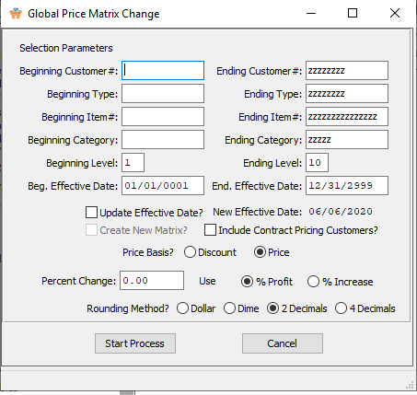

### Global Price Increase Field Definitions

#### Beginning Customer #

Enter starting customer number.

#### Ending Customer #

Enter ending customer number.

#### Beginning Type

Enter starting price type.

#### Ending Type

Enter ending price type.

#### Beginning Item

Enter starting item number.

#### Ending Item

Enter ending item number.

#### Beginning Category

Enter starting price category.

#### Ending Category

Enter ending price category.

#### Beginning Level

Enter starting level.

#### Ending Level

Enter ending level.

#### Beginning Effective Date

Enter starting effective date.

#### Ending Effective Date

Enter ending effective date.

#### Update Effective Date – Toggle Box

If the user chooses to update the effective date, please make sure the toggle box is ‘checked’.

#### New Effective Date

This field will become changeable if the user has checked the Update Effective Date toggle box.

#### Create New Matrix? – Toggle Box

If the user chooses to create a new matrix, please make sure the toggle box is ‘checked’.

#### Include Contract Pricing Customers? – Toggle Box

If the user chooses to include contract pricing customers, please make sure the toggle box is ‘checked’.

#### Price Basis

To choose the preferred price basis of Discount vs. Price, please make sure the desired option choice bubble is toggled.

#### Percent Change

Enter the desired percent change.

#### Use (Choice)

To choose the preferred use of the percent change of Profit vs. Increase, please make sure the desired option choice bubble is toggled.

#### Rounding Method?

To choose the preferred rounding method, please make sure the desired option choice bubble is toggled.

## Copy Order [OF5]

The *Copy Order* function allows a user the option to copy all information about an order from one customer to another in one simple process.

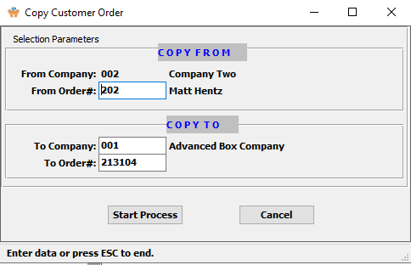

#### From Order #

Enter the starting order number.

#### To Company

Enter the company number you wish to copy the order to.

#### To Order #

Enter the order number you wish to copy the order to.

## Misc. Surcharges [OF6]

### Overview

The Miscellaneous Surcharges may be updated via the “***O”-“F”-“6”*** menu. They provide the ability to automatically invoice for charges such as a fuel charges to reflect the increase in gasoline costs for delivery. The charge may apply to specific customers or to all customers and may be applied as a flat charge per invoice or a flat charge per bill of lading delivery or as a percentage of sales and tax value. There are three options listed:

Valid Options are as follows:

|  |
| --- |
| Sales Value + Tax |
| Flat Dollar per Invoice |
| Flat Dollar per Bill of Lading |

#### Sales Value + Tax

If the value is "Sales value + Tax" the valid figure in the amount field is decimal only.

This will trigger a markup percentage times the Invoice (total dollars + tax) for each finished goods product category that is defined as FUEL CHARGE. If customer code exists in the Misc. Surcharge File, then the Fuel Charge will be added to all Invoices for that customer at the percentage defined for that MISC Fuel Charge. If customer code does not exist in the Misc. Surcharge File, then the percentage will be added to all invoices for all customers.

For categories without the MISC CHARGE such as DIES or RESAL, the markup would not apply. The description of the Misc. Surcharge Charge will print on the Invoice form at the bottom of the invoice above the Non-Taxable Subtotal. The new Misc. Surcharge will be added to the invoice totals.

#### Flat Dollar per Invoice

The valid figure in the amount field is at least $1.00.

The flat charge is always applied to each invoice regardless of how the billing method is set in the customer file (i.e. invoice per PO, or invoice per BOL or batch invoices).

#### Flat Dollar per Bill of Lading

If the value is " Flat dollar per Bill of Lading ", then the valid figure in the amount field is at least $1.00.

This provides the option to bill a flat surcharge by Bill of Lading regardless of how the billing method is set in the customer file (i.e. invoice per PO, or invoice per BOL or batch invoices). If the charge is per BOL, if there are multiple invoices on the bill of lading, the flat surcharge will be applied to the first invoice only.

#### Finished Goods Categories

The Add MISC Surcharge must be added to the finished goods product categories file.

### Browse

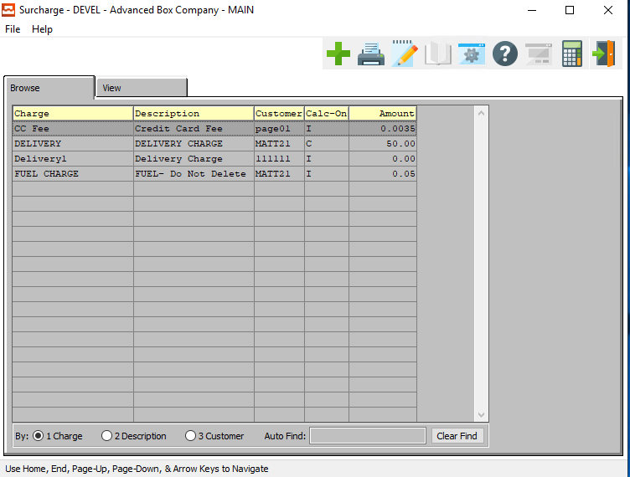

#### ADD

Click the ***“Green + Icon”*** to add a new miscellaneous surcharge.

### View

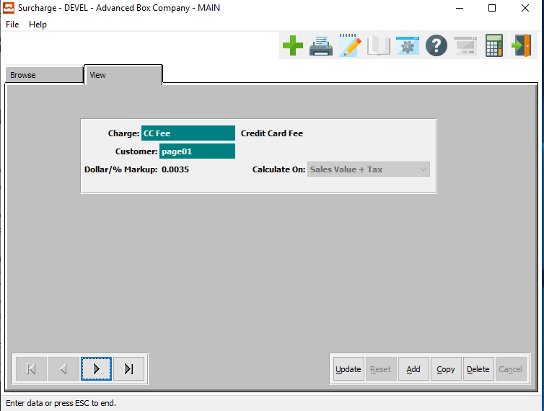

#### UPDATE

Click the ***“Update”*** button to update the current surcharge.

#### ADD

Click the ***“Add”*** button to add a new surcharge.

#### COPY

Click the ***“Copy”*** button to copy the information from the current surcharge.

#### DELETE

Click the ***“Delete”*** button to delete the current surcharge.

#### NEXT

Press ***"N"*** (Next) to find next surcharge to view or modify. Alternatively, press the ***“Right Arrow”*** on the screen.

#### PREVIOUS

Press ***"P"*** (Previous) to find previous surcharge to view or modify. Alternatively, press the ***“Left Arrow”*** on the screen.

### Add/Update Surcharge

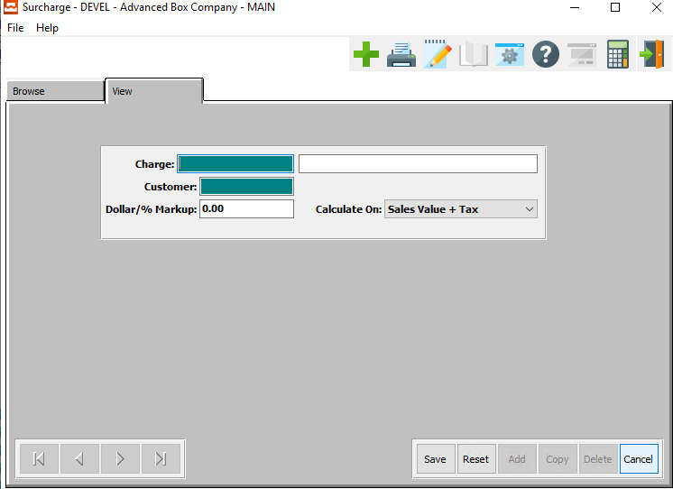

#### SAVE

Click the ***“Save”*** button to save the new surcharge.

#### RESET

Click the ***“Reset”*** button to reset all fields.

#### CANCEL

Click the ***“Cancel”*** button to cancel the new surcharge.

### Add/Update Surcharge Field Definitions

#### Charge

The charge code is a combination of the estimating prep charges as well as miscellaneous sub-contract charges which were defined in the estimate as billable charges.

Please Note: The SIMON code on the estimate must be set to ***"S"*** for separate billable charge so that the charges will transfer automatically. Additional charges may be added by simple typing a new charge code and cost. The ***“F1”*** key will also provide a pop-up window for defined prep codes for transferring to the order. The charge codes will be billed with the first invoice for this order. If commissions are to be paid on miscellaneous charges, the order processing control file must set the flag to ***"Y"*** for yes to pay commissions of prep charges.

#### Customer Name

Enter the customer’s name.

#### Dollar / % Markup

The user may enter the percentage of the markup they wish to charge the customer.

#### Calculate On

The user can select what they wish the dollar/% markup to calculate on for this surcharge.

Valid Calculation codes are as follows:

|  |
| --- |
| Sales Value + Tax |
| Flat Charge per Invoice |
| Flat Charge per BOL |

## Comm Cost by Item [OF7]

The *Comm Cost by Item* screen allows a user to see detailed cost percentage reports for items. It also allows a user to change costs and percentage levels for items, and add new item cost detail information.

### Browse Costs

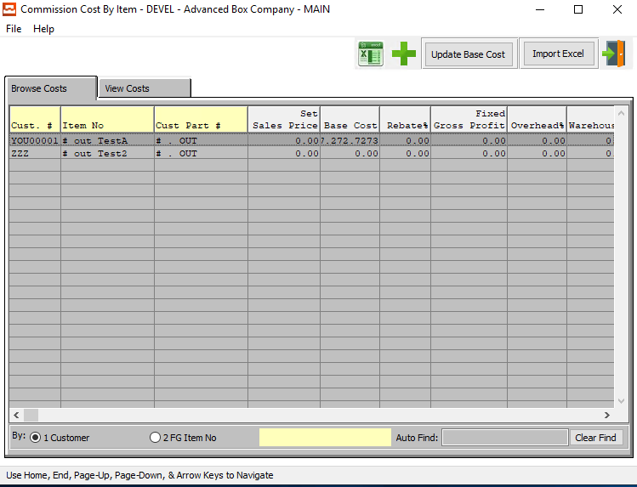

#### ADD

Click the ***“Green + Icon”*** to add a new cost.

#### UPDATE BASE COAT

Click on the ***“Update Base Cost”*** button to set all Base Cost from FG Item Average Cost. This will update the base cost column of the selected item.

#### IMPORT EXCEL

Click on the ***“Import Excel”*** button to choose an excel file of an item to import into the system.

#### EXIT

Click the ***“Exit Door Icon”*** to exit the Comm Cost by Item screen.

### View Costs

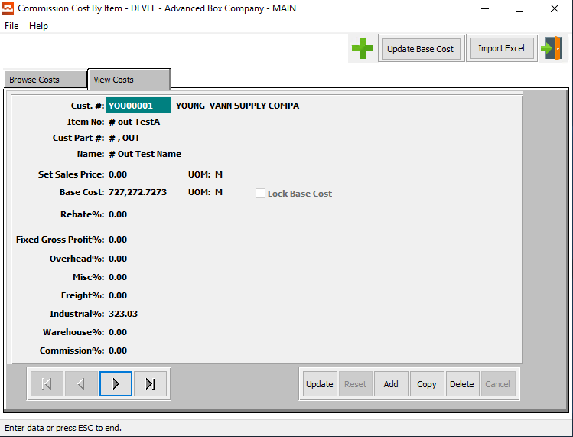

#### UPDATE BASE COAT

Click on the ***“Update Base Cost”*** button to set all Base Cost from FG Item Average Cost. This will update the base cost column of the selected item.

#### IMPORT EXCEL

Click on the ***“Import Excel”*** button to choose an excel file of an item to import into the system.

#### EXIT

Click the ***“Exit Door Icon”*** to exit the View Cost screen.

#### UPDATE

Click the ***“Update”*** button to update the current cost.

#### ADD

Click the ***“Add”*** button to a new cost. Alternatively, click the ***“Green + Icon”.***

#### COPY

Click the ***“Copy”*** button to copy the current cost.

#### DELETE

Click the ***“Delete”*** button to delete the current cost.

### Add/Update Commission Cost

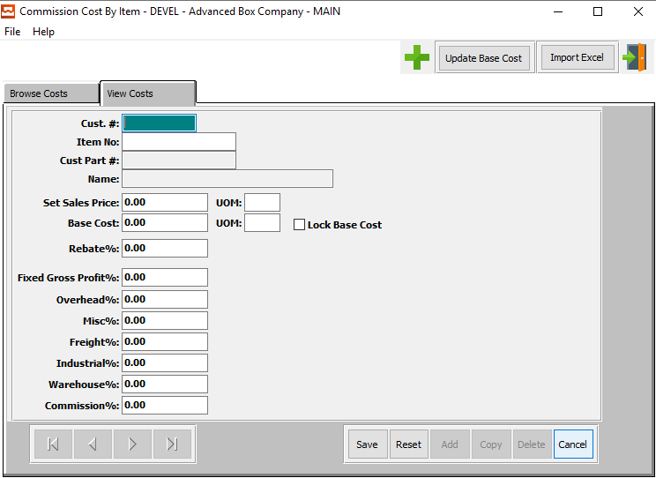

#### ADD

Click the ***“Green + Icon”*** to add a new cost.

#### UPDATE BASE COAT

Click on the ***“Update Base Cost”*** button to set all Base Cost from FG Item Average Cost. This will update the base cost column of the selected item.

#### IMPORT EXCEL

Click on the ***“Import Excel”*** button to choose an excel file of an item to import into the system.

#### EXIT

Click the ***“Exit Door Icon”*** to exit the Add/Update Comm Cost screen.

#### SAVE

Click the “***Save”*** button to add the new commission cost.

#### RESET

Click the ***“Reset”*** button to reset all fields.

#### CANCEL

Click the “***Cancel”*** button to cancel the new commission cost without saving.

### Add/Update Commission Cost Field Definitions

#### Customer #

Enter a unique customer number. The customer name, address, city, state, zip, salesman, common carrier and delivery zone will transfer to Estimating, Order Entry, and Accounts Receivable modules. When entering an order, for this estimate, this information would transfer to the items record so that customer, inventory reporting, and sales analysis are available.

#### Item Number

The item will transfer from the order file. To find an item for this order, press “***F1”*** or the ***“Page Up”*** / ***“Page Down”*** keys. Once an item is selected, a ship quantity may be added for each tag number or a total ship quantity may be entered.

#### Customer Part #

This is your customer's part number for this item. This should be entered on all estimates. However, it is mandatory for tandem runs, two-piece box estimates and combination jobs. The system looks at the customer part number in order to calculate the cost of each item based on the blank square inches as a percentage of the total square inches of all items on a form/sheet.

For example, to combine costs for an item located on multiple forms on a combo, the system adds the cost of an item on each form to calculate the total cost of the item. When an order for an estimate is entered, the customer part number will become the Finished Good's item number unless it is modified. Alpha numeric look ups by part number throughout the system are available to find this item or estimate.

#### Part Name

The description transfers from the Finished Goods file for Stock Items, but will transfer from the estimate if no item exists. For orders from estimates, the description entered here will transfer to the Finished Good's item record. The item name provides alpha numeric search capability throughout the system.

#### Set Sales Price

Enter the sell price per unit of measure.

#### UOM (Sales Price)

The sell price unit of measure defaults to M for per thousand, however this may be modified. Each unit of measure will yield a different total selling price.

Valid Units of Measure are:

|  |  |
| --- | --- |
| C | Per Hundred |
| CS | Per Case |
| EA | Per Each |
| L | Per Lot |
| M | Per Thousand |

#### Base Cost

The items cost is always per thousand. The standard factory cost for direct labor, material and overhead are automatically calculated for each order from an estimate. However, Stock Item's cost default from the Finished Goods file. For each order from an estimate, the standard cost is transferred to the item's job file for later comparison to actual costs for that job. The weighted average cost of quantities on hand is based on all jobs received for that item and is displayed in the item file as the average standard cost. The standard labor and overhead cost are calculated on either the machine standards defined on the estimate or the machine speeds defined in the machine standards file.

#### UOM (Base Cost)

The sell price unit of measure defaults to M for per thousand, however this may be modified. Each unit of measure will yield a different total selling price.

Valid Units of Measure are:

|  |  |
| --- | --- |
| C | Per Hundred |
| CS | Per Case |
| EA | Per Each |
| L | Per Lot |
| M | Per Thousand |

#### Lock Base Cost – Toggle Box

In order to lock the base cost of this item, make sure that the toggle box is ‘checked’.

#### Rebate %

The rebate percentage defined on the order will automatically transfer, but may be modified for each order. The rebate can be set by customer, customer type and product category and may be calculated on the selling price or gross profit as defined in the salesman matrix file.

#### Fixed Gross Profit %

The fixed gross profit percentage defined on the order will automatically transfer, but may be modified for each order. The fixed gross profit can be set by customer, customer type and product category and may be calculated on the selling price or gross profit as defined in the salesman matrix file.

#### Overhead %

The overhead percentage defined on the order will automatically transfer, but may be modified for each order. The overhead can be set by customer, customer type and product category and may be calculated on the selling price or gross profit as defined in the salesman matrix file.

#### Miscellaneous %

The miscellaneous percentage defined on the order will automatically transfer, but may be modified for each order. The miscellaneous can be set by customer, customer type and product category and may be calculated on the selling price or gross profit as defined in the salesman matrix file.

#### Freight %

The freight percentage defined on the order will automatically transfer, but may be modified for each order. The freight can be set by customer, customer type and product category and may be calculated on the selling price or gross profit as defined in the salesman matrix file.

#### Industrial %

The industrial percentage defined on the order will automatically transfer, but may be modified for each order. The industrial can be set by customer, customer type and product category and may be calculated on the selling price or gross profit as defined in the salesman matrix file.

#### Warehouse %

The warehouse percentage defined on the order will automatically transfer, but may be modified for each order. The warehouse can be set by customer, customer type and product category and may be calculated on the selling price or gross profit as defined in the salesman matrix file.

#### Commission %

The commission percentage defined on the order will automatically transfer, but may be modified for each order. The commission can be set by customer, customer type and product category and may be calculated on the selling price or gross profit as defined in the salesman matrix file.

## Import Order [OF8]

The *Import Order* system allows a user to import an order from an existing file, rather than entering information manually via the Add Order system. This program allows for importing of orders through a .csv file.

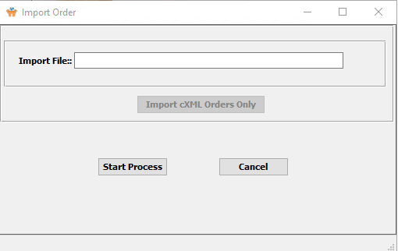

#### Import File

Enter the correct path of the order file you wish to import.

#### START PROCESS

Click the ***“Start Process”*** button begin the file importation process.

#### CANCEL

Click the ***“Cancel”*** button to cancel the file import.

## Date Change Reasons [OF9]

The *Date Change Reason* system allows a user to define their own reasons for making date changes to orders.

### Browse Reason

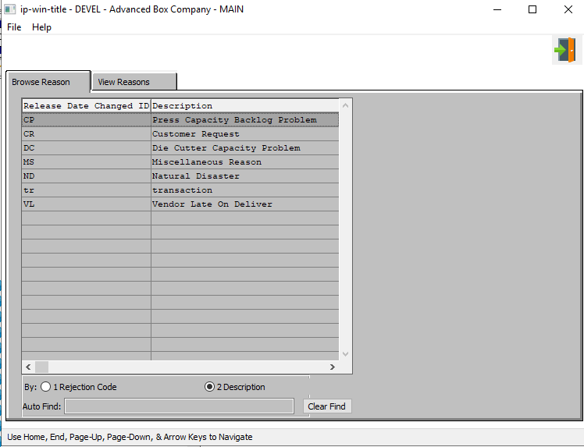

#### EXIT

Click the ***“Exit Door Icon”*** to exit the data change reason popup screen.

### View Reasons

#### 

#### UPDATE

Click the ***“Update”*** button to update the description field of the release date change reason.

#### ADD

Click the ***“Add”*** button to add a new reason.

#### COPY

Click the ***“Copy”*** button to copy the current reason.

#### DELETE

Click the ***“Delete”*** button to delete the current reason.

#### NEXT

Press ***"N"*** (Next) to find next reason to view or modify. Alternatively, press the ***“Right Arrow”*** on the screen.

#### PREVIOUS

Press ***"P"*** (Previous) to find previous reason to view or modify. Alternatively, press the ***“Left Arrow”*** on the screen.

### Update Reason

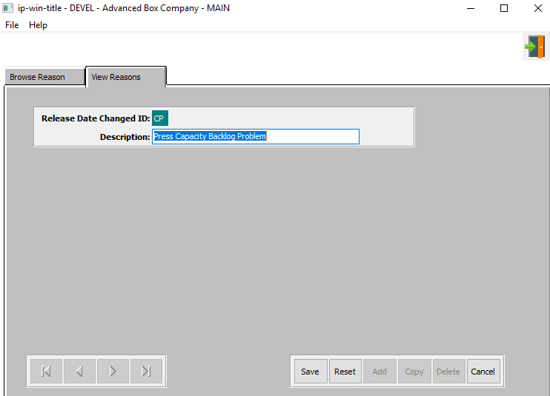

#### SAVE

Click the ***“Save”*** button to save the all changes to the reason.

#### RESET

Click the ***“Reset”*** button to revert all changes back to their original information.

#### CANCEL

Click the ***“Cancel”*** button to exit the reason update without saving changes.

#### EXIT

Click the ***“Exit Door Icon”*** to exit the data change reason popup screen.

#### Description

Enter a new description for the chosen release date change ID.

### Add Reason

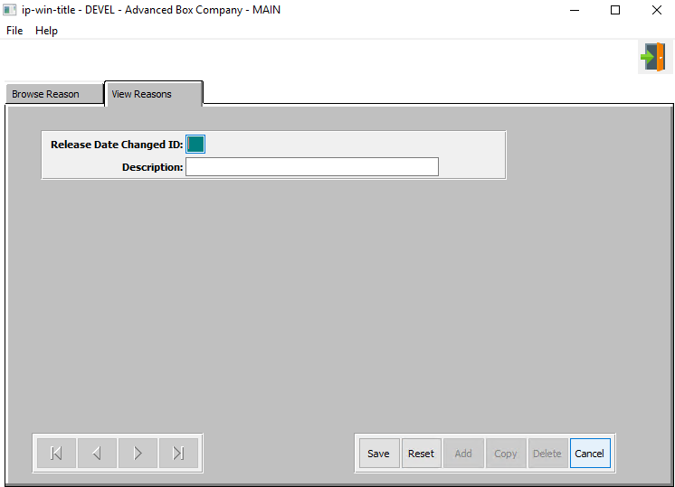

#### SAVE

Click the ***“Save”*** button to save the new reason.

#### RESET

Click the ***“Reset”*** button to reset all fields.

#### CANCEL

Click the ***“Cancel”*** button to cancel the new reason without saving changes.

#### EXIT

Click the ***“Exit Door Icon”*** to exit the data change reason popup screen.

#### Release Date Change ID

The user can choose two letters to represent the new date change reason.

#### Description

Enter a description for the date change reason code.